Supplementary Material

Identifying the causes of drivers’ negative states using driver characteristics, vehicle kinematics and physiological measurements
Ali Darzi, Sherif M. Gaweesh, Mohamed M. Ahmed, Domen Novak
* Correspondence: Domen Novak: dnovak1@uwyo.edu

Examples of representative classifiers
All classifiers are validated using the leave-one-out method. Though the presented classification accuracy in the paper is the mean accuracy across all k subsets, it is not rational to present the mean classifier coefficients across all subsets. Therefore, classifier coefficients or rules (in case of decision tree (DT) are presented for one representative subset.

Cell phone vs. no cell phone classification.
Among all three classifier types, logistic regression (LR) shows the highest accuracy for cell phone vs. no cellphone classification. For the representative data subset, the training and testing accuracies in cross-validation are 98.2% and 91.5%, respectively. Table S.1 shows the selected features and the obtained logistic regression coefficients.
Table S.1. Best selected features for cell phone use classification using logistic regression. Abs = absolute value, ECG = electrocardiogram, GSR = galvanic skin response, Std = standard deviation.
Feature | Coefficient
Abs (gradient (ECG)) | 2.6926
Mean (respiration rate) | 2.0508
Mean (lane offset) | 2.6869
Difference of tonic GSR | -0.8758
Number of GSR | 1.1414
Mean amplitude of GSR | 0.7175
Mean (HR) | 1.7986
Std (respiration rate) | -0.7553
Std (Throttle) | -1.5769
Std (vertical velocity) | 1.2017
Fluctuation of (slip of front tires) | -1.9901
Constant | -3.1835

Alert vs. drowsy classification
Among all three classifier types, the decision tree (DT) shows the highest accuracy for alert vs. drowsy classification. Different members of the DT family are used: simple, medium, complex and ensemble boosted. Due to the size of the medium and complex DTs, they cannot be presented here. Instead, a simple representative decision tree is shown in Fig. S.1. Furthermore, Table S.2 lists the features selected for classification of all subsets using ensemble boosted DT. For the representative data subset, the training and testing accuracies in cross-validation are 84.2% and 72.0%, respectively.
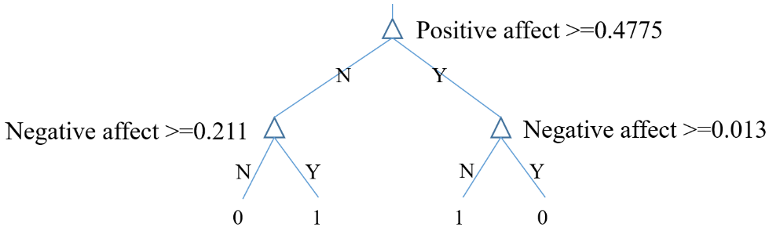
Figure S.1. A simple decision tree for alert vs. drowsy classification.
Table S.2. Best selected features for alert vs. drowsy classification using Decision Tree
# | Feature | # | Feature
1 | Positive Affect | 4 | Stress level
2 | Negative Affect | 5 | Intellect/Imagination
3 | Difference of GSR tonic | 6 | Participant’s Age

Low vs. high traffic density classification.
Among all three classifier types, logistic regression (LR) shows the highest accuracy for low vs. high traffic density classification. For the representative data subset, the training and testing accuracies in cross-validation are 99.3% and 100%, respectively. Table S.3 shows the selected features and the obtained logistic regression coefficients.
Table S.3. Best selected features for cell phone use classification using logistic regression. Abs = absolute value, ECG = electrocardiogram, RR = respiration rate, HR = heart rate, GSR = galvanic skin response, Std = standard deviation.
Feature | Coefficient
Std (lane number) | 2.8220
Power of low frequencies (HR) | -5.5572
Std amplitude of GSR | 2.3701
Std (respiration rate) | 1.4894
Mean (HR) | 1.9481
Std of inter heart beat interval | 1.2852
Power of high frequencies (HR) | 0.8574
Abs (gradient (ECG)) | 1.9799
Mean (slip of front tires) | -1.7403
Fluctuation of (slip of front tires) | -1.3552
Fluctuation of (slip of back tires) | 1.8332
Constant | -1.2931

Sunny vs. snowy weather classification
Among all three classifier types, the Support Vector Machine (SVM) with linear kernel shows the highest accuracy for sunny vs. snowy weather classification. For the representative data subset, the training and testing accuracies in cross-validation are 93.1% and 87.5%, respectively. Table S.4 shows the selected features and the obtained logistic regression coefficients.
Table S.4. Best selected features for classification of alert vs. drowsy classification using support vector machines. HR = heart rate, GSR = galvanic skin response, Std = standard deviation.
Feature
Mean of tonic GSR
Power of low/high (HR)
Std (throttle)
Std (slip of back tires)
Fluctuation of (slip of back tires)

Raw data
The raw data supporting the conclusions of this manuscript are included as a Microsoft Excel (.xls) spreadsheet. The file contains the different features (vehicle kinematics, physiology and driver characteristics) for all participants, sessions and scenarios within each session. To protect participant anonymity, potentially identifiable information (age, gender, height, dominant hand, use of glasses etc.) have been omitted.

