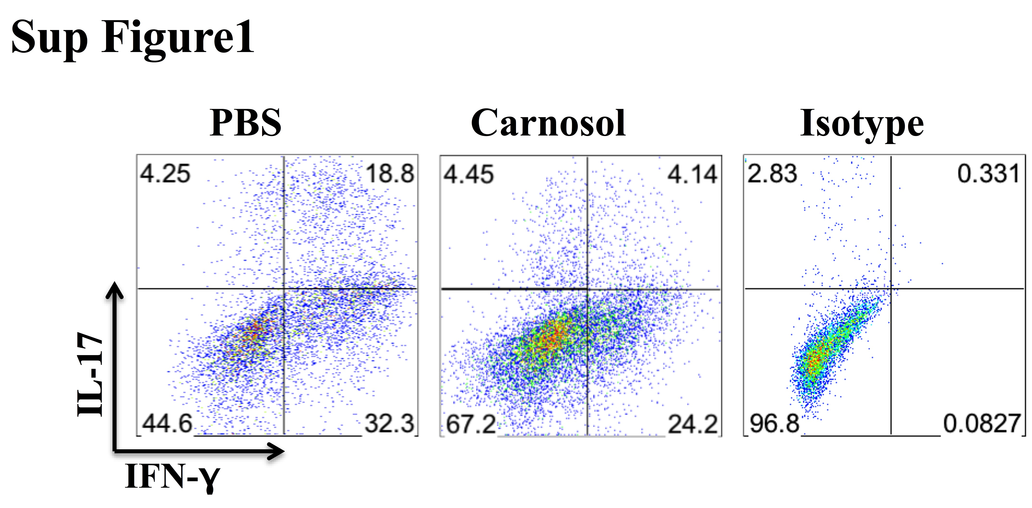
Sup. Fig.1. Carnosol treatment reduced the proportion of IFN-γ⁺IL-17⁺ CD4⁺ T cells in the CNS. Mice were treated with PBS or carnosol at the day of EAE induction and sacrificed at day 30 p.i. Spinal cords and brains were harvested and MNCs isolated (n = 10 each group). Frequencies of IFN-γ⁺IL-17⁺ cells among CD4⁺ cells were assessed by flow cytometry.

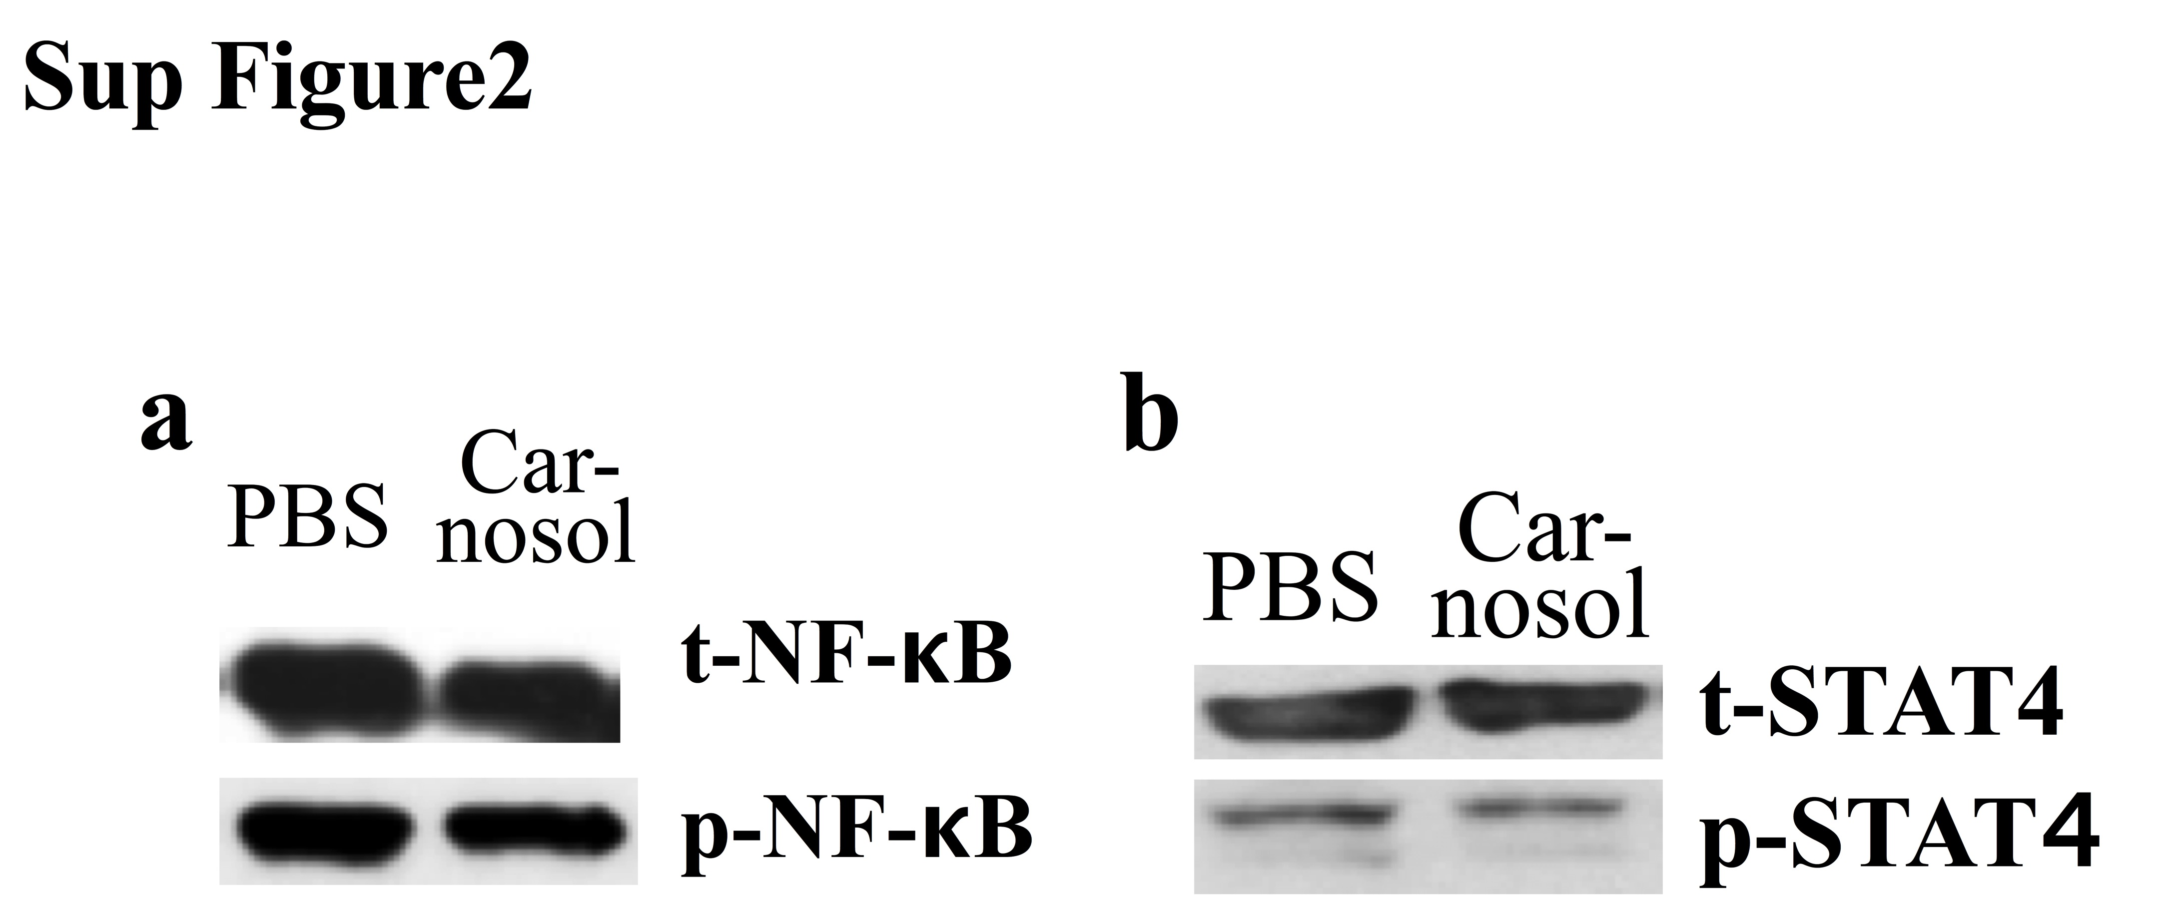
Sup. Fig. 2. Carnosol treatment did not alter Th1 cell differentiation and NF-κB and STAT3 expression. CD4+ T cells were cultured under Th1 polarizing condition with soluble anti-CD3e (1 μg/ml), anti-CD28 (1 μg/ml), anti-IL4 (10 μg/ml) and IL-12 (5 ng/ml) and treated with 10 μM carnosol or PBS for 3 days. Cells were then analyzed for NF-κB and STAT4 expression by Western blot.

