Supplementary Figures
Supplementary Figure 1
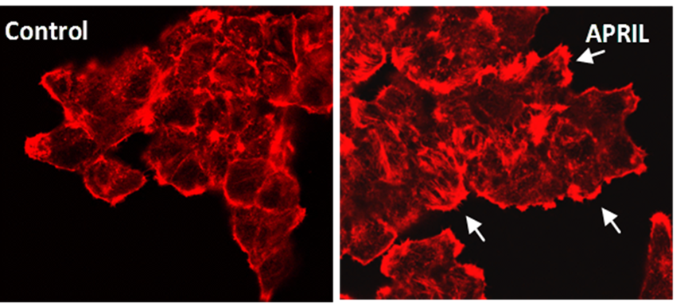
Representative images of actin cytoskeleton of T47D cells treated with APRIL. Actin cytoskeleton was visualized by rhodamine-phalloidine staining and a representative image of untreated (control) and treated with APRIL (100ng/ml, for 20 min) T47D cells are presented. Arrows point out fillopodia. Experiments were performed in triplicate.

Supplementary Figure 2
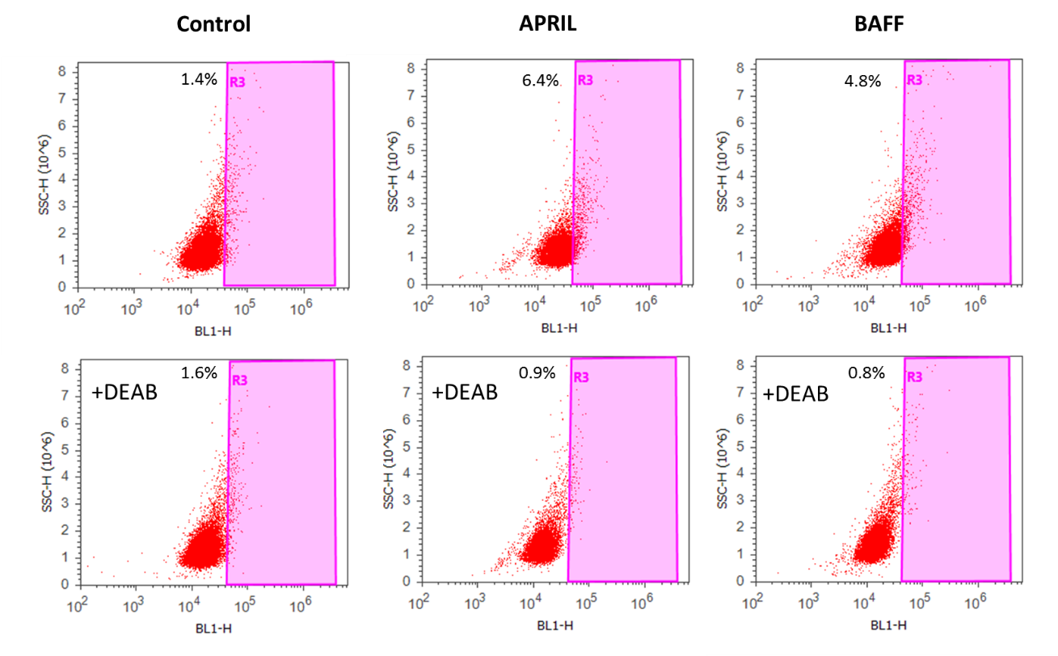
Percentage of breast cancer stem cells that are positive for ALDH activity as estimated by the ALDEFLUOR kit. Cells were treated with or without APRIL or BAFF (100ng/ml) for 4 days. Lower panel presents DEAB-treated cells that serve as the negative control, since DEAB is an inhibitor of ALDH1A1 activity. Three independent experiments were performed and the results of a representative one are presented.

Supplementary Figure 3
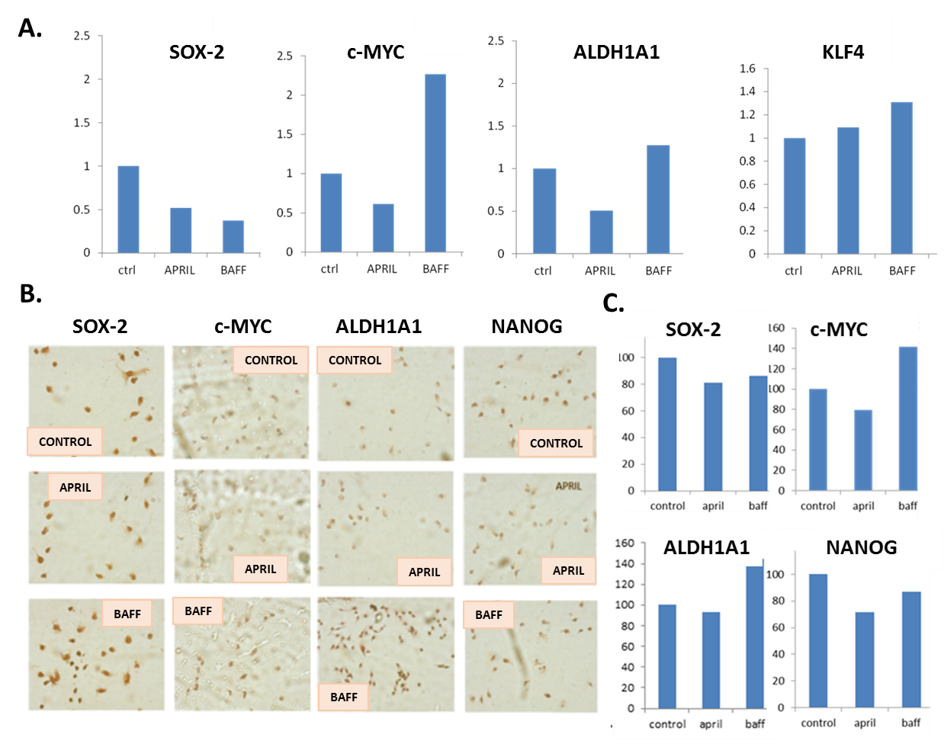
Expression levels of pluripotency markers in MDA cells after APRIL or BAFF treatment. A. Expression levels of ALDH1A1, KLF4, SOX-2, and c-MYC, genes (quantified by Real-Time PCR and expressed as percentage of control) after treatment of MDA cells with APRIL or BAFF (100ng/ml) for 4 days. B. and C. Expression of SOX-2, c-MYC, ALDH1A1 and NANOG proteins (assayed by immunocytochemistry). Representative images of three independent experiments are presented (B) Quantification of the proteins’ expression levels was performed using Image J and is expressed as percentage of control (C).

Supplementary Figure 4
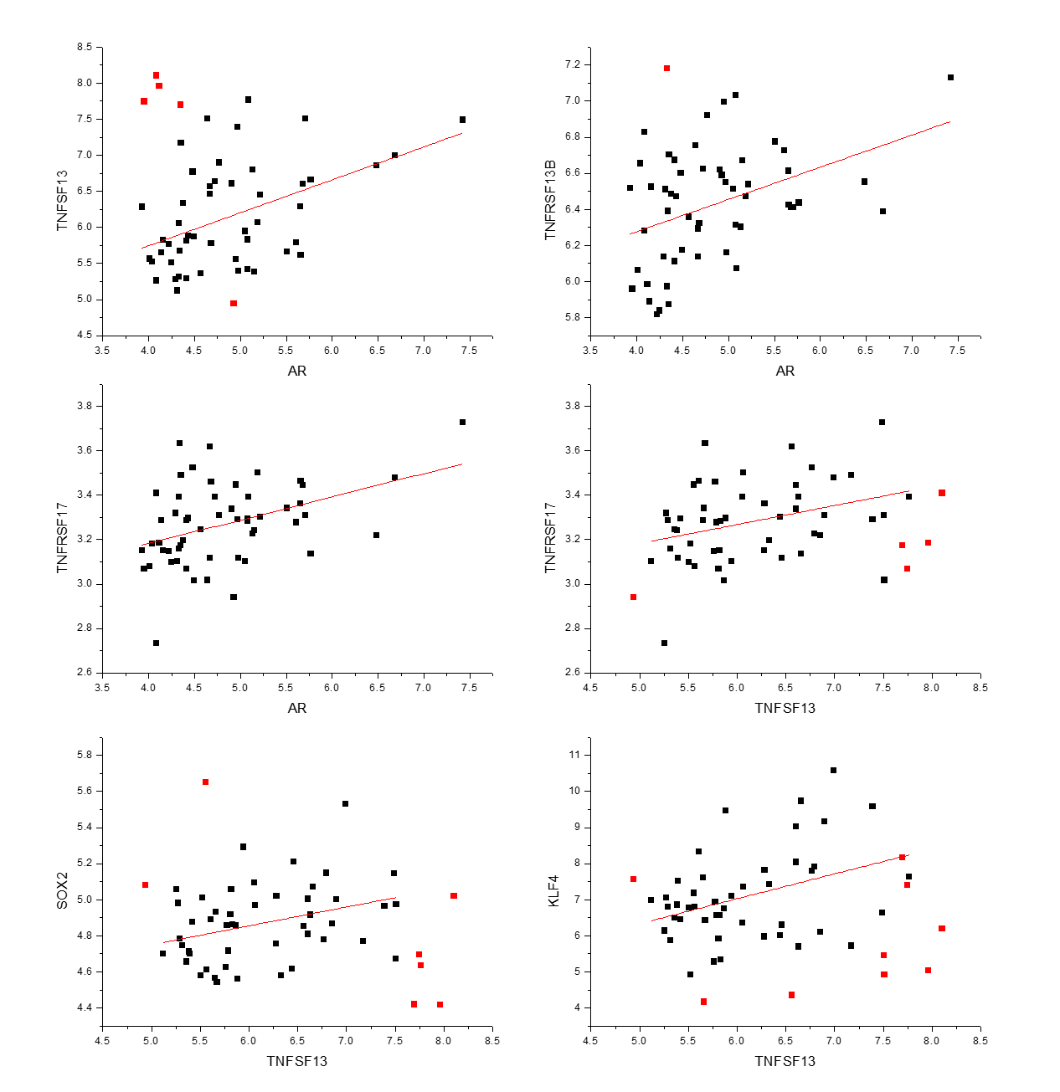
Correlation analysis of APRIL (TNFSF13), BAFF (TNFSF13B), BCMA (TNFRSF17), androgen receptor (AR), SOX2 and KLF4 in 56 different breast cancer cell lines. Normalized matrix data of the study E-TABM-157 were downloaded from Array Express. Expression data for TNFSF13, TNFSF13B, TNFRSF17, AR, SOX2, ALDH1A1, c-Myc, KLF4 and NANOG were extracted and analyzed in Origin 8, through a linear fit. Outliers (the same in each analysis) were denoted in red.

