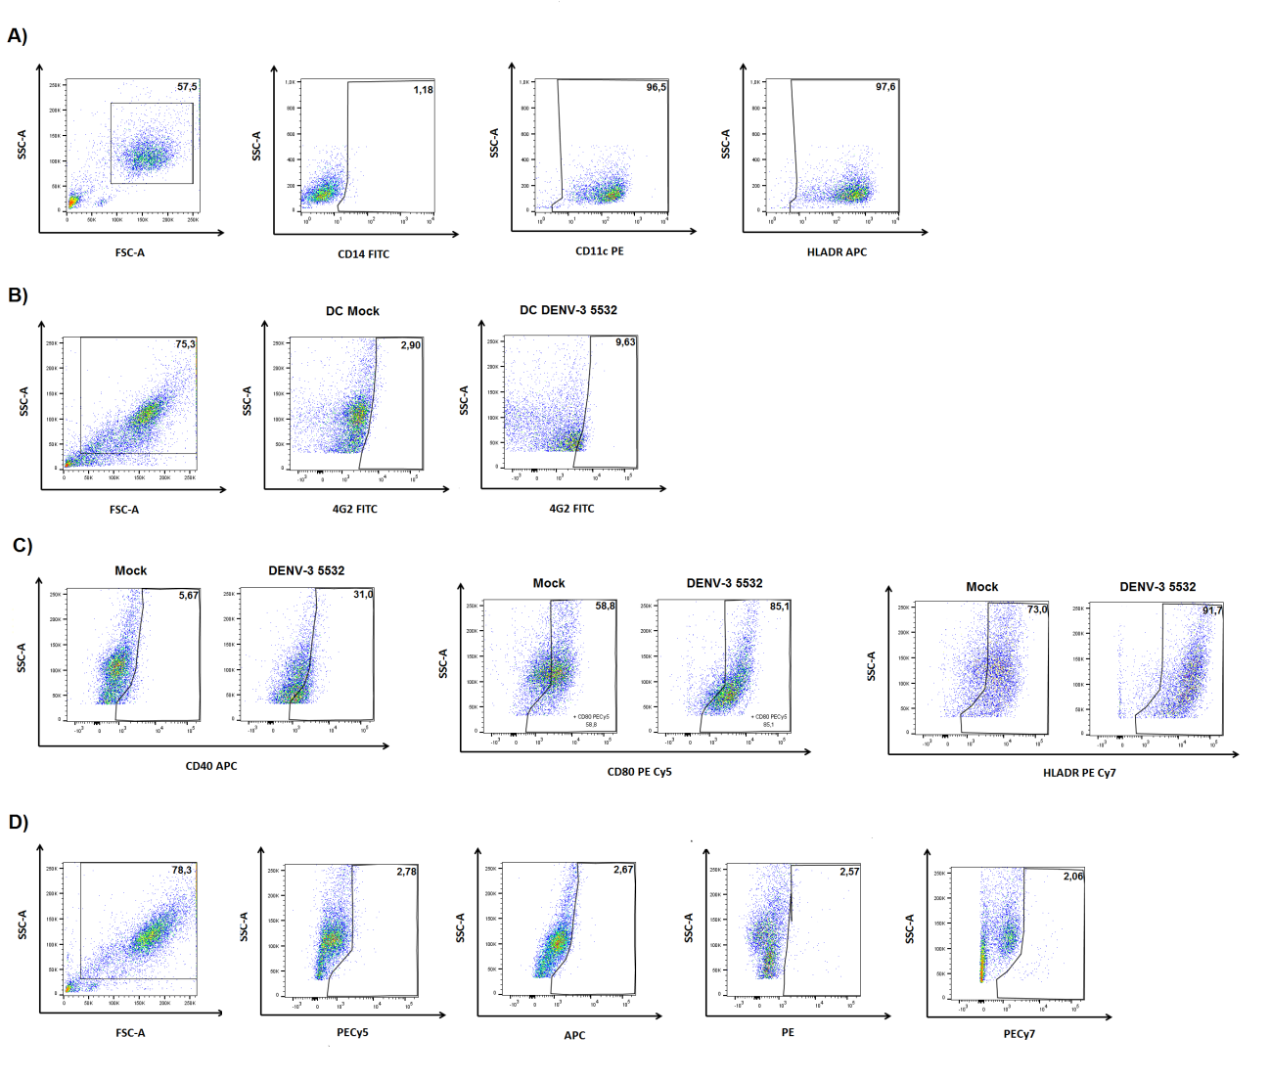
Supplementary figure 1 - A) Representative dot plots showing the expression of CD14, CD11c and HLADR on monocyte-derived dendritic cells. The gates were delimitated using isotype controls for each antibody, as shown in S1 C. B) Representative Plots showing intracellular staining of viral E protein in mdDCs. Left panel: gate delimiting the mdDCs population; center panel: E protein staining of Mock cells; Right panel: E protein staining of mdDCs infected with DENV3-5532. C) Representative Plots showing the expression of CD40, CD80 and HLADR for cells infected with DENV3-5532 (MOI10, 72h) and Mock. D) Isotype controls for the fluorophores used.
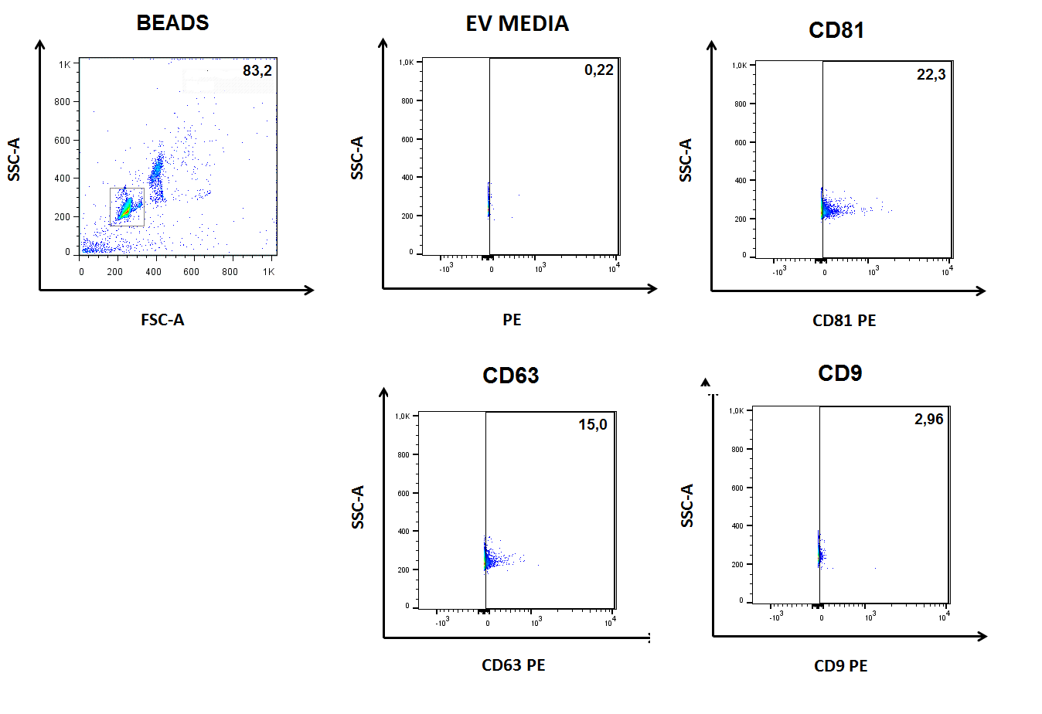
Supplementary figure 2 - Representative plots showing the expression of CD9, CD63 and CD81 in EVs captured with latex beads. Gates were delimitated with microspheres bound to samples and stained with isotype antibodies conjugated with PE.
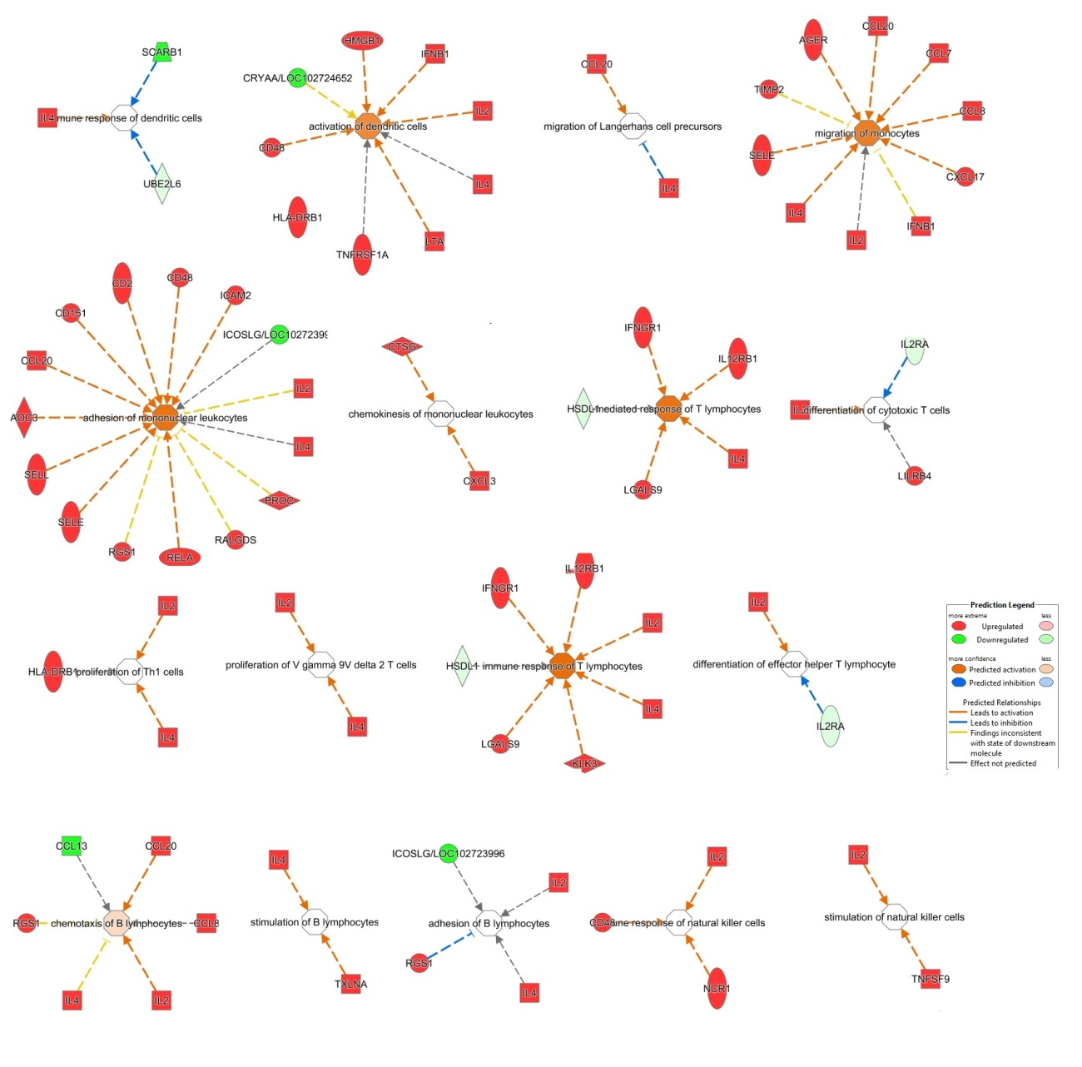
Supplementary Figure 3 – IPA Pathways related to immune responses for mRNAs found in DENV3-5532 and DENV3-290 EVs. mRNAs marked in red are more expressed in DENV3-5532 EVs, while those marked in green are more expressed in DENV3-290 EVs. Arrows indicate the putative action of those genes over the pathways – orange arrows indicate an activator role, while blue arrows indicate a repressive role

Supplementary Figure 4 – Eletrophoretic profile of amplicons obtained from mdDC EV RNAs, after RT-PCR. Samples marked as (-) represent RT-PCR negative controls for each specific primer. Marker: 1kb Plus (invitrogen)
Supplementary figure 5 - Evaluation of depletion efficiency of DENV from mdDC-EV pools by RT-PCR. Agarose gels stained with ethidium bromide showing amplification of a DENV3-specific fragment. In: input EVs before depletion. B1, B2, B3: supernatants or first, second and third rounds of depletion, respectively

Supplementary table 1 – miRNAs found in EVs secreted by mdDCs infected with DENV3- 5532, DENV3-290 or by mock cells, collected 72h post infection

Supplementary table 2 - Putative targets of EV miRNAs in recipient cells predicted in DIANA mirPATH

Supplementary table 3 - Subset of mRNAs used as input for Ingenuity Pathway Analysis

Supplementary table 4- Ingenuity Pathway Analysis of EV mRNAs in the Diseases and Functions mode

Supplementary table 5 - Ingenuity Pathway Analysis of EV mRNAs in the Canonical Pathways mode

