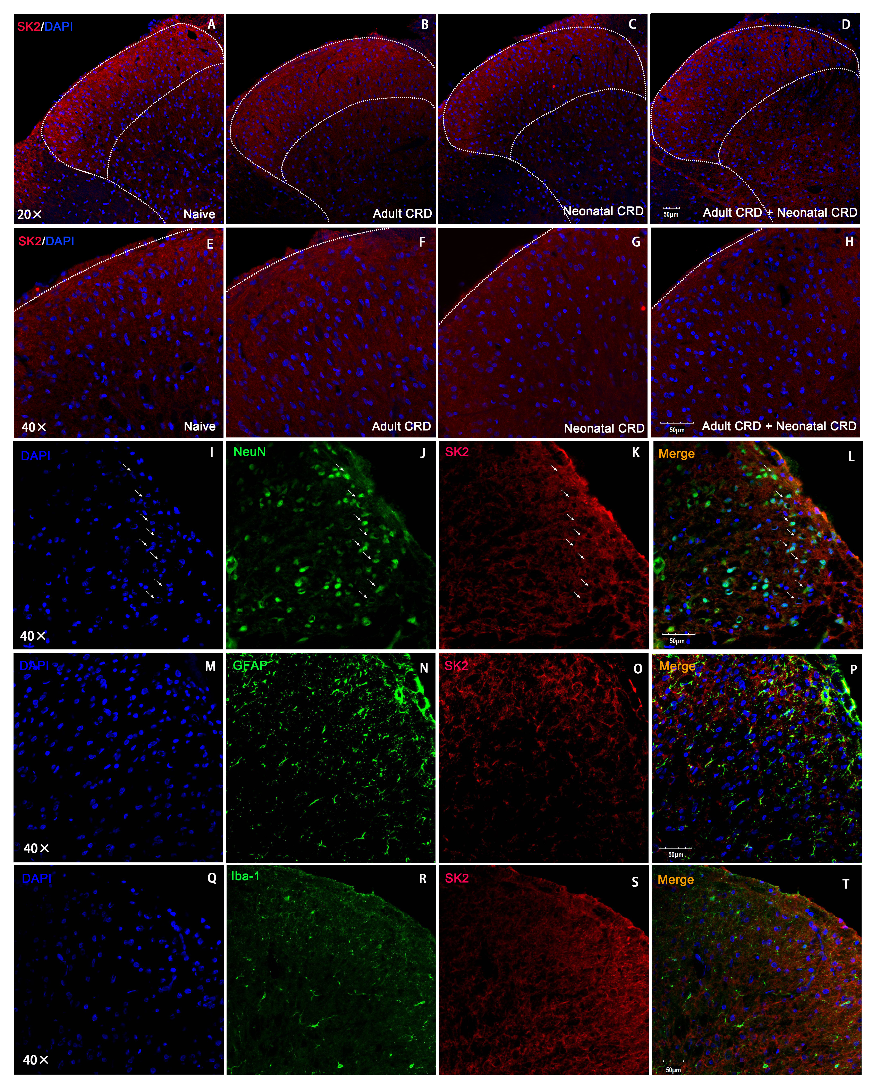
SUPPLEMENTARY FIGURE 1. Immunofluoresence staining of SK2 channels in the spinal DH of rats. (A-H) SK2 channel positive stainings were located at the layer I and II of the spinal DH. (I-L) SK2 channel protein was co-labeled with NeuN. (M-P) A limited number of SK2 channel protein was co-labeled with GFAP. (Q-T) A limited number of SK2 channel protein was co-labeled with Iba-1. Low magnification: 20×, High magnification 40×; Scale bars 50 μm.

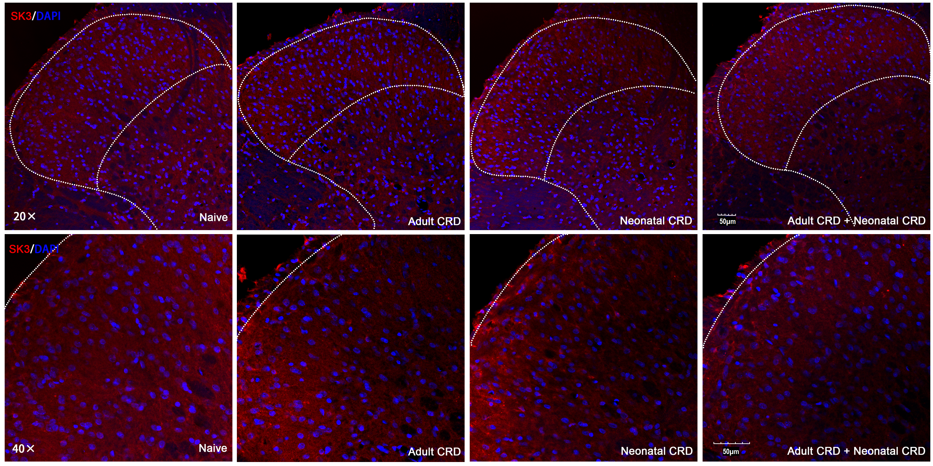
SUPPLEMENTARY FIGURE 2. Distribution of SK3 channel protein in the spinal DH of rats that experienced neonatal and/or adult CRD. Scale bars 50 μm.

SUPPLEMENTARY FIGURE 3. Spinal SK3 channel protein was not changed in rats that experienced neonatal and/or adult CRD. Data are expressed as mean ± SEM. n = 3 per group.

