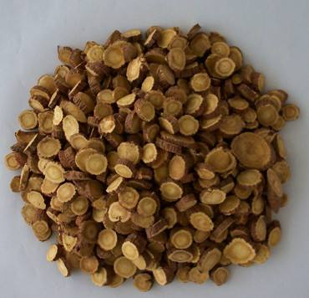
黄芪, Huang qi, Astragalus membranaceus (Fisch.) Bge. var. mongholicus (Bge.) Hsiao
Obtained from the Inner Mongolia Province, China.

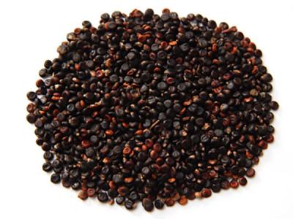
水红花子，Shui hong hua zi (Polygonum orientale L.)
Obtained from the Heilongjiang Province, China.

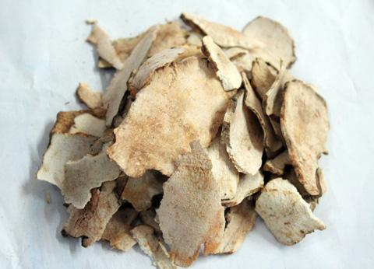
茯苓, Fu ling, Poria cocos (Schw.) Wolf
Obtained from the Yunnan Province, China.

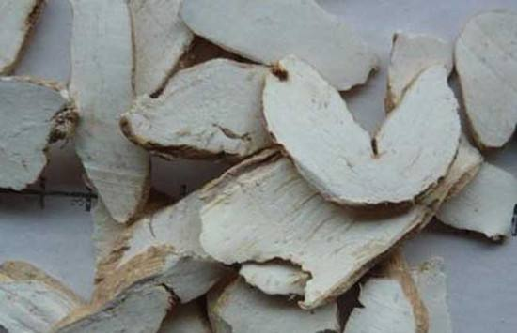
丹参, Dan shen, Salvia miltiorrhiza Bge.
Obtained from the Hebei Province, China.

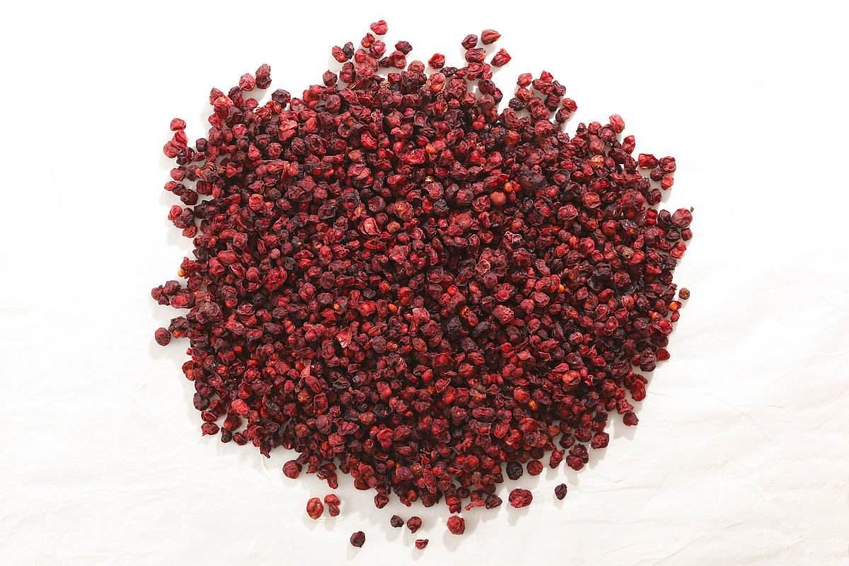
五味子，Wu wei zi, Schisandra chinensis (Turcz.) Baill.
Obtained from the Liaoning Province, China.

