Supplementary Material
Computationally Exploring and Alleviating the Kinetic Bottlenecks of Anaerobic Methane Oxidation
Matthew J. Grisewood, James G. Ferry, Costas D. Maranas*
* Correspondence: Corresponding Author: costas@psu.edu

Supplementary Data

Deviation of Equations 3 and 4
Using Figure 5 to portray the mechanism of Mcr inhibition by HDS, Equations S1-S4 describe the transient behavior of each of the reaction intermediates, substrates, and products. The following abbreviations are used in the derivation: HS-CoB (CoB), CH₃-S-CoM (CoM), CH₃-S-CoM·HS-CoB (CoM·CoB), and CoM-S-S-CoB (HDS).
 | $$\frac{\text{d}\left[\text{Mcr∙CoM}\right]}{\text{dt}}\text{ = }{\text{k}}_{\text{9}}\left[\text{CoM}\right]\left[\text{Mcr}\right]\text{ + }{\text{k}}_{-\text{10}}\left[\text{Mcr∙CoM∙CoB}\right] \\ \text{– }{\text{k}}_{-\text{9}}\left[\text{Mcr∙CoM}\right] \text{– }{\text{k}}_{\text{10}}\left[\text{Mcr∙CoM}\right]\left[\text{CoB}\right]$$ | (Eq. S1)
 | $$\frac{\text{d}\left[\text{Mcr∙CoM∙CoB}\right]}{\text{dt}}\text{ = }{\text{k}}_{\text{10}}\left[\text{Mcr∙CoM}\right]\left[\text{CoB}\right] \text{– }\left({\text{k}}_{-\text{10}}\text{ + }{\text{k}}_{\text{11}}\right)\left[\text{Mcr∙CoM∙CoB}\right]$$ | (Eq. S2)
 | $$\frac{\text{d}\left[\text{Mcr∙CoB}\right]}{\text{dt}}\text{ = }{\text{k}}_{\text{13}}\left[\text{Mcr}\right]\left[\text{CoB}\right]\text{ – }{\text{k}}_{-\text{13}}\left[\text{Mcr∙CoB}\right]$$ | (Eq. S3)
 | $$\frac{\text{d}\left[\text{Mcr∙HDS}\right]}{\text{dt}}\text{ = }{\text{k}}_{\text{12}}\left[\text{Mcr}\right]\left[\text{HDS}\right]\text{ – }{\text{k}}_{-\text{12}}\left[\text{Mcr∙HDS}\right]\text{ + }{\text{k}}_{\text{11}}\left[\text{Mcr∙CoM∙CoB}\right]$$ | (Eq. S4)
Using the assumption that the concentration of HDS formed through reaction is negligible (as discussed in the “Developing a complete model for Mcr kinetics” subsection of “Results and Discussion”. Using this assumption, Equation S4 reduces to Equation S5.
 | $$\frac{\text{d}\left[\text{Mcr∙HDS}\right]}{\text{dt}}\text{ = }{\text{k}}_{\text{12}}\left[\text{Mcr}\right]\left[\text{HDS}\right]\text{ – }{\text{k}}_{-\text{12}}\left[\text{Mcr∙HDS}\right]$$ | (Eq. S5)
Using Briggs-Haldane kinetics, the left-hand side of Equations S1, S2, S3, and S5 can be set equal to 0. Setting the left-hand side of Equation S2 equal to 0 and rearranging yields Equation S6.

 | $$\left[\text{Mcr∙CoM}\right]\text{ =}\frac{\left({\text{k}}_{-\text{10 }}\text{+ }{\text{k}}_{\text{11}}\right)\left[\text{Mcr∙CoM∙CoB}\right]}{{\text{k}}_{\text{10}}\left[\text{CoB}\right]}$$ | (Eq. S6)
Setting the left-hand side of Equation S1 equal to 0, substituting [Mcr·CoM] from Equation S6, and simplification leads to Equation S7.
 | $$\left[\text{Mcr}\right]\text{ =}\frac{{\text{k}}_{-\text{9}}\left({\text{k}}_{-\text{10}} \text{+} {\text{k}}_{\text{11}}\right)\left[\text{Mcr∙CoM∙CoB}\right]}{{\text{k}}_{\text{9}}{\text{k}}_{\text{10}}\left[\text{CoB}\right]\left[\text{CoM}\right]} \text{+} \frac{{\text{k}}_{\text{11}}\left[\text{Mcr∙CoM∙CoB}\right]}{{\text{k}}_{\text{9}}\left[\text{CoM}\right]}$$ | (Eq. S7)
Setting the left-hand side of Equation S5 equal to 0, substituting in the expression for [Mcr] from Equation S7, and simplifying yields Equation S8.
 | $$\left[\text{Mcr∙HDS}\right]\text{ =}\frac{{\text{k}}_{\text{12}}}{{\text{k}}_{-\text{12}}}\left[\text{HDS}\right]\left(\frac{{\text{k}}_{-\text{9}}\left({\text{k}}_{-\text{10}}\text{ + }{\text{k}}_{\text{11}}\right)\left[\text{Mcr∙CoM∙CoB}\right]}{{\text{k}}_{\text{9}}{\text{k}}_{\text{10}}\left[\text{CoB}\right]\left[\text{CoM}\right]}\text{ + }\frac{{\text{k}}_{\text{11}}\left[\text{Mcr∙CoM∙CoB}\right]}{{\text{k}}_{\text{9}}\left[\text{CoM}\right]}\right)$$ | (Eq. S8)
Setting the left-hand side of Equation S3 equal to 0, substituting in the expression for [Mcr] from Equation S7, and simplifying yields Equation S9.
 | $$\left[\text{Mcr∙CoB}\right]\text{ =}\frac{{\text{k}}_{\text{13}}}{{\text{k}}_{-\text{13}}}\left[\text{CoB}\right]\left(\frac{{\text{k}}_{-\text{9}}\left({\text{k}}_{-\text{10}}\text{ + }{\text{k}}_{\text{11}}\right)\left[\text{Mcr∙CoM∙CoB}\right]}{{\text{k}}_{\text{9}}{\text{k}}_{\text{10}}\left[\text{CoB}\right]\left[\text{CoM}\right]}\text{ + }\frac{{\text{k}}_{\text{11}}\left[\text{Mcr∙CoM∙CoB}\right]}{{\text{k}}_{\text{9}}\left[\text{CoM}\right]}\right)$$ | (Eq. S9)
A site-balance can be written for Mcr, as shown in Equation S10.
 | $${ \left[\text{Mcr}\right]}_{\text{Total}}\text{ =} \left[\text{Mcr}\right] \text{+} \left[\text{Mcr∙CoM}\right] \text{+} \left[\text{Mcr∙CoM∙CoB}\right] \text{+} \left[\text{Mcr∙CoB}\right] \text{+} \left[\text{Mcr∙HDS}\right]$$ | (Eq. S10)
With the exception of [Mcr·CoM·CoB], the terms on the right-hand side of Equation S10 can be substituted by the right-hand sides of Equations S6-S9. Applying this substitution and simplifying the expression yields Equations S11 and S12.
 | $$\left[\text{Mcr∙CoM∙CoB}\right]\text{ =} \frac{{\left[\text{Mcr}\right]}_{\text{Total}}}{{\text{C}}_{\text{1}}\left(\text{1} \text{+} \frac{{\text{k}}_{\text{13}}}{{\text{k}}_{-\text{13}}}\left[\text{CoB}\right] \text{+} \frac{{\text{k}}_{\text{12}}}{{\text{k}}_{-\text{12}}}\left[\text{HDS}\right]\right) \text{+} \text{1} \text{+} \frac{{\text{k}}_{\text{11}} \text{+} {\text{k}}_{-\text{10}}}{{\text{k}}_{\text{10}}\left[\text{CoB}\right]}}$$ | (Eq. S11)
 | $${ \text{C}}_{\text{1}} \text{=} \left(\frac{{\text{k}}_{-\text{9}}\left({\text{k}}_{-\text{10}}\text{ + }{\text{k}}_{\text{11}}\right)}{{\text{k}}_{\text{9}}{\text{k}}_{\text{10}}\left[\text{CoB}\right]\left[\text{CoM}\right]}\text{ + }\frac{{\text{k}}_{\text{11}}}{{\text{k}}_{\text{9}}\left[\text{CoM}\right]}\right)$$ | (Eq. S12)
The rate of formation of product (methane) can be written as Equation S13.
 | $$\text{v}\text{ = }{\text{k}}_{\text{11}}\left[\text{Mcr∙CoM∙CoB}\right]$$ | (Eq. S13)

Substitution of Equation S11 into Equation S13 equals Equation S14, the rate of formation of methane in the presence of the HDS inhibitor (v_{Inhib}).
 | $${\text{v}}_{\text{Inhib}}\text{ = }\frac{{{\text{k}}_{\text{11}}\left[\text{Mcr}\right]}_{\text{Total}}}{{\text{C}}_{\text{1}}\left(\text{1 + }\frac{{\text{k}}_{\text{13}}}{{\text{k}}_{-\text{13}}}\left[\text{CoB}\right]\text{ + }\frac{{\text{k}}_{\text{12}}}{{\text{k}}_{-\text{12}}}\left[\text{HDS}\right]\right)\text{ + 1 + }\frac{{\text{k}}_{\text{11}}\text{ + }{\text{k}}_{-\text{10}}}{{\text{k}}_{\text{10}}\left[\text{CoB}\right]}}$$ | (Eq. S14)
The IC₅₀ value represents the concentration of the inhibitor at which the reaction rate is 50% of its maximum value. This can be expressed mathematically (Equation S15).
 | $$\frac{{\text{v}}_{\text{Inhib}}}{{\text{v}}_{\text{Uninhib}}}\text{=}\frac{\text{1}}{\text{2}}$$ | (Eq. S15)
As apparent from Equation S15, an expression for v_{Uninhib} is also required. Eliminating the inhibitor (HDS) from Figure 5 requires forming expressions akin to that of Equations S1-S3. The presence of HDS as an inhibitor does not affect Equations S6, S7, or S9, but it does affect the site balance (Equation S10). The new site balance is provided as Equation S16.
 | $${ \left[\text{Mcr}\right]}_{\text{Total}}\text{ =} \left[\text{Mcr}\right] \text{+} \left[\text{Mcr∙CoM}\right] \text{+} \left[\text{Mcr∙CoM∙CoB}\right] \text{+} \left[\text{Mcr∙CoB}\right]$$ | (Eq. S16)
Substituting the right-hand side of Equations S6, S7, and S9 into Equation S16 and simplifying reveals Equation S17, where C₁ is defined in Equation S12.
 | $$\left[\text{Mcr∙CoM∙CoB}\right]\text{ =} \frac{{\left[\text{Mcr}\right]}_{\text{Total}}}{{\text{C}}_{\text{1}}\left(\text{1} \text{+} \frac{{\text{k}}_{\text{13}}}{{\text{k}}_{-\text{13}}}\left[\text{CoB}\right]\right) \text{+} \text{1} \text{+} \frac{{\text{k}}_{\text{11}} \text{+} {\text{k}}_{-\text{10}}}{{\text{k}}_{\text{10}}\left[\text{CoB}\right]}}$$ | (Eq. S17)
Substitution of Equation S17 into Equation S13 leads to an expression for the reaction velocity in the absence of HDS as an inhibitor.
 | $${\text{v}}_{\text{Uninhib}}\text{ = }\frac{{{\text{k}}_{\text{11}}\left[\text{Mcr}\right]}_{\text{Total}}}{{\text{C}}_{\text{1}}\left(\text{1 + }\frac{{\text{k}}_{\text{13}}}{{\text{k}}_{-\text{13}}}\left[\text{CoB}\right]\right)\text{ + 1 + }\frac{{\text{k}}_{\text{11}}\text{ + }{\text{k}}_{-\text{10}}}{{\text{k}}_{\text{10}}\left[\text{CoB}\right]}}$$ | (Eq. S18)

Combining Equations S14, S15, and S18 leads to the final expression for k₁₂ (see Equation 3 in “Results and Discussion”), where [HDS] in Equation S14 is replaced by the IC₅₀ concentration. The IC₅₀ value, [CoM], and [CoB] are taken from Figure 5 of (Ellermann et al., 1988). The values from k₉, k₋₉, k₁₀, k₋₁₀, k₁₁, k₁₃, and k₋₁₃ are taken from Scheme 2 of (Wongnate and Ragsdale, 2015), and the lower limit for k₋₁₂ is also taken from (Wongnate and Ragsdale, 2015), which is established by the k_{cat} value.

Supplementary Figures
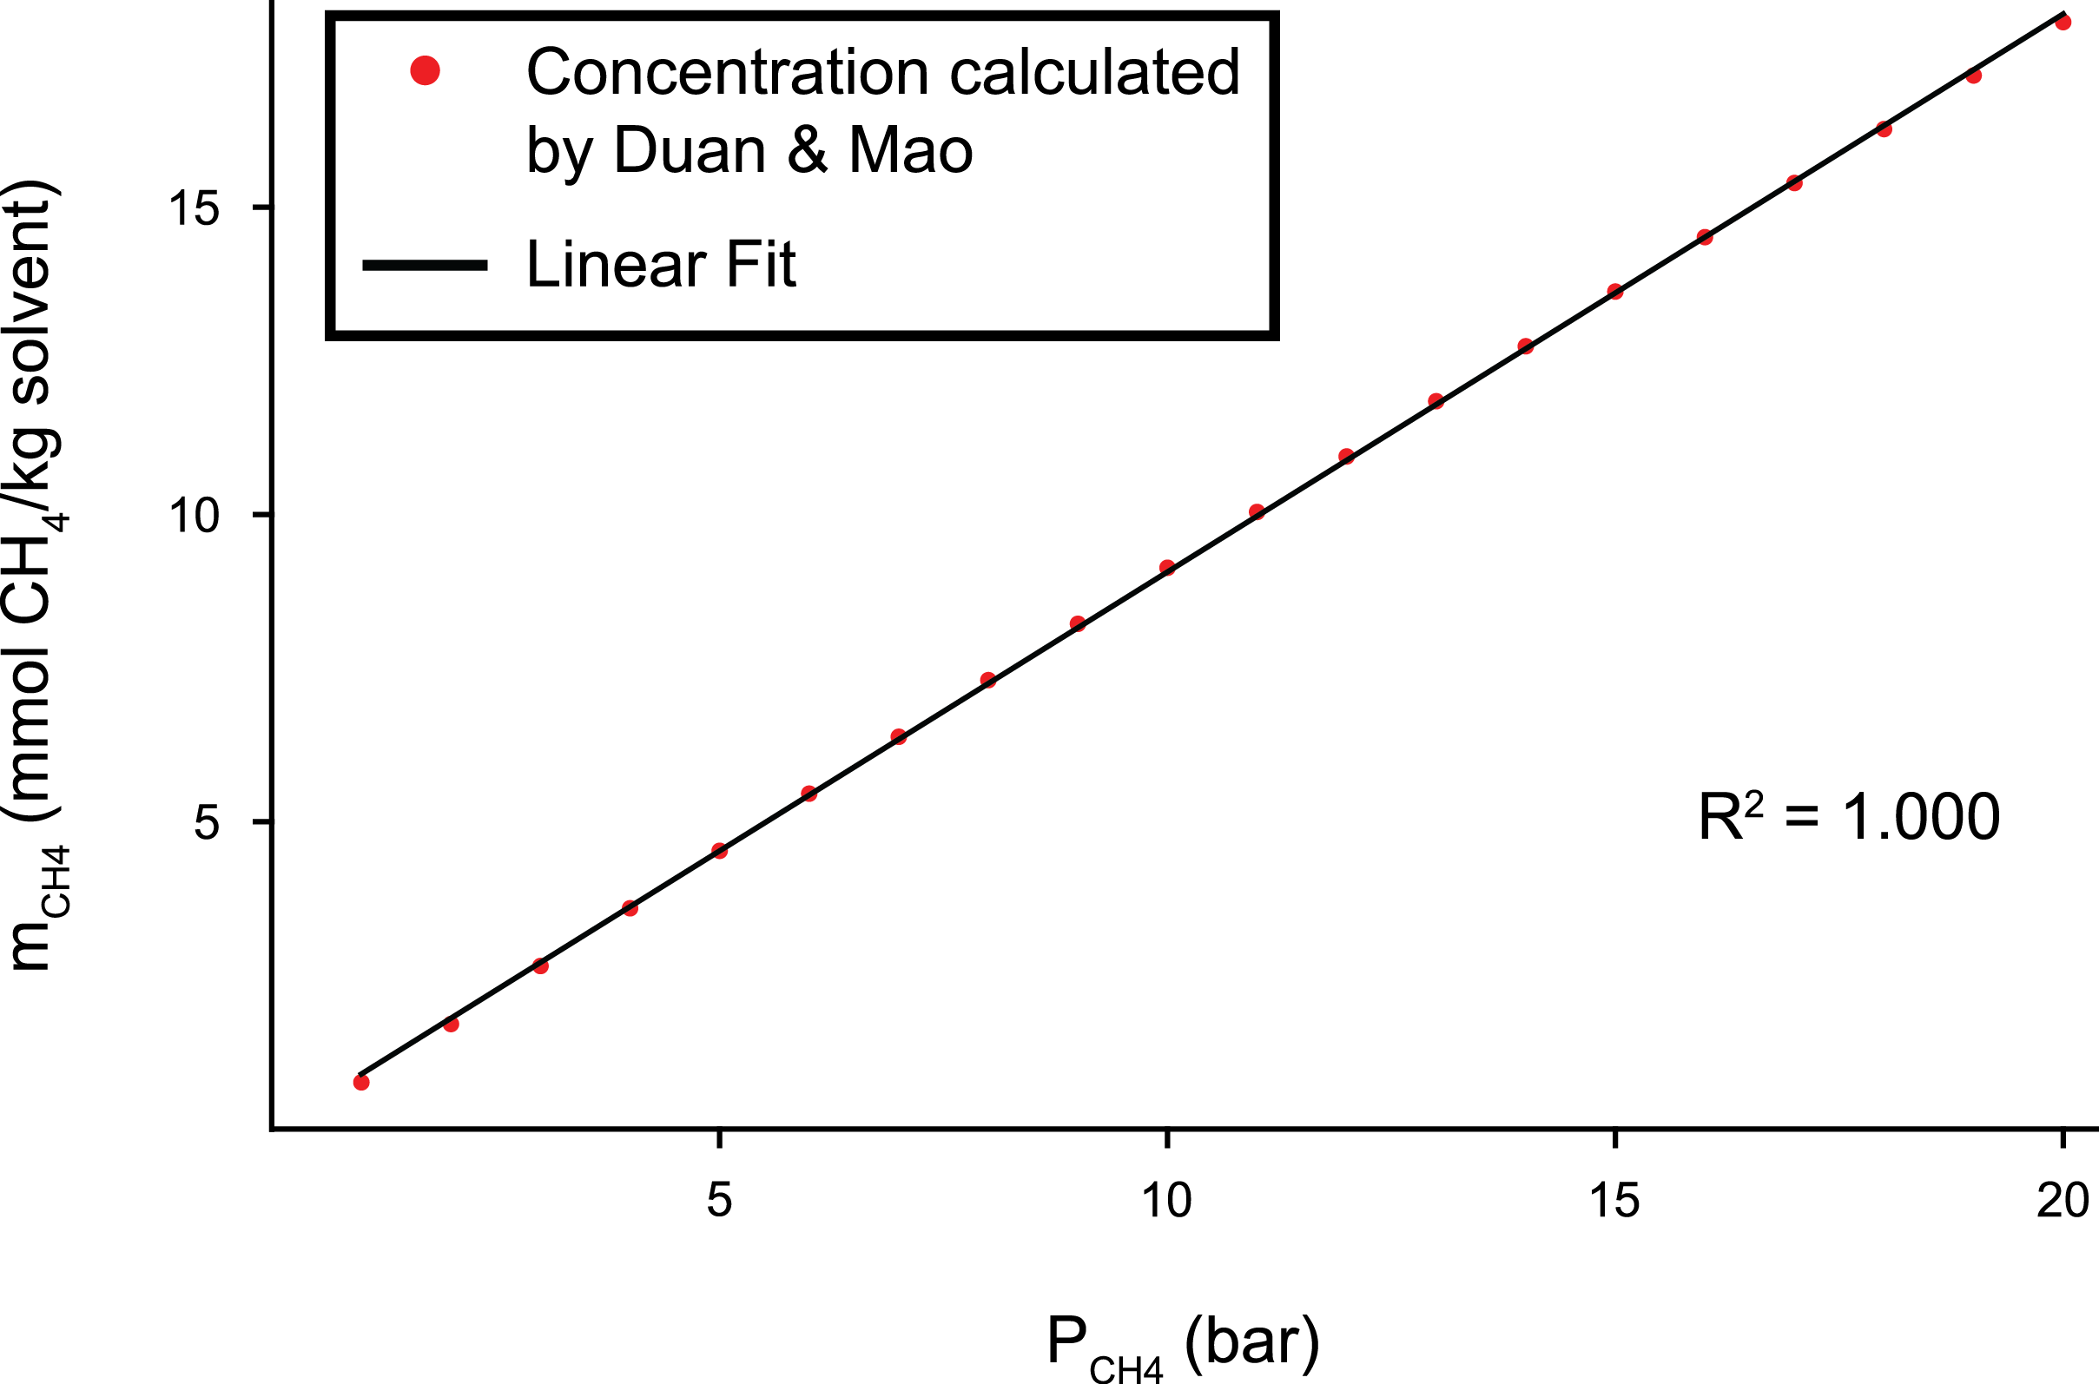
Supplementary Figure 1. Linear relationship between methane partial pressure and concentration at low pressures. The methane partial pressure was calculated using the empirical equation developed by Duan and Mao (Duan and Mao, 2006).
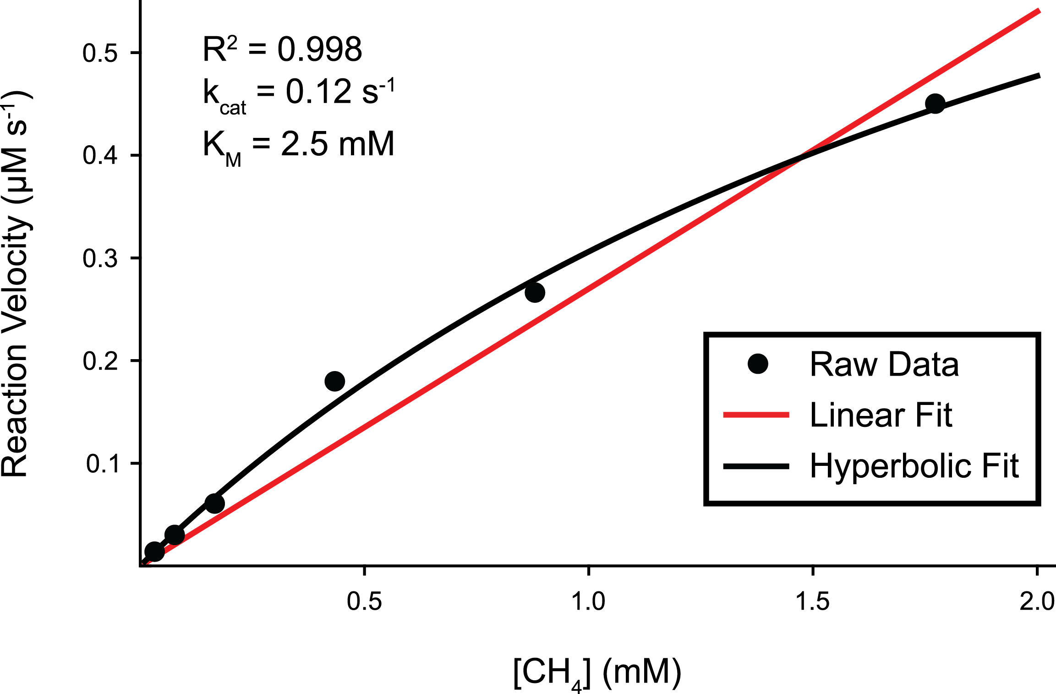
Supplementary Figure 2. Michaelis-Menten fit of reaction velocity versus methane concentration.

References
Duan, Z.H., and Mao, S.D. (2006). A thermodynamic model for calculating methane solubility, density and gas phase composition of methane-bearing aqueous fluids from 273 to 523 K and from 1 to 2000 bar. Geochimica Et Cosmochimica Acta 70(13), 3369-3386. doi: 10.1016/j.gca.2006.03.018.
Ellermann, J., Hedderich, R., Bocher, R., and Thauer, R.K. (1988). The final step in methane formation. Investigations with highly purified methyl-CoM reductase (component C) from Methanobacterium thermoautotrophicum (strain Marburg). Eur J Biochem 172(3), 669-677.
Wongnate, T., and Ragsdale, S.W. (2015). The Reaction Mechanism of Methyl-Coenzyme M Reductase: HOW AN ENZYME ENFORCES STRICT BINDING ORDER. Journal of Biological Chemistry 290(15), 9322-9334. doi: 10.1074/jbc.M115.636761.

