Appendix 1
MEDLINE electronic search strategy
Search | Query | Items found
Patient
#1 | Carcinoma, Non-Small-Cell Lung[MeSH Terms] | 42,471
#2 | NSCLC*[Title/Abstract] | 32,064
#3 | (lung*[Title/Abstract]) OR (bronch*[Title/Abstract]) | 692,736
#4 | (carcino*[Title/Abstract]) OR (cancer*[Title/Abstract]) OR (tumor*[Title/Abstract]) OR (tumour*[Title/Abstract]) OR (malignan*[Title/Abstract]) OR (oncol*[Title/Abstract]) | 2,837,970
#5 | #1 OR #2 OR (#3 AND #4) | 254,217
Intervention
#6 | Cranial Irradiation[MeSH Terms] | 4,854
#7 | Brain Neoplasms/radiotherapy[MeSH Terms] | 12,181
#8 | (brain*[Title/Abstract]) OR (cran*[Title/Abstract]) | 1,007,160
#9 | (carcino*[Title/Abstract]) OR (cancer*[Title/Abstract]) OR (tumor*[Title/Abstract]) OR (tumour*[Title/Abstract]) OR (malignan*[Title/Abstract]) OR (oncol*[Title/Abstract]) OR (metasta*[[Title/Abstract]) | 2,837,971
#10 | (Radiotherapy[MeSH Terms]) OR (Radioth*[Title/Abstract]) OR (Radiat*[Title/Abstract]) | 518,712
#11 | #6 OR #7 OR (#8 AND #9 AND #10) | 31,341
Outcome
#12 | Survival Analysis[MeSH Terms] | 243,741
#13 | Radiation Effects[MeSH Terms] | 71,206
#14 | Brain/Radiation Effects[MeSH Terms] | 8,646
#15 | Survival[MeSH Terms] | 4,433
#16 | Mortality[MeSH Terms] | 334,306
#17 | Survival Rate[MeSH Terms] | 150,629
#18 | Survival*[Title/Abstract] | 782,165
#19 | #12 OR #13 OR #14 OR #15 OR #16 OR #17 OR #18 | 1,162,700
Design
#20 | RCT*[Title/Abstract] | 34,109
#21 | random*[Title/Abstract] | 944,737
#22 | #20 OR #21 | 949,604
#23 | #5 AND #11 AND #19 AND #22 | 360

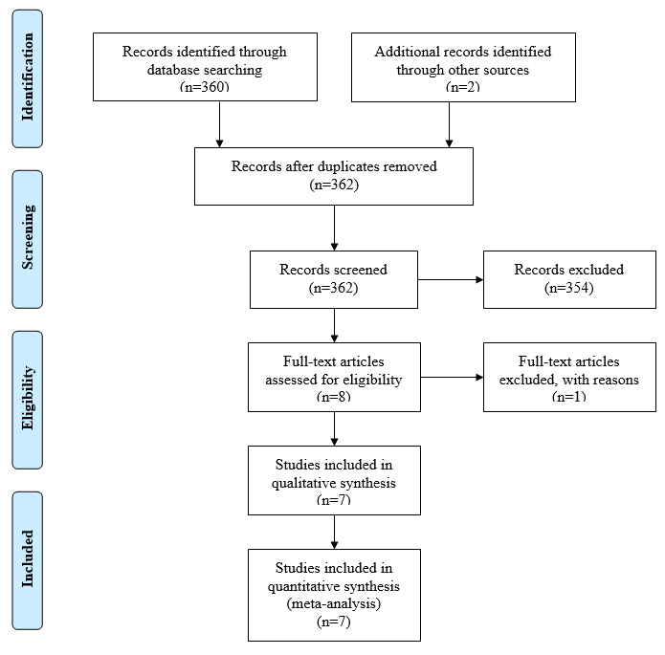

Flowchart of the trial selection
Appendix 2
Methodological quality of the included RCTs evaluating the effect of PCI on BM in NSCLC
Study | Random sequence generation | Allocation concealment | Blinding of participants and personnel | Blinding of outcome assessment | Free of Incomplete outcome data | Free of Selective reporting | Free of other bias
VALG | V | V | V | X | V | V | X
MDACC | V | ? | V | X | V | V | V
RTOG8403 | V | V | V | X | V | V | V
SWOG | V | ? | V | ? | V | V | V
RTOG0214 | V | V | V | V | V | V | V
Li | V | V | V | V | V | V | V
NVALT-11 | V | V | V | V | V | V | V
V = low risk of bias
X = high risk of bias
? = no/not enough information available

