Supplementary data
Supplemental Figures
Fig. S1 Effect of Pro-Gly on the cell viability in vitro. Cell counting kit-8 assay was used to examine HepG2 cells viability after 24 h incubation with 0.5 mM Pro-Gly (n=6). Pro-Gly had no effect on cell viability in HepG2 cells. Data are presented as mean±SEM.

Fig. S2 Effects of chronic injection of Pro-Gly on ALT、OTC and SDH mRNA levels. The 30 four-week-old female mice were intraperitoneal injected with physiological saline (Control, n=10) or Pro-Gly (150 mg/kg, n=10) every other day for 35 days. Pro-Gly had no significant effects on the ALT, OTC and SDH mRNA levels compared with control group, suggesting that injection of Pro-Gly had no effect on liver toxicity in vivo. Data are presented as mean±SEM.

Fig. S3 Effect of Pro-Gly on the relative fluorescence intensity of p-STAT5 in nuclei of HepG2 cells. HepG2 cells were incubated in the presence of Pro-Gly (0.5 mM) and/or AZD1480 (1 μM) for 6 h and phospho-STAT5 translocation to nuclei was detected by ICC. The fluorescence intensity was quantified with Nis-Elements BR software (Nikon Instruments, Tokyo, Japan) and the mean relative fluorescent intensity (MRFI) from the nucleus was analyzed (Control: n=19, Pro-Gly: n=23, AZD1480: n=26, Pro-Gly+AZD1480: n=29). Pro-Gly treatment increased the relative fluorescence intensity of phospho-STAT5 in HepG2 cells nuclei. However, the increased intranuclear p-STAT5 level in response to Pro-Gly was eliminated in the presence of JAK2 inhibitor AZD1480, which alone had no effect on the level of nuclear p-STAT5. Data are presented as mean ± SEM. Bars that do not share the same letter are significantly different (P < 0.05).

Images used for fluorescence intensity analysis for Fig. S3.
Control
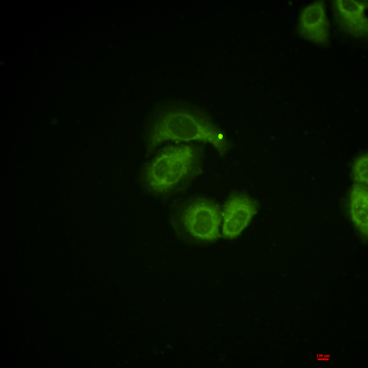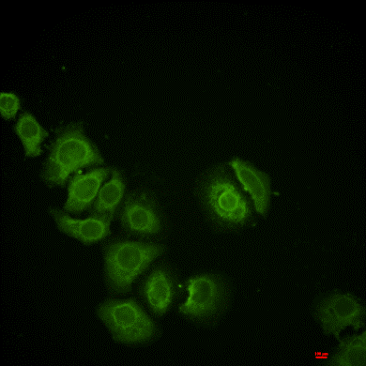
Pro-Gly
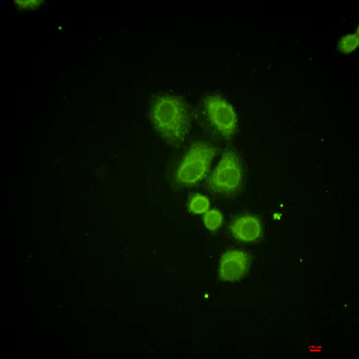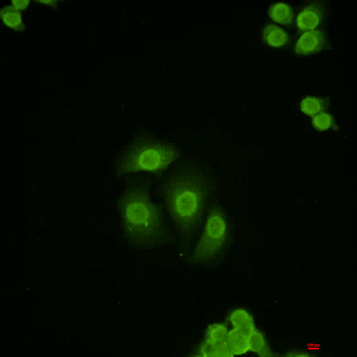
AZD1480
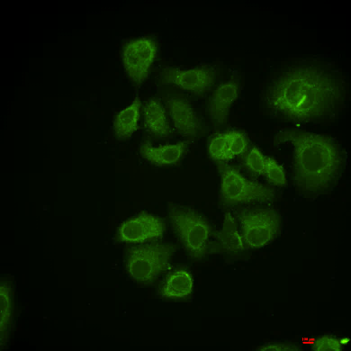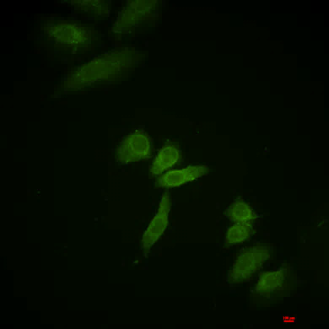
Pro-Gly+AZD1480
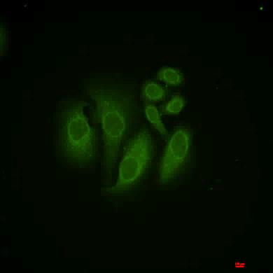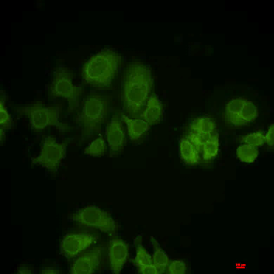

The raw bands of Western blot
Figure 1
IGF-1
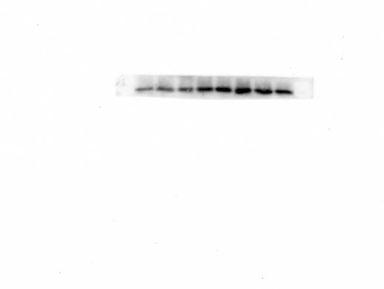
β-tubulin

Figure 2
IGF-1
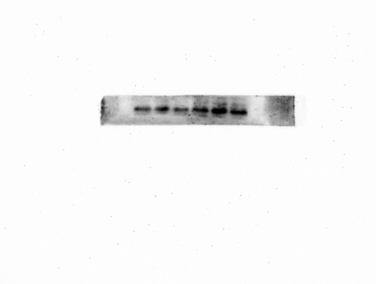
β-actin (the last six)
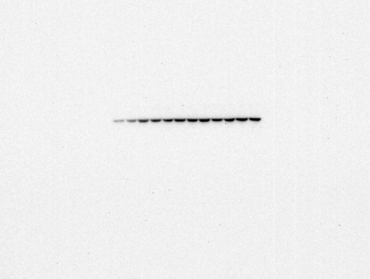

Figure 3
IGF-1
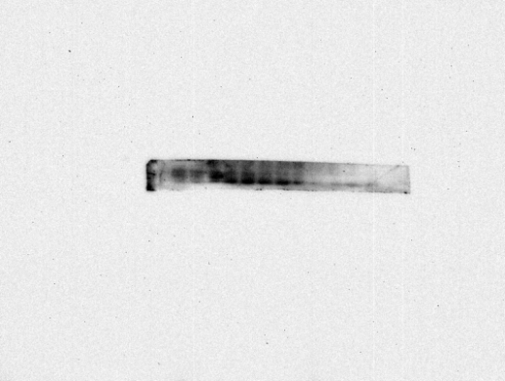
β-actin

Figure 4A
p-JAK2
JAK2
p-STAT5
STAT5
β-actin

Figure 4C
IP: STAT5
IP: JAK2
Input: STAT5
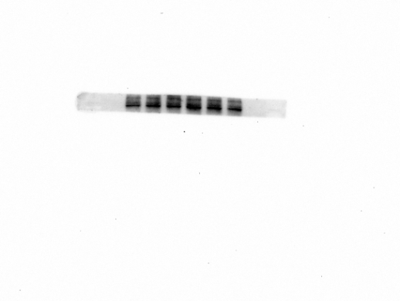
Input: JAK2
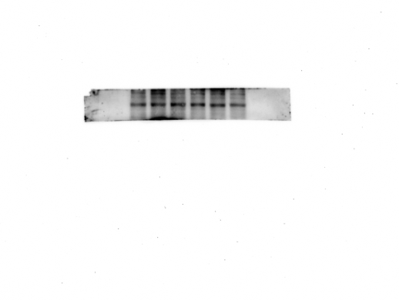
β-actin
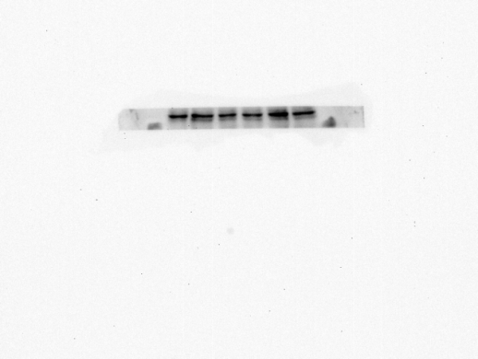

Figure 5
p-JAK2
JAK2
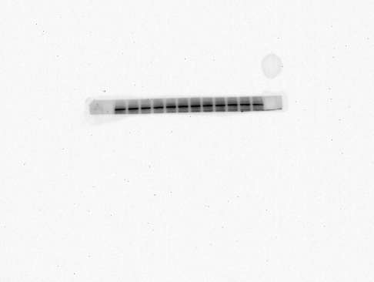
p-STAT5
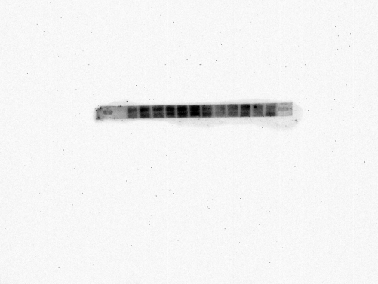
STAT5
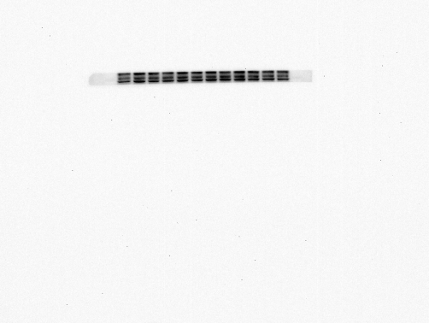
β-actin
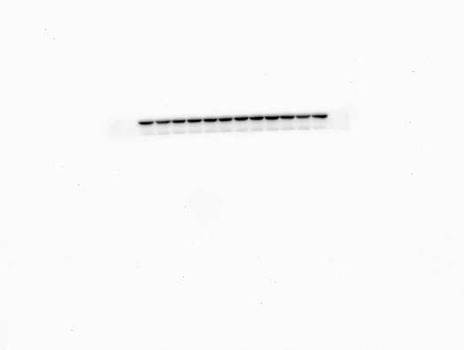
IGF-1
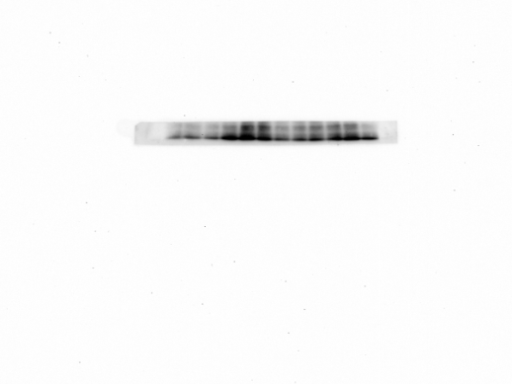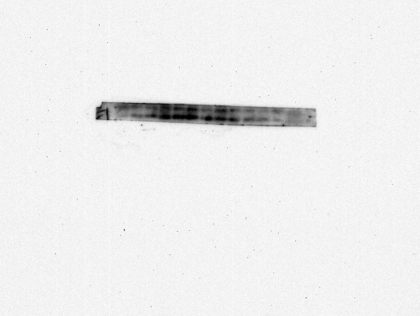
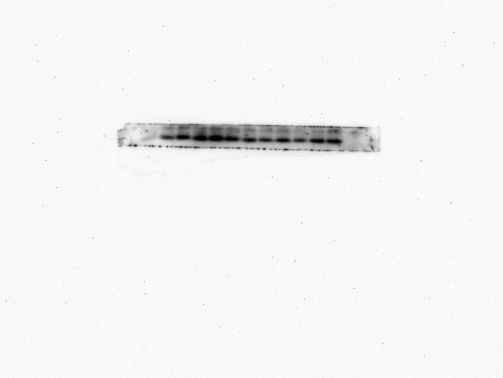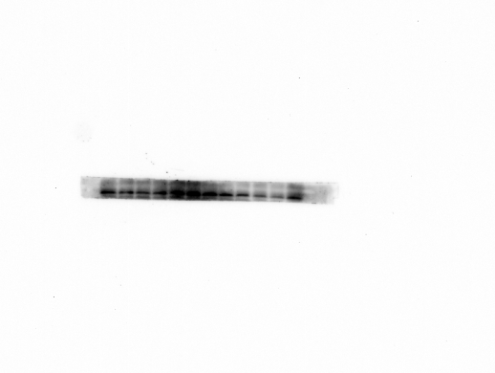
β-actin

Figure 6B
p-JAK2 (the first six)
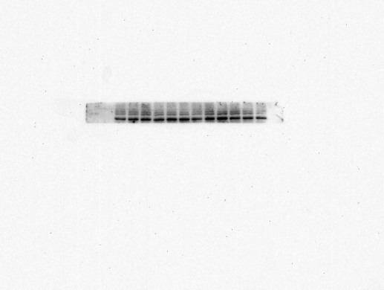
JAK2 (the first six)
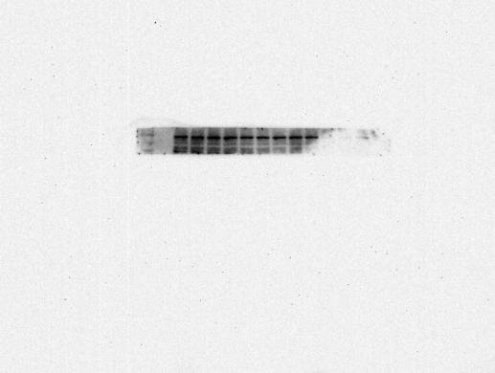
p-STAT5
STAT5
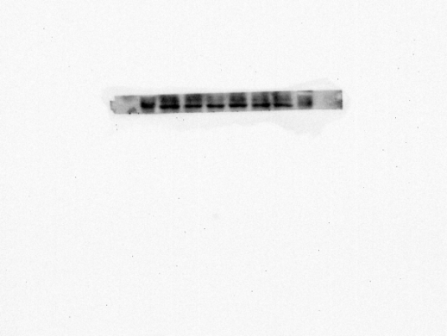
IGF-1
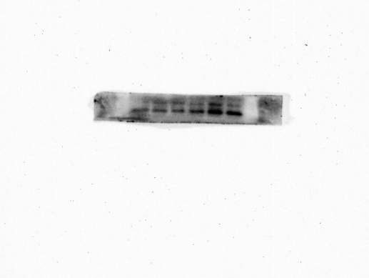
β-actin
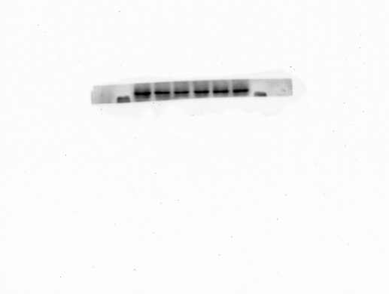

Figure 6F
p-JAK2
JAK2
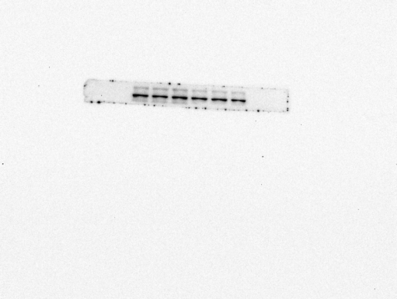
p-STAT5
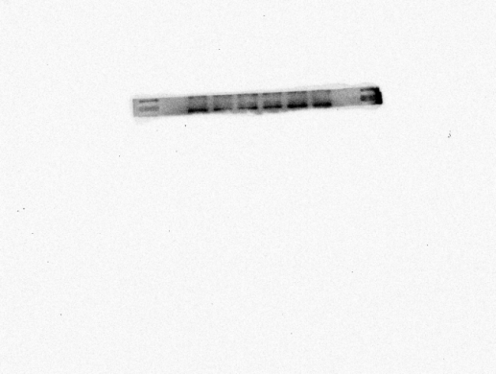
STAT5
IGF-1
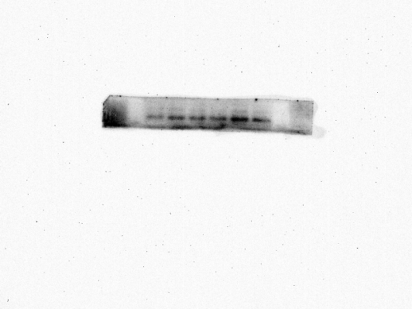
β-actin
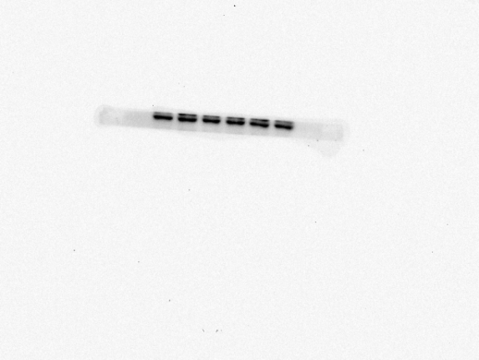

Figure 7
p-JAK2
JAK2
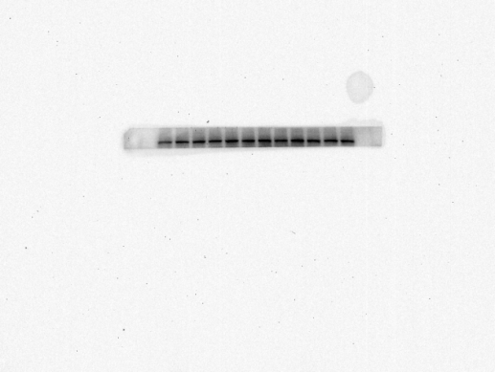
p-STAT5
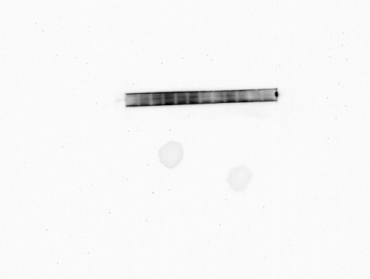
STAT5
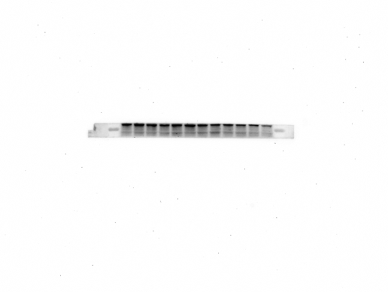
IGF-1
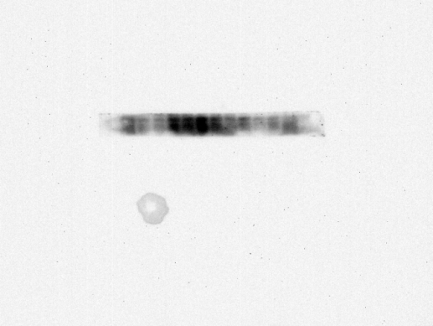
β-actin
