Supplementary Material
- Regulation of nitrogen fixation in Bradyrhizobium sp. strain DOA9 involves two distinct NifA regulatory proteins that are functionally redundant during symbiosis but not during free-living growth
Jenjira Wongdee¹, Nantakorn Boonkerd¹, Neung Teaumroong¹, Panlada Tittabutr^{1a}*, Eric Giraud^{2a}*
Corresponding author: eric.giraud@ird.fr and panlada@sut.ac.th
Supplementary Text S1

Analysis of insertion sequence

From >PlasmDOA9_398416 to 402975_+1 at upstream of nifAp

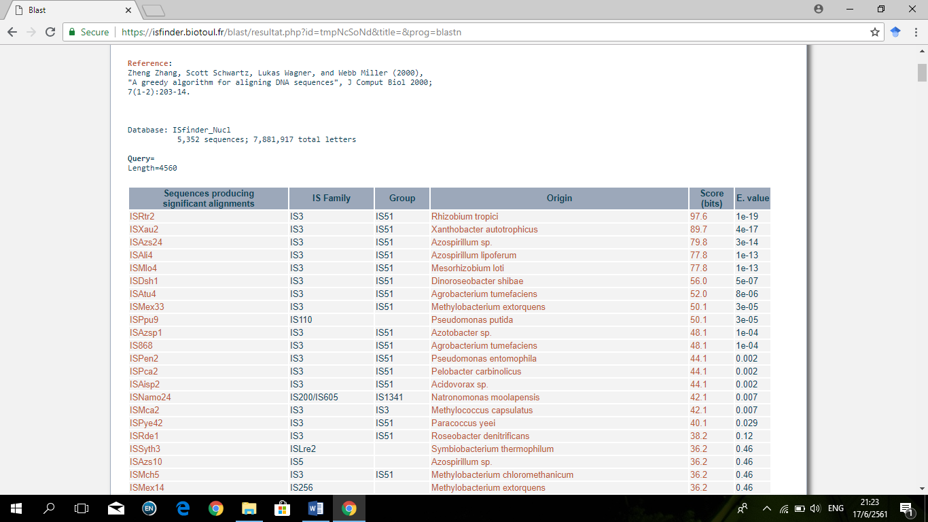
BlastN in https://isfinder.biotoul.fr to find IS type

TGAACCGCGCCGGGTTTGCCGGAGGCTCCAACTCGTGAGAAAGTGGAGCC --> IRL
TGGCCGCATAACTTAAACCAAACGGCCTCCGGCAAACCCGGCGCGGTTCA --> IRR (reverted)

>PlasmDOA9_398416_402975_+1
ATGAAACAATCTCTTGCAATTTTATCATGTTTGGTTTGCGGTTTGCTCGTTTTGAATGGG
ATCGCACTCGCAGACTCAATGCGACGCTACAGCTGCACCGTAGAGGGGTCCGATCGAGAG
CCGGTCGGTGATCGGGACGGGCACCTTATTGTCAGCCTCCAGTACACCTGTCACGTCGCC
AATGGAGCGCTGAAGGACTCGGGAATTACGGGACTGTTCGTCAGCGAATGGAGCAGCGAG
AAACAAACGTACTTGGCTTCTCTTGACGTTCATCGCGCGCTCGACGGATTTGCGGTTAGT
CAGCTCCTGGAGGGGATCGGCTCCTCCCTTATGGAGGACAACAGGGCTGCCGGCATTGCT
GCTTCCGGCAAGACTGTGTTTAAGTTTGCCTCAGGCTCGTTAGCGGTTCTCTCAGGAAGG
ACTGTGACTTTCACGACTAAGCCCCTCGACTATCGTCAATTCGAGATGGAGTTCACGGAT
TGGCCTGACACTATTCAGCCTAAATGAACCTGCTGCCGTCGCACCAAGGAT

TGAACCGCGCCGGGTTTGCCGGAGGCTCCAACTCGTGAGAAAGTGGAGCC --> IrL
TGAACCATGCCGGGGCTGTCGGAGGCCAGTTTGGTTTAAGTTATGCGGCC --> COMPLEMENTARY

ATGCCTTGGGGGCCGGCAT
GGCGTAGTAGCGTTGCTCAGCTTCGACCGGCGGTATGTTGCCGATGGGCTCGAGGAGCCG
CCGGTTGTTGAACCAATCGACCCATTCTAGGGTGGCGAACTCGACAACCTGGAAGCTGCG
ACATAAGCGAAGTCGGAGAGCCAGGGGACATTCGGTCGTGGCTCCTTGAACTGGCGGTTG
ACGTGATCAGCGGGCAGGGCGCGGCCTTGTCGCTGAGCGTGGGCGGGCTTGCCGCGGATC
CCCCTTGCAAATCCATGTCCCGCATCAGCCGCGAGCCCGTGCAACGGGCAACATCGGCGC
CTTCGCGCTTGAGCTGTCGCCGGCAGCGTCGTCCTATTCAGAAAACAGCCGATGACATTG
AGCGGAGTTATTGGGCGCGCTTCTTGGGAAGCGAGCCGCCATTCAGCGCATCACCACACG
CTGCCGTCACGCCATGGGCCAGCCCAGTGCACCCTGCGAGAGCGATTCGATCCCGCCGCC
ACATAAAGCCAGCCCTCGACTGCCCAGAGATAGGCGAAGTCGGCGATTAGTTGTAGTACG
GCCGCTCAGCGGTAAACTCCCGATCCAGCAGATGCGCCGACACGATCTCGGCTGCCGACC
CCCGCCATTCATAAAGCGCCGGCGGGCCCCGCGCCCGCAAGCCCTGCAAGCGCATCAGCC
GCTGCTCGACCCGGTGCAGGGCACAATTCGCCCCGTCAGCCAGAAACTCGCGCCAGAGCC
GGCGCGCGCTATGAGTTCAGTCGCTGACGGCGAAGCTGGCCTTCACTTTGCCGCCGAGAC
CAACGTCCTGCGGGCCCTGACGCTTGGTGAGTGGTTACGCCCATTGAAGCTCGACCGCGA
TACCCCCAGCGCATCGCATAGCCATGCCACCGGCCAGATTGTCCGGCGCCTCGCGATGAA
GACGAACTTCATGTCGCTCCTTCGCGAAGACGGCTGCGGCCTTCCTAAGAAACAGCCAAT
GCCCGGGTCCACTTGCAGGACGAAGCCGAGTGACTTGGCACGTCGCCTCAGATTGGCGAC
GACACGGCCGCGATATTGTTCTTCGTAGTGATCAGCACCCGGATCCCTGTAGGTCATGCC
GTGCCGGAGCGTATTGTAGAACAGAACTGCTATTTTGCGAGCGGTTGCCGTCACCGCGTT
TGGCTTGCCGGCGCGCAAAGCCAGCCGTCGATAAAATGCGCCAAGCGCCGTATCGCTCCA
CCCAACCGAGGTCGCTGCAAGCCGCAGCAGTGCCGCTGCCCGACTGGACGATCGCCGCAT
GCGCGAAGATAGTAGCTTGCCACCGGAGATATTGTTTGGGCCTCCCCTAAATCGGTGGAC
ACCTATAGCTCAGGCAGCGAGAGGTGTCAGATGGCGAAACGGCAGCGTCGGTCCTATTCG
GACGAGTACAAGCGACAGGCAGTTGATCTGGTTGTATCGAGCGGCCGCTCGGCGAAGTCG
ATATCGAAGGAGCTCGGGCTCGACGGCTCCGTGCTCAGCCGATGGGCGAAGGAGCTGGTC
ACAGTGGCAGCGGGCGGCAGCGCCGCGGCGCCCACGCCGCAAGCGGCGGTGCCGTCGGCG
GACCAGGCTGACATGATCGCCAAGTTGCAGCGGGAAAACGAACAGCTGCGCATGGAGCGC
GACATTTTGAAAAGGTCGATCGCGATCTTTGCTGGACCCCGGACGAAGGGTTCCGCTTTA
TCGAAGATCGCCGTGCGGACTAATCCGGTTGAGGTCATGTGCCGCGCGCTCGGCGTCTCG
CCTGCAGGCTATTAGGCGGTCGCGCCCGGAAAGCCTCCGGGCCTTGGCCAATCGAGAGCT
GCTGGATGCTATTAAGCGGGTTCGTCGCGATAGCCGTGGTCGCTATGGCAGCCCGCCATC
CAGCCGAGGACGCCGTATAGCGCTGTCCTGACGTCGAACGACGGTGTGTTAACCTGCTTG
GTCTTTACCCGCGGCCTGGAGAGCTCGCCGATCGGCTTGGCTCCTTTGTCAGTCAGCGCC
GTGATCAAGGATTCCAGCTTGCGGTCACAATCGAGCATCTTGGCCTGGTAGGTGTCGTAG
AGCTCCGGCGACTGGGTCAGTGCGAAGACAAGTTCGTCCCGATCGTTGCCTACCAGTGCG
GCGCGGATGGTCTCGATGGTGTATTGACAGCGCACGTCACGGTAGGTCGCCAACACGTCA
GCATTCCGCTCGCCTGCCACAATAGCTCGGATAATCCGCATCCCGGTCGCGCCCGTGGTG
TCGGAGACGACGTGATGAAGTTGCAAGTTCATCTCCATCAGGGCCTTCTGCATGTGCTGG
ATATGAGCGGCTGCATATTCGACTAGCCGCTCTCGCTGGCGGAGATAGGCGCGTAGCGTC
GCAATATCGGCATCAGGCCGGAAGCTGCCGCGCAGCAAAACCACAGGAATGAAGCTGGCG
CAGCCAAGCGACGTCACTGACATCAGTTTTTGCGTCCAGGCACGCTCTTGGCGTAACGTG
CGTTGACCAGAATGACGTCGAACCACGCTGCTCGAGAATCTCGTACACCGGGATCCAATA
GACCCCCGTGGATTCCATCGCGACACCGATC

ACGCCGCACGCTTTGAACCAATCCGCCACTTCGTGCAGGTCCTGCGTGAATGT --> COMPLEMENTARY
TGGCCGCATAACTTAAACCAAACGGCC---TCCGGCAAACCCGGCGCGGTTCA --> IRR

GCCAAATGCACGCACCGGCGTGCCGGTGCCGCCTGG
GTCGACCGCCGCCATGTGCATTTTTGACCCTATGTCGATGGCGGCGGCTTCAACGTTGAC
CGGCTTTAATCCGGGCGGCCACCGGCAGGCGTCTTCGGCATTGCAACTCCTCCATCCAGT
CATGGGGCTGGAGGGTCTGGGTTATGCCAATCGTCATCCTCCAAATCGGGATCGCCGTCC
GAACAGCGTCACCATTCTCACGTTCCCATCCACCCATTGGCCTCCAGCTTGGCGACCTCA
CGGCGCTGCGGCTCGATCTCTTGCTGCTCGGGCTTCATCTGCCCATGCCGGGGAACGCCT
GTACCGGGTCAGGGCCGAACTCCTTCACCCATTTGCGCAGTACGTACTCATGAACCCCCC
GGTCGCGGCCGGCTTGCGCCACCGACACCCCGCGCTCCCTGACACGCTTGACCGCTTCGA
TCTTGAACTCTCGGCTAAACTTCCGTCTCTGCATGGCCAACCTCCGGCTTGATAAAACAC
CCAATCTCGGGTCCATCAAAACGGCAGCAGCTCACTGCCTGCTATCAATTTTGGCGGAAA
CTAGTTTGCACCATGTCCGACGAATCTAACCAGAGTCGGGATCTGTAGTAAGGCTGTTGC
AAGCCCTTTTCCGTTACTAATTGTTACATGCCTTGGCAAAGCGGTCTTTCGCAGGGGTCG
TGGAGCGTACGCTCCCGGCGTCCAACTCATTGCGCCGAGGCGGTTACATGATGCCCATAG
GAGGCAGAGGCATCGATGGCCGAGCGCTTGCAACCCCTGAGGGCAAGTCGCGGTTCGCCT
CACACATGCGCCAATGTGGCGCACCCCTTGGATTGAGTGGCCTCACGCAGCCAAATAGGC
GCGAGAGGCTCGCCCGGCACGTGGCAATTGGGATGAGTAATGCCCGATTTTCGCGCCTCA
TCGCACCTGGAGAGAACCCGATGGGGGGGAGCTGCACCGGGGCATATCCTCCCGTGGGGA
CCGGATTGTTAATGCTAGTTGGCCTTGTCGCTGCTCTAGGAACGTTGTTGTTAGGTCCGC
GGCATCGCAGATACCAAACGCCGACGTGACACCACTGGTCTCGAACTACGAATTGGCCAA
AAACACGACATATGACCGGCAACCCTGCTTTTCTTTCGGCGGCCAACTCCGACTTATCCG
GAGCGGGGCCCTATCATCTTAGCCGTCCGCCAAGCCTGGACGCGCCAGAGATCTTGCTGT
CGATCGCAGAACAACTCGCCGCACTCTATCGGCTCGAGCTCGCGCTTGAGGCGGTCGCCG
GGTTAATACAGTCGCGGCTTGGGATGCAACATTCCGTGGTGTGTCCAAGTCTTGCCGAAA

From >>PlasmDOA9_404488 to 408844_+1 at downstream of nifAp

BlastN in https://isfinder.biotoul.fr to find IS type
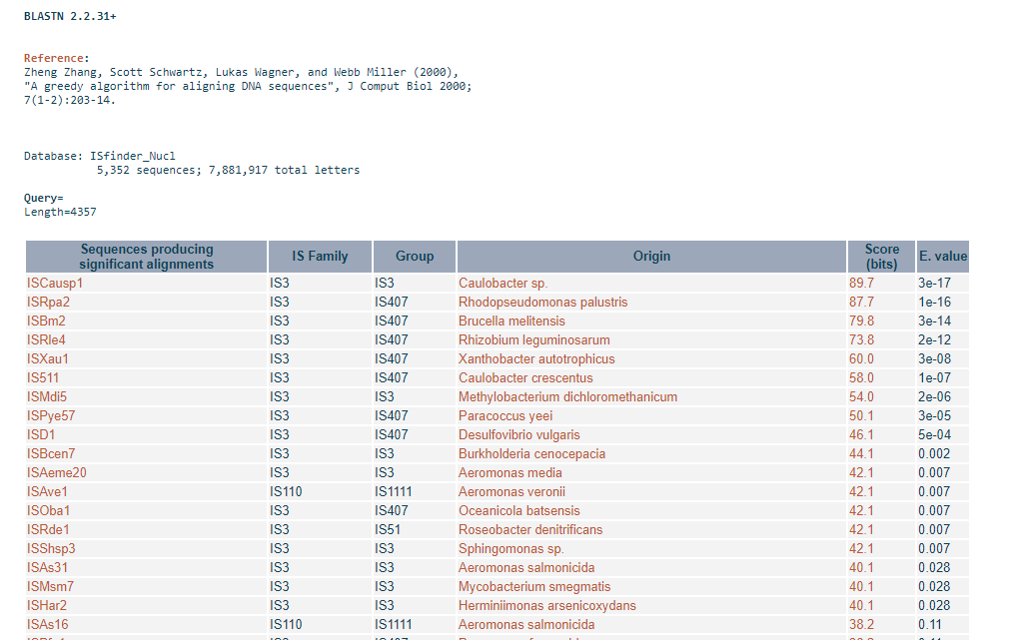
TGATCCTCCCTCGTTTCAGTGGACACCCATGCTAGCTTTTCGGAGCTGGA --> IRL
GATGGAACGCAGAGCGGCTTAACCCC-GTCCACTTTCTCGGGGGAAGATCA --> IRR (reverted)

From >>PlasmDOA9_404488 to 408844_+1
TCGTACTTGACCGGAGGCGAGCTGCAACTTCATCAGGTCTGGTTTGTAGGCATGAGATCT
CACCTTGCCCCGGCCATAATCCAGTTCGAAGCTCGTTTCGGCGCCCAGTGAGGACCGGAA
GGAGCATGAGGCTGACGCTGGTCCGTGGCGGAAGCCGAGCGCAAGCGACGCCAGCATCTA
CCAGTGGAAAGCCAAGTTCGGCGGAACGGACGTCTCGGAAGCCAAGCGGCCGAAGACGCT
GGAGGACGAGAACACGCGGGTCAGGCAGGCGAATGATCATGCGCTTCGTGCCGATTAAGA
CGCTGGGATTGACGCCACAGTCTCATTCAAACGGAGGCAAACAGCGGCTGGGACGAATAC
CGAAGATGGCAAGTCCGGAATTCCGCCCTCTCCTCGTTGCCAGGGAACGGCCGTCTTGCG
GGTTCTCCGAACCGGCGCTTGGGCGCGCCGTGGCTGAAGGCGCTTCTTGCCAGACGGCCC
TTTAAGGTCGTTGCTGTCCCGCAGGCCAATAAGATGAGCGGATCACCTGGGCGCTCCTGA
ACGAGGGCGAAATTGGCGTCCTGACCCCCAATAGCGATTACCGCGGTCGCCGTCTGATGG
ACGCCATGACCGCCAAAACGATCTGATCGGCGCAGGCCGGCAGAGGCAAGGTGCAACAAC
AGGCGATGAACCCATGGGACGAAATCCCGAAAGAAACGTGGCACTCACCGAATGTCGGCC
TCGACGACACTCTGGAGTACTGTCGCCGCCATAAAGGGCTCTTATTGTGCTACCAGGTAG
ATGCGGCAAGACACAGGAAATAGGGTTGCAACGGCCCGCCATGCCGGTTCGGCCGACCCA
TTGAGAATGTGGATGCCCTTTATCATAACAATCGATTTCACCGACGCCGGTCAAGCTTGC
TACTGGTGACACGGCGTCGGATCTGCTGAGAGTTATACGTTGAGAAATCGCTCCCGTGAC
GGCGTCGCTTCGGGAAGGCTCGCTGGCCTCCAAACGGAACCTTATAACGAGTGCTCATGA
CGACCATGATGAATAGTATCAGAAACGCAACCTCGACGGAAATAATGGGAATGCGAGATC
AGGCATTGGCGTGGTGGCTACCGAAGCTGAAACACTATGCATCTTGTTTGCGGCTGCTAG
AGAGCGCCTTACCCGTTCGTCGGCCTCACCTTGAGTCGCTTGCTGACCCGCCTGCTCCGG
TCGGTTGCAGCACTTCTCATGAACATCTCAGGCAAAGTATCGAGTCGCGAATCGCAGAGA
TTGGAAGGTTAGTAGGCGAAGGTGAAAAGCCGGTCGAAGCAACCCGGCATCTCGCTGACC
TGGCGAACGCGCTCATATTCGCGCAGCTCGGCATCTTTTCCAAAGTCAAATTGGTCAGTA
CCGAGACAGCCGGCGGCCTCACGAACCGTGCTCCCTTAGAGACGAGCGGGATCTATGAAC
CGGATGCGCTTTTGAGGCTTGGCCATTTGTTCGACAAAGCTGTATTGGCGTTAACTCCGA
ATTTGCGAACGCAAGCCAATAAAGCAGAGATCGCAAAACTTATCCTCGGCCGGGCATCTG
AAAGCAAAGCCGAGCAATGTCTTTTCATTAGGCTTGTCATTGCGATTGTTGCCGCCGCCG
AAGGGATGTAACGCCTGGCGGCCATTGTACGTTACGCAATATGATTTCGGCACCCGCAAA
GCAGCTGTCGAGGTGCTCAACCTCGGCATTTGCTGTGTCTCCCGCCGTGGCGAGGTGCGG
CGAAGCCAGACC

TGATCCTCCCTCGTTTCAGTGGACACCCATGCTAGCTTTTCGGAGCTGGA --> IRL
TGAGCCTCCCCTAATTCGGTGGACACCGAGCTTAGGCAGCAAGAGGTGTC --> COMPLEMENTARY

AGATGGCGAAACGGCAGCGACGGTCCTATTCGGACGAGTACAAGCGGCAAGCAGTTGA
CCTGGTTTTGTCGAGCCGGCGCTCGGCGAAGTCGGTCTCGAAGGAGCTCGGGCTCGACGG
CTCGGTGCTAAGCCGATGGGTGGCGGAGCGGGGCACCGTGGCAGCCGGCGGCAGCGCCGA
GGCTCCCACACGGCAAGCGGCGGTGCCGTCGGCGGACCAGGCTGACGTGATCGCGCGGCT
GCAGCGGGAAAATGAGCAGCTGCGGATGGAGCGCGACATTTTAAGAAAGTCGATCGCGAT
CTTCGCTGGACCCAAGACATGAGATTCCGCTTCATCGAAGATCGCCGCGCGGATTATCCT
GTCAAGGTCATGTGCCACGTGCTCGGGATCTCTCCTGCAGGCTACTATGCTTGGCGGGCG
CGCCCGGAAAGCTCTCAGGCCGCTGCCAATCGCGAGCTGCTGGAGAACATCAGGCGGGTT
CATCGCGACACCCATGGTCGCTATCGCAATCCGCGCATTCATGCCGAACTCAAGGCCCAG
GAACACCATGCAAGCCGTGGCCGGATCGAGCGGCAAATGCGCTGCCATCTCGGCCGGCCT
GCGGCGATGCCGCACCACCGATAGCGGGCATGGCTTCCCGATCGCGCCAAACCTGCTCGA
CCGGAACTTCTCGGCCGCCATGCGCAATCAGGTCTGGCTCGCCGACATCACCTATGTCTG
GACCGGAGAGGGCTGGCGTACCTGGCCGCCATCATGGATCTGTGCACTCGCCGTATCGTG
GGTTGGGCGATGGACGAGCATCTGCGCACCGAATTGCCGCTCGCCGCATTACGAATGGCC
ATCAAGGGACAAGGGCCCGGAGCCGGGCTGATCCATCACTCCGATCGCGGCACCCAATAT
GCTTCGACCGAGTACCGCCAGGCGCTGCAAGCCGCCGGCTTCCGGCCCTCGATGAGCCGT
AGAGCCGACTGCTACGACAATGCCCCGATGGAAAGTTTCTTCCATACCCTCAAGACCGAA
CTGGTCCATCACCGCAAATATGCAGCTCGCGATGAAGCACAACGCGACATCTTTGCCTAT
ATCGAGGGCTTCTATAATCAAACCCGCAGACACTCGGCCATCGGCTATATCAGCCCGATC
G

AGATGGAGCTAAAATCGGCTTGATCCCAGTCCACTTTTTTGGGGCAAGATCA --> COMPLEMENTARY
GATGGAACGCAGAGCGGCTTAACCCC-GTCCACTTTCTCGGGGGAAGATCA --> IRR

GGCCGCG
CTGCCACCGCGTCGCAGAGGGCACCAACCTCAATTCACTCCGCTCCGCTGCTAATGGATA
GCACTTCGGCGCGAGGTCACTGAAACACCGCTTCATTTTCCACATGCCATCCGAGGTACG
TCTTGCGGCGTTGTGCGATCCGCTCATGGCCCTGGAACCGGAAAAGCTCGCGTGTCGAAT
CAGGAGAGAAGCCAGAGGATAGCACGAAAGATAAGTATCCACGTTGTAAGGCAGAAAAGT
ACCCCGAACAGCCATACTCTCGCTCTGAATCGGCGGCGCCAGTTTACAAGTTCCGATGCA
CAACCGTTGAAGCGTCGACCGCGGACGACGTCAATCATTTCCCGGTAATTGCCAAAAACA
AAATATGAGCGATTACTTCGGATGTACCTTATCCGATCTTGAGGTGAAAGGCACCATTCC
CAGACGTACTGCGCCTCCTCCAGCACACTGTCCAACCTTGGCCTATACTTTCGGGAGTTG
GGTGCACGCCGCTCAATGAGCGGCGAGTTGGAGTGAAGCGATCGCGGGCTCTCGGTAAGC
GTGAACATTTGCCGAAACATCAAAGTGAACCTTTTCGAAATACTTCGGACGATGCGTACA
ATGTGACGTAACGAGAGAATCAAGAGGATCAGGCGCAGTGCATCATCTATTTCTGTACAA
GGCCGGTGGCGGGGACCTCGAGTTCGAGTGCCAGCACCGGATAACGGCCGGATGTGAGCA
CGGGTACTGTGGCCGGCATAGGCCGGGCGCCGCTGGCTAACGGACTTTCAGCTCCTGAGG
CAGCAGATAGTGCGTATATTGTTTATCGTATAAGTAGCGGCCAGTTGAGCTAGCCCCCGG
GAACGTAGGACATGGGCGATGCGGCCTCGCCGAGAAAGAATGATCAACTGATTAGGAAAA
GGCTTGAATCGCACGCGACTGGAGATCGTACGATGCAGGGAAATGGTGAACTGCGAGACG
AGTCACAGGAAGCGGTGACCCAGCCCGGATGCCCCTCAAACTGCCGCTCGTGGCGCGGCT
GACCGTGTAGGCGGCTGCAAATGGACAAGGTTTGAATGGCTCAAGATGAACCGCTTGAAC
GTTATTGTCGTAGCACTTGTATACGTTCAACTGCACCTGCACACGATATGACGATACCGC
GCCAGCACTCAACGGTCCTAACCTCCTAGAGGACATAATGCATCAAAGGCAACTCAACTG
GTGCCTCTGGATCTGTAAAATGAACTGCTGTTTGATCGCGTTCAGTATTGTTGCAGCGAT
GAGCATTTTGTCAGTACGGTGTGCCAAAGCCAACGAATCGCTTCCAGCTGCGCAGGAAAC
GCAGGCGTGTATGCCCGAGCGTCGTTCGTTTCTGTAG

