Supplementary Material

The evolutionary conserved γ-core motif influences the
anti-Candida activity of the Penicillium chrysogenum
antifungal protein PAF

Christoph Sonderegger, Györgyi Váradi, László Galgóczy, Sándor Kocsubé, Wilfried Posch, Attila Borics, Sandrine Dubrac, Gábor K. Tóth, Doris Wilflingseder and Florentine Marx*

*Correspondence:
Florentine Marx, PhD
florentine.marx@i-med.ac.at

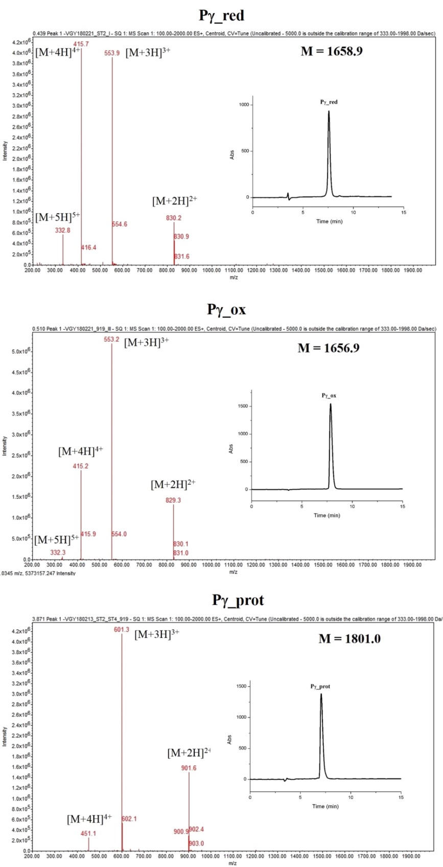

Figure S1. Mass spectrometry and RP-HPLC data (insets) for Pγ peptides. Shown are the three modifications of Pγ: in its reduced (Pγ_red) and oxidized form (Pγ_ox) and with protecting groups at the cysteines (Pγ_prot). Linear gradient from 12 to 27% (Pγ_red and Pγ_prot) and from 10 to 25% (Pγ_ox) solvent (B) over 15 min. Flow rate: 1.0 mL min⁻¹.

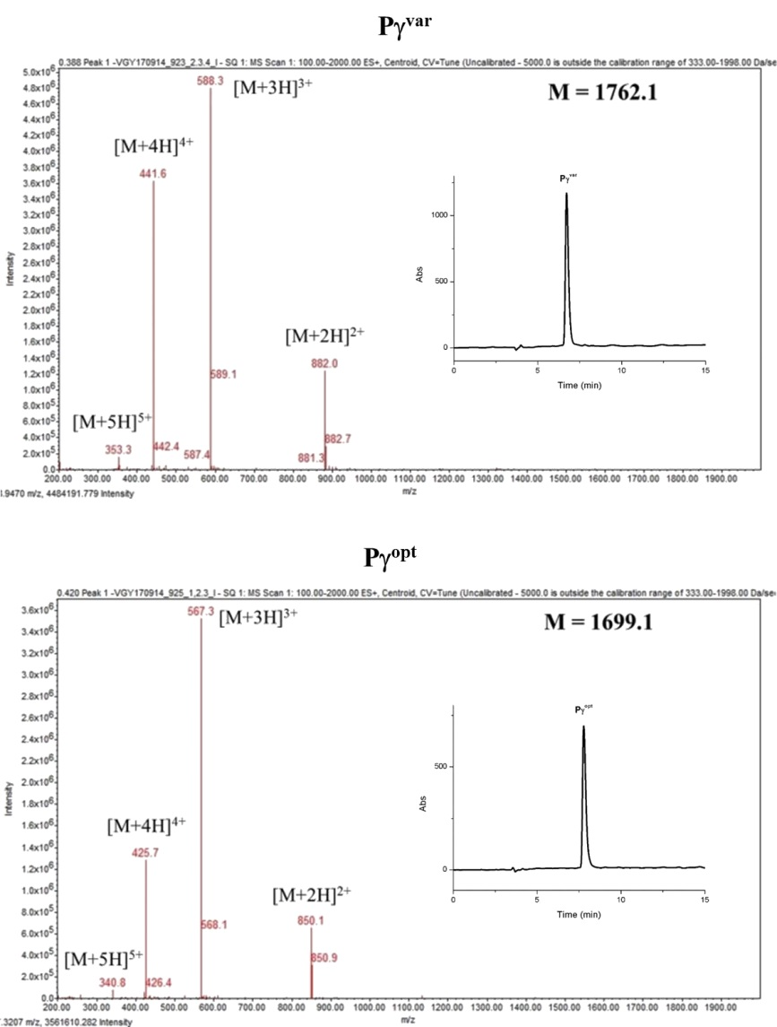

Figure S2. Mass spectrometry data and RP-HPLC profiles (insets) for the peptides Pγ^{var} and Pγ^{opt}. Linear gradient from 14–29% (Pγ^{var}) and from 11–26% (Pγ^{opt}) solvent (B) over 15 min. Flow rate: 1.0 mL min⁻¹.

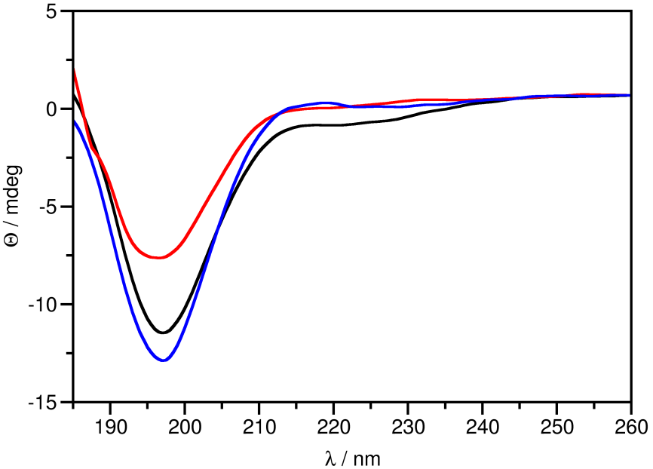
Figure S3. ECD spectra of γ-core peptides. ECD spectra of Pγ (black), Pγ^{var} (red) and Pγ^{opt} (blue) γ-core peptides, acquired in pure H₂O at 25 ºC.

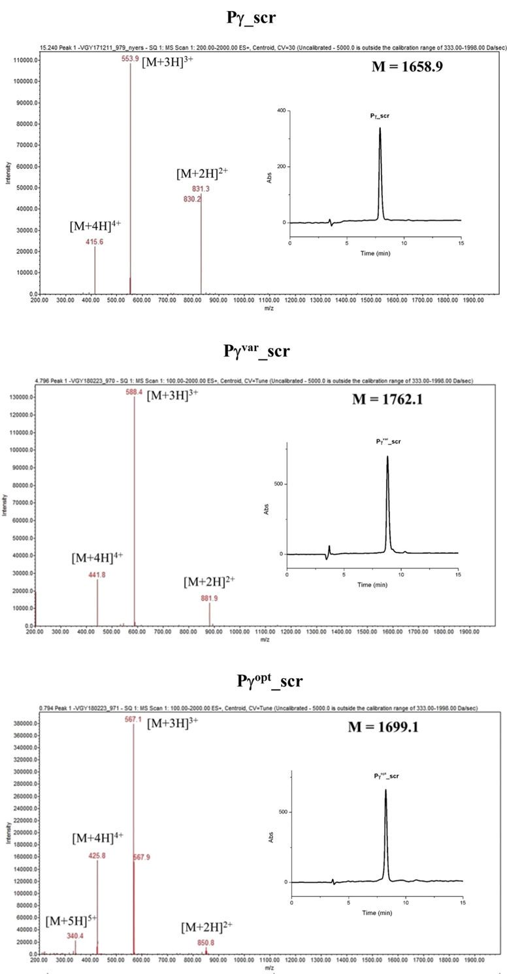

Figure S4. Mass spectrometry and RP-HPLC profiles of Pγ^{var}_scr and Pγ^{opt}_scr. Linear gradient from 12–27% (Pγ_scr and Pγ^{var}_scr) and from 10–25% (Pγ^{opt}_scr) solvent B over 15 min. Flow rate: 1.0 mL min⁻¹.

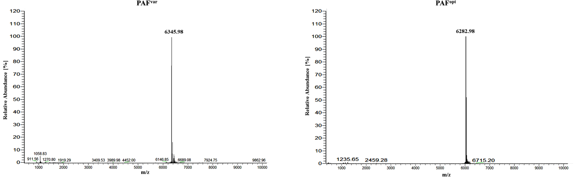

Figure S5. Mass spectrometry of PAF variants. ESI-MS proved the correct amino acid exchange and processing of PAF^{var} (6,345.98 Da) and PAF^{opt} (6,282.98 Da). No impurities could be detected.

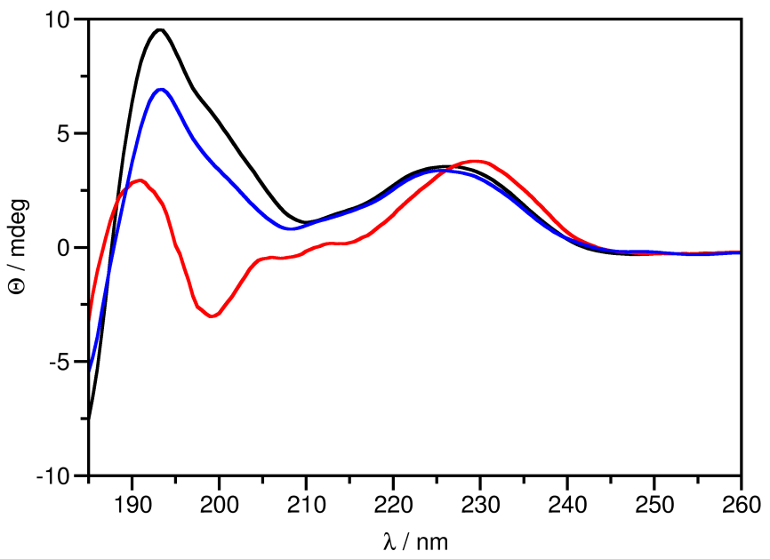

Figure S6. ECD spectra of PAF variants. Comparative overlay of ECD spectra of PAF (black) (Sonderegger et al., 2016), PAF^{var} (red) and PAF^{opt} (blue), acquired in pure H₂O at 25 °C.

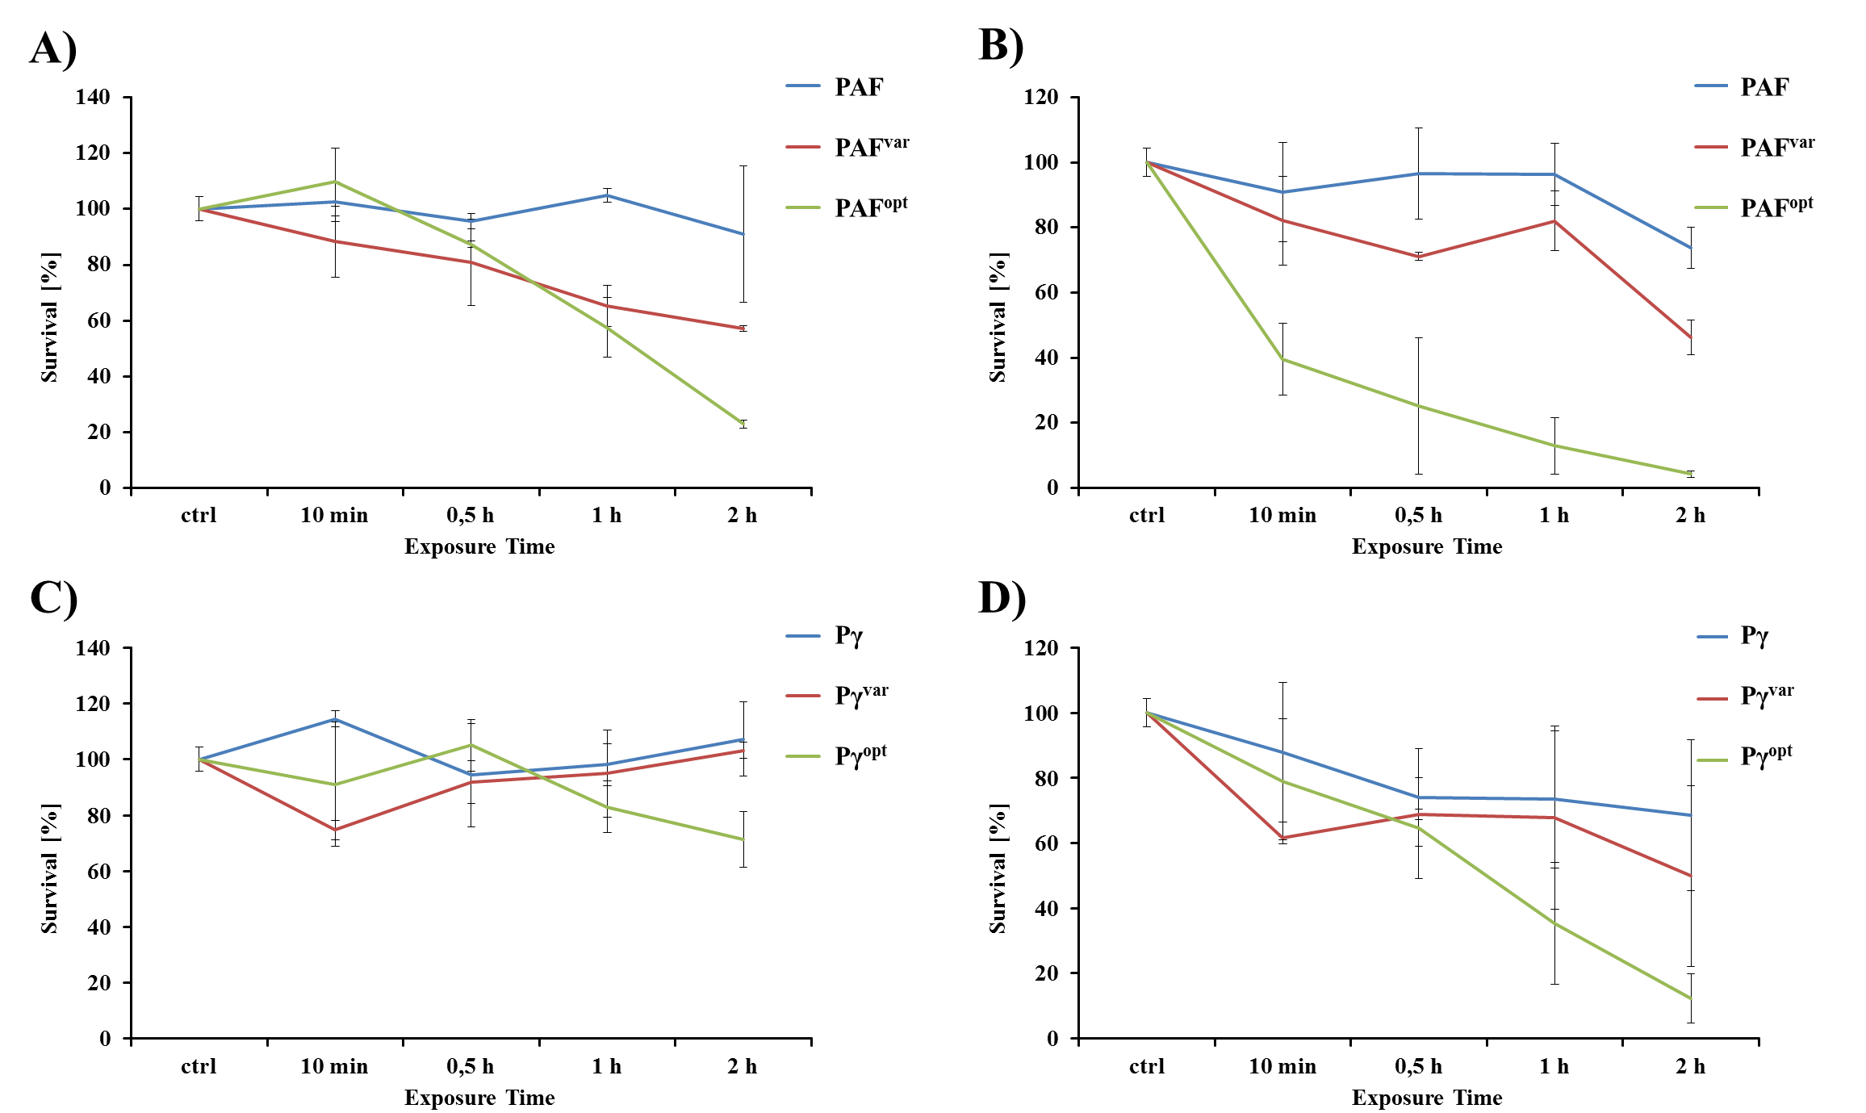

Figure S7. Fungicidal activity of AMPs. C. albicans was exposed to (A, C) 1x MIC and (B, D) 2x MIC of AMPs before plating appropriate dilutions on agar plates to determine viable cfu. The untreated control was set as 100%. Values represent mean ± SD.

Figure S8. Cell size of C. albicans. (A) Yeast cells were maintained in growth medium for up to 30 minutes and cell size was analyzed by flow cytometry (% change in FSC) at the indicated time points. Cells at 0 minutes were set as 100% and heat inactivated cells were used as a control. Values represent mean ± SD; * P = 0.045. (B) Images were taken from the samples in (A) to visualize cell death after heat-inactivation of C. albicans. Nuclei were stained with Hoechst 33342 and dead cells with propidium iodide. (C) Magnified section of the brightfield image in (B) that illustrates the reduced cell size of dead C. albicans cells. The average cell area (Aø) of the displayed cells was measured with ImageJ (Schindelin et al., 2012). Scale bars = 20 µm.

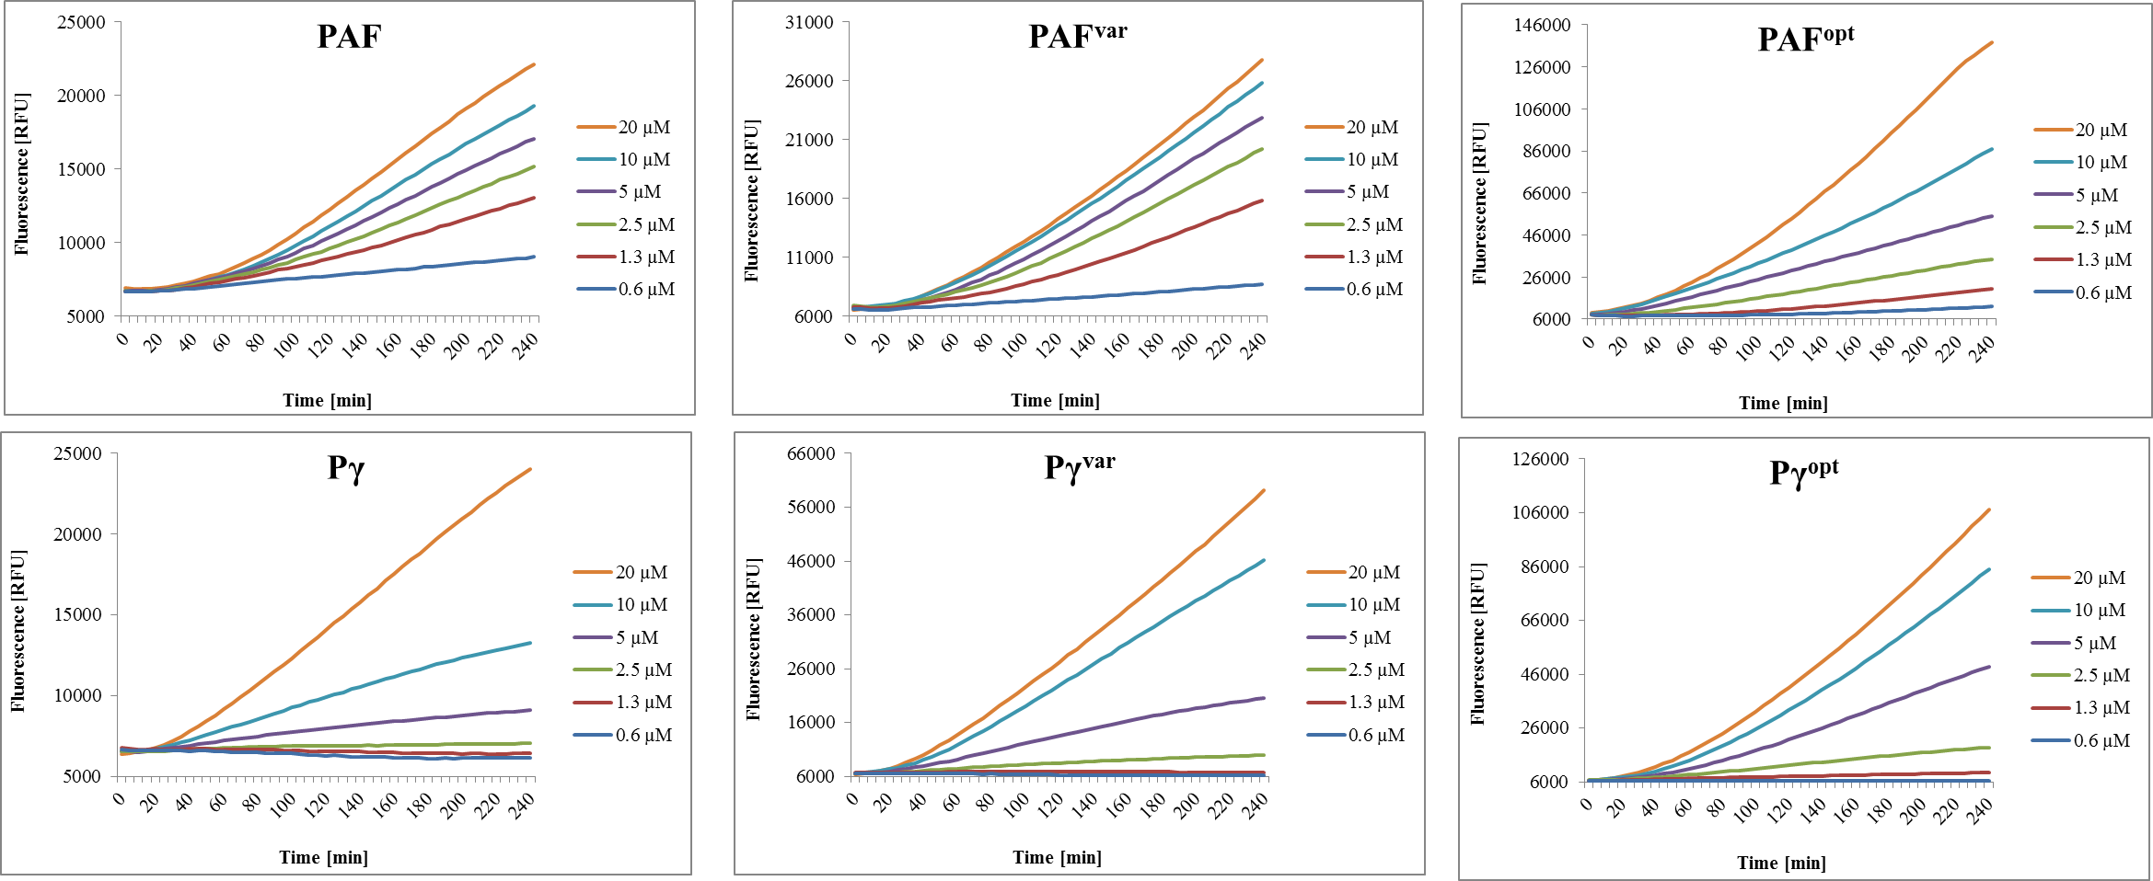

Figure S9. ROS production in C. albicans exposed to AMPs in time-course. Fungal cells were pre-treated with DCFH-DA and exposed to AMPs ranging from 0–20 µM. DCF fluorescence intensities (RFU) were detected every five minutes over a four-hour time course. Values represent the mean from three independent experiments.

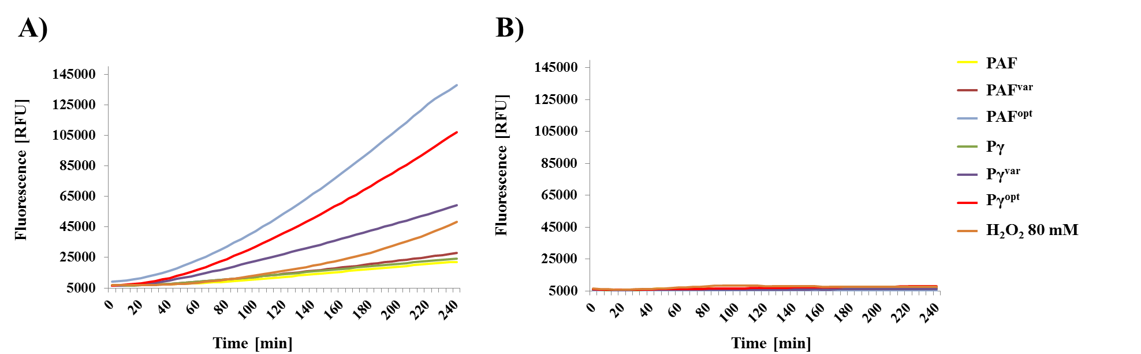

Figure S10. AMP-dependent ROS production in C. albicans is prevented in the presence of Vitamin C. Fungal cells were exposed to (A) 20 µM AMPs and (B) 20 µM AMPs plus 200 µg mL⁻¹ Vitamin C for up to four hours and DCF fluorescence intensities were detected every five minutes.

Figure S11. Hemolytic activities of AMPs. Paper filter discs (Ø 5 mm) were put on Columbia blood agar and soaked in 15 µL (20 µg) of each AMP. The agar plates were incubated for 24 hours at 37 °C, including positive (20% Triton-X 100) and negative controls (H₂O).

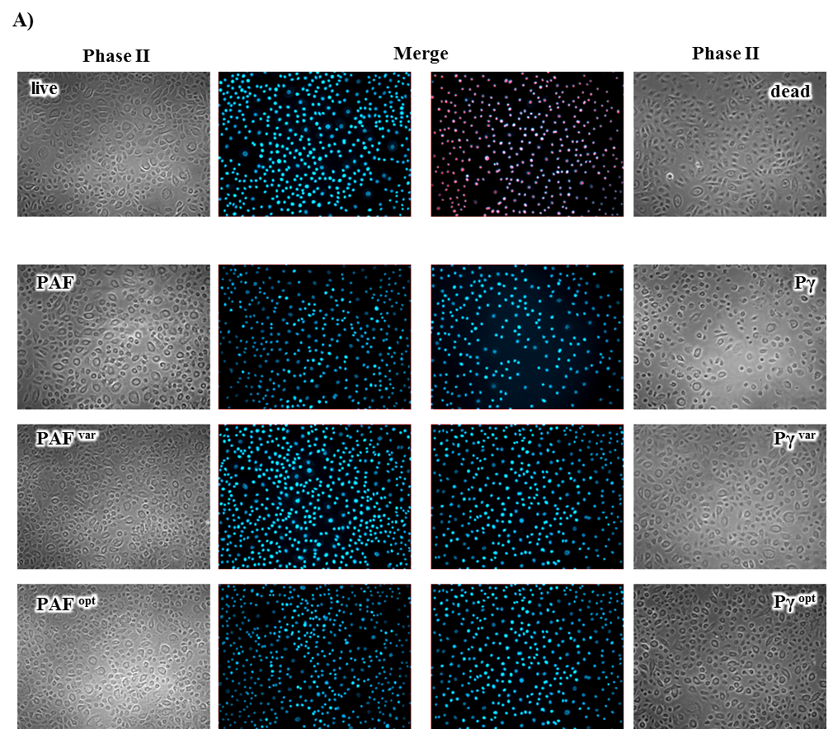
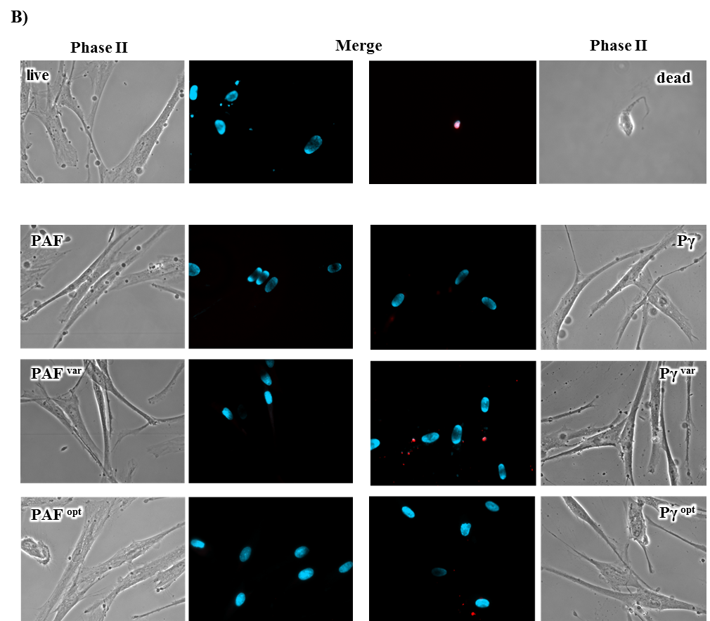

Figure S12. Toxicity-testing of AMPs against primary human skin cells. Fluorescence staining with propidium iodide (red) and Hoechst 33342 (blue) of (A) keratinocytes and (B) fibroblasts after 24 hours exposure to 30 µM AMPs. Controls: "live" cells remained untreated and "dead" cells were ethanol treated.

Figure S13. Growth reduction and cell morphology of AMP treated C. albicans. Fungal cells were exposed to increasing concentrations of AMPs (upper panel: peptides; lower panel: proteins) and microscopic images were taken after 24 hours of incubation. The insets are magnifications of the respective overview images to visualize the morphology of C. albicans cells.

Table S1. Fungal strains used in this study.
Strain | Genotype | Reference
Candida albicans | wild-type, human isolate | CBS 5982
Penicillium chrysogenum ∆paf | ∆paf:nat1 | (Hegedüs et al., 2011)
P. chrysogenum paf | ∆paf:nat1, paf⁺, ptrA⁺ | (Sonderegger et al., 2016)
P. chrysogenum paf^{T8Y S10K} | ∆paf:nat1, paf^{T8Y S10K}, ptrA⁺ | this study
P. chrysogenum paf ^{T8K K9T S10K E13K} | ∆paf:nat1, paf ^{T8K K9T S10K E13K}, ptrA⁺ | this study

Table S2. Composition of media used in this study.
Description | Composition
P. chrysogenum minimal medium (PcMM) | 2% sucrose, 0.3% NaNO₃, 0.05% KCl, 0.05% MgSO₄ x 7 H₂O, 0.005% FeSO₄ x 7 H₂O, 0.1% trace elements solution, 25 mM NaCl/P_{i} (pH 5.8)
Trace elements solution | 0.1% FeSO₄ x 7 H₂O, 0.9% ZnSO₄ x 7 H₂O, 0.4% CuSO₄ x 5 H₂O, 0.01% MnSO₄ x 1 H₂O, 0.01% H₃BO₃, 0.01% Na₂MoO₄ x 2 H₂O
R10 (Fibroblast cell culture medium) | RPMI 1640 (Lonza BE12-167F), 10 mM HEPES buffer (Biochrom-Merck L1613), 0.1% gentamicin (Gibco 15750-037), 10% heat inactivated FCS (PAN Biotech P30-1502), 2 mM L-alanyl-L-glutamine (GlutaMAX, Gibco 35050-038)
YPD (Yeast extract peptone dextrose medium) | 1% yeast extract (Lab M), 2% bacteriological peptone (Lab M), 2% D-(+)-glucose (Carl Roth)

Table S3. Oligonucleotides used in this study. Mutation primers for generation of PAF variants are in bold and mismatches for amino acid substitutions are underlined.
Name | Sequence 5'-3'
M13 | GTAAAACGACGGCCAGTGAG
T7var | TACGACTCACTATAGGGCG
opaf10 | GCTGCCACCCCCAAGATGACTG
opaf11 | CACTCCCCTCATACTTCATG
opaf12 | CTTCTCTGACTGAAAGTACC
opaf14 | CCCAATTTAATGCGGTCCTGC
opaf15 | GCCTCTTCGCTATTACGCC
opaf^{T8Y S10K_fw} | CAGAAATGCTACAAAAAGAAGAAC
opaf^{T8Y S10K_rev} | GATGTTCTTCTTTTTGTAGCATTTC
opaf^{T8K K9T S10K E13K_fw} | CAGAAATGCAAGACCAAGAAGAACAAGTGTAAATAC
opaf^{T8K K9T S10K E13K_rev} | GTATTTACACTTGTTCTTCTTGGTCTTGCATTTCTG

Table S4. Sequence characteristics of the γ-core peptides based on their physicochemical features. The analysis was performed with the online analysis tool (http://www.biosyn.com/peptidepropertycalculatorlanding.aspx#).

 |  | Hydrophobicity/Hydrophilicity analysis in %
Peptide name | Peptide sequence | Hydrophobic | Acidic | Basic | Neutral
Pγ | KYTGKCTKSKNECK | 21.4 | 7.1 | 35.7 | 35.7
Pγ^{var} | KYTGKCYKKKNECK | 28.6 | 7.1 | 42.9 | 21.4
Pγ^{opt} | KYTGKCKTKKNKCK | 21.4 | 0 | 50 | 28.6

Table S5. ECD spectrum deconvolution for PAF and PAF^{opt}.

 | Helix1 | Helix2 | Strand1 | Strand2 | Turns | Unordered | Total
PAF | 0.00 | 0.04 | 0.39 | 0.21 | 0.15 | 0.21 | 1.00
PAF^{opt} | -0.10 | 0.02 | 0.27 | 0.14 | 0.20 | 0.36 | 0.98

Table S6. Putative AMP homologs of Eurotiomycetes from MycoCosm portal (Grigoriev et al., 2014) of DOE Joint Genome Institute. Red letters indicate the putative prepro-sequence and bold letters the mature protein. The γ-core motifs are highlighted with grey background. White, red, and blue letters indicate neutral (-0.2 – +0.3 at pH 7.0), negatively and positively charged γ-cores respectively. * The same isolate.
Fungus | Protein ID|Model name | Net charge of γ-core(s) at pH=7.0 | GRAVY of γ-core(s)
PAF-cluster proteins
MQITSIAIVLFAAMGAIANPIAAEADDLLAREAQLSKYGGECSLEHNTCTYRKDGKNHVVACPTAANLRCKTDRHHCEYDDHHKTVDCQTPV
Aspergillus brasiliensis | 108415|gw1.5.1853.1 | -1.9 | -0.68
MQISSISIVLFAAMGAVAKPFAAGSDDLNARDIQLSKYGGECSLKHNTCTYRKGGKNQIVKCGSAANKKCKSDRHHCEYDEHHKTVNCQTPV
Aspergillus brevijanus CBS 111.46 | 277361|MIX991_1_54 | +0.1 | -0.72
MQITSIAIVLFAAMGAVANPIATESDNLDARDVQLSKFGGECSLKHNTCTYLKGGKNHVVNCGSAANKKCKSDRHHCEYDEHHKTVDCQTPV
Aspergillus chevalieri CBS 522.65 v1.0 | 199501|gm1.9097_g | +0.1 | -0.72
MQLTNIAIILFAAMGAIANPIAAESDDLLARDVQLSKYGGECSLEHNTCTYRKDGKNHVVSCPSAANLRCKTDRHHCEYDDHHKTVDCQTPV
Aspergillus costaricaensis CBS 115574 | 286799|estExt_Genemark1.C_120084 | -1.9 | -0.68
MQLTNIAIILFAAMGAIANPIAAESDDLLARDAQLSKYGGECSLEHNTCTYRKDGKNHVVSCPSATNKRCKTDRHHCEYDDHHKTVDCQTPV
Aspergillus kawachii IFO 4308 | 15612|AKAW_04140m.01 | -1.9 | -0.68
MQLTSIAIILFAAMGAIANPIAAESDDLLARDAQLSKYGGECSLEHNTCTYRKDGKNHVVSCPSATNLRCKTDRHHCEYDDHHKTVDCQTPV
Aspergillus luchuensis CBS 106.47 | 214633|estExt_Genemark1.C_2_t10089 | -1.9 | -0.68
MQLTSIAIILFAAMGAIANPIAAEADNLVAREAELSKYGGECSVEHNTCTYLKGGKDHIVSCPSAANLRCKTERHHCEYDEHHKTVDCQTPV
Aspergillus lacticoffeatus CBS 101883 | 440952|gm1.729_g | -1.9 | -0.64
MQLTSIAIILFAAMGAIANPITAESDDLLARDAQLSKYGGECSLEHNTCTYRKDGKNHVVSCPSATNLRCKTDRHHCEYDDHHKTVDCQTPV
Aspergillus neoniger CBS 115656 | 379350|fgenesh1_kg.32_*_23_*_Locus4v1rpkm28984.84 | -1.9 | -0.68
MQLTSIAIILFAAMGAIANPIAAEADNLVAREAELSKYGGECSVEHNTCTYLKGGKDHIVSCPSAANLRCKTERHHCEYDEHHKTVDCQTPV
Aspergillus niger CBS 513.88 | 160366|An07g01320m.01 | -1.9 | -0.64
MQLTSIAIILFAAMGAIATPITAEADNLAAREAELSKYGGECSVEHNTCTYLKGGKDHIVSCPSAANLRCKTERHHCEYDEHHKTVDCQTPV
Aspergillus niger NRRL3 | 4330|NRRL3_04330 | -1.9 | -0.64
MKLTSIAIILFAAMGAIANPIAAESDDLLARDVQLSKYGGECSLEHNTCTYRKDGKNHVVSCPSATNLRCKTDRHHCEYDDHHKTVDCQTPV
Aspergillus eucalypticola CBS 122712 | 383499|fgenesh1_kg.46_*_38_*_Locus15133v1rpkm0.70 | -1.9 | -0.68
MQLTSIAIILFAAMGAIANPITAEANNLVAREEELSKYGGECSVEHNTCTYLKGGKDHIVSCPSAANLRCKTERHHCEYDEHHKTVDCQTPV
Aspergillus phoenicis ATCC 13157 | 339122|estExt_Genemark1.C_230094 | -1.9 | -0.64
MQLTSIAIILFAAMGAIANPIATESDDLLARDAQLSKYGGECSLEHNTCTYRKDGKNHVVSCPSATNLRCKTDRHHCEYDDHHKTVDCQTPV
Aspergillus piperis CBS 112811 | 465083|estExt_fgenesh1_pm.C_1_t20013 | -1.9 | -0.68
MQLTSIAIILFAAMGAIANPIAAESDDLLARDAQLSKYGGECSLEHNTCTYRKDGKNHVVSCPSAANLRCKTDRHHCEYDDHHKTVDCQTPV
Aspergillus tubingensis | 202739|estExt_Genemark1.C_6_t10079 | -1.9 | -0.68
MQLTSIAIILFAAMGAIANPIATESDDLLARDAQLSKYGGECSLEHNTCTYRKDGKNHVVSCPSATNLRCKTDRHHCEYDDHHKTVDCQTPV
Aspergillus vadensis CBS 113365 | 455414|gm1.7532_g | -1.9 | -0.68
MQLTSIAIILFAAMGAIATPITAEADNLVAREAELSKYGGECSVEHNTCTYLKGGKDHIVSCPSAANLRCKTERHHCEYDEHHKTVDCQTPV
Aspergillus welwitschiae CBS 139.54b | 172455|gm1.7704_g | -1.9 | -0.64
MQFTKIAIFLFAAMGAVANPIAAESGDLDVRDVQLSKYGGECSLQHNTCTYLKGGKNQVVHCGSAANQKCKSDRHHCEYDEHHKTVNCQTPV
Monascus ruber NRRL 1597 | 434904|fgenesh1_kg.74_*_59_*_Locus401v1rpkm368.85 | -0.9 | -0.68
MQITKISLFLFVGIGVVASPIHAESDGLNARAVNAADLEYKGECFTKDNTCKYKIDGKTYLAKCPSAANTKCEKDGNKCTYDSYNRKVKCDFRH
Neosartorya fischeri NRRL 181 | 4785|7000001156984285 | -1.1 | -0.84
MQITKISLFLFAAIAAVANPIDAESDGIVERDVDAADITYTGQCFRKNNECRYVANGKTHYVKCPSKFANKRCQMDKHKCTFDSYSRVVNCNA
Paecilomyces variotii CBS 101075 | 453640|fgenesh1_kg.1_*_4840_*_TRINITY_DN12373_c0_g2_i1 | +0.8 | -1.50
MQIISIAIVLFAAMGAVATPIATESDDLDARDVQLSKYGGECSLKHNTCTYRKDGKDHVVNCGSATNRKCKTDRHHCEYDDHHKTVDCQTPV
Penicillium antarcticum IBT 31811 | 2600|PENANT_c015G07856T0 | +0.1 | -0.72
MHITSIAIVFFAAMGAVASPIATESDDLDARDVQLSKFGGECSLKHNTCTYLKGGKNHVVNCGSAANKKCKSDRHHCEYDEHHKRVDCQTPV
Penicillium chrysogenum Wisconsin 54-1255 | 137905|PCH_Pc12g08290 | +0.1 | -0.72
MQITTVALFLFAAMGGVATPIESVSNDLDARAEAGVLAKYTGKCTKSKNECKYKNDAGKDTFIKCPKFDNKKCTKDNNKCTVDTYNNAVDCD
Penicillium chrysogenum Wisconsin 54-1255 | 150051|PCH_Pc24g00380 | +1.8 | -1.56
MQITKVALFLFAAMGAMATPIESVENGLDARAEAGVLAKYTGTCNRAKNECKYKNDRGKTTFIKCPSKIANKRCTKDGAKCTVDTYNNSVDCD
Penicillium coprophilum IBT 31321 | 2359|PENCOP_c011G02314T0 | +0.8 | -1.32
MQITSIAIILFTAMGAVANPIATASDDLDARDVQLSKYGGQCSLKHNTCTYLKGGRNVIVNCGSAANKRCKSDRHHCEYDEHHRRVDCQTPV
Penicillium digitatum PHI26 | 6476|PDIG_68840m.01 | +1.1 | -0.72
MQITRIAIFLFAAMGAVASPIVAESRDVDAQALSKYGGECSKEHNTCTYRKDGKDHIVKCPSADNKKCKTDRHHCEYDGHHKTVDCQTPV
Penicillium expansum ATCC 24692 | 444546|estExt_Genemark1.C_6_t10265 | -0.9 | -1.45
MQITKIALFLFAAMGAVASPIEAEAESGINARAENGANVLYTGQCFKKDNICKYKVNGKQNIAKCPSAANKRCEKDKNKCTFDSYDRKVTCDFRK
Penicillium expansum ATCC 24692 | 376451|fgenesh1_kg.4_*_1163_*_Locus5213v1rpkm9.21 | +0.8 | -0.64
MQITRIAIFFFAAMGAVANPITNDLNAQALSKYGGECSKEHNTCTYRKDGKDHKVKCPSADNLKCKTDRHHCEYDDHHKKVDCQTPV
Penicillium italicum PHI-1 | 9261|PITC_075430T0 | -0.9 | -1.45
MQITSIAIVLFAAMGAVANPIPTESDDLVARDVQLSKFGGECSLKHNTCSYRKGGKTRIVNCGSAANKKCKTDRHHCEYDEHHRRVDCQTPV
Penicillium polonicum IBT 4502 | 10100|PENPOL_c008G10355T0 | +0.1 | -0.72
MQITSIAIALFAAMVVVANPIATDSDSLGARDAQLSKYGGECSLQHNTCTYRKDGKNHVVNCPTATNKKCKTDRHHCEYDDHHKTVDCQTPV
Penicillium raistrickii ATCC 10490 | 364170|gm1.10905_g | -0.9 | -0.68
MQITSIAIVLFAAMGAVANPTATESDGLDARDVELSKYGGECSLAHNTCTYLKGGKNQVVACGTAANKRCKTDRHHCEYDEYHKMVDCQTPV
Penicillium subrubescens FBCC1632 / CBS132785 | 1094|scaffold_157.8 | -0.9 | -0.15
MQITTVALFLFAAMGAVATPIESVSNGLDARAEAGILAKYTGKCTKSKNECKYKNDAGKDTFIKCPKFDNKKCTKDGNKCTVDTYNNAVDCD
Penicillium swiecickii 182 6C1 v1.0 | 362586|estExt_fgenesh1_pm.C_140186 | +1.8 | -1.56
MQITRIAIVLFAAMGAVANPVATESNDLDAEAFGSKYGGECSKQHNTCKYRKNGKTHIIKCPSANNLKCKTDRHHCEYDEHHKKVDCQTPV
Penicillium vulpinum IBT 29486 | 95|PENVUL_c001G01660T0 | +0.1 | -1.45
AFP-cluster proteins
MRISPVSISFIILAAMGVAATPLNHAESVGVRSENNVQVKYDGQCRKSENQCRYTAQSGRTAICKCQFRKCSKDGAKCNFDSYNRDCNCY
Aspergillus aculeatinus CBS 121060 | 471682|estExt_Genemark1.C_260034 | +0.8 | -1.86
MKISPVSISFIILAAMGVAATPLNHAESVGVRSENNVQVKYDGQCRKSENQCRYTAQSGRTAICKCQFRKCSKDGAKCNFDSYNRDCNCY
Aspergillus brunneoviolaceus CBS 621.78 | 277955|CE277954_62 | +0.8 | -1.86
MQLISLASMGLVLFAAVGAVASPVDNNALDVNDNLEVHDEAATLITYNGSCSKKNNSCKYKGQKGKTSFCHCKFKKCGKDGNKCHFDSYSRDCKCI
Aspergillus campestris IBT 28561 | 329071|estExt_Genemark1.C_10_t10236 | +1.8 | -1.26
MQLISLASMGLVLFAAVGAVASPMDNNALDVNDNLEVRDEAATLIKYHGHCSKKNNSCKFKGQHGKTSFCHCKFKKCSRDGNKCHFDSYSRDCKCI
Aspergillus candidus CBS 102.13 | 104765|fgenesh1_kg.18_*_257_*_TRINITY_DN6146_c0_g1_i1 | +2.1 | -1.50
MKMSPVSISFIILAAMGVAATPLNHAESVGVRSENNVQVKYDGQCRKSENQCRYTAQSGRTAICKCQFRKCSKDGAKCNFDSYNRDCNCY
Aspergillus fijiensis CBS 313.89 | 309816|CE309815_48 | +0.8 | -1.86
MKISPVSISFIILAAMGVAATPLNHAESVGVRSENNVQVKYDGQCRKSENQCRYTAQSGRTAICKCQFRKCSKDGAKCNFDSYNRDCNCY
Aspergillus indologenus CBS 114.80 | 430342|fgenesh1_kg.134_*_18_*_Locus199v2rpkm1.21_PRE | +0.8 | -1.86
MKISPVSIGFILLAAMGVAATPLNHAESVGVRSENNVQVKYDGQCRKSENQCRYTAQSGRTAICKCQFRKCSKDGAKCNFDSYNRDCNCY
Aspergillus japonicus CBS 114.51 | 129218|CE129217_19 | +0.8 | -1.86
MQLISLASMGLVLFAAVGAVASPVDNNALDIDNNLEVRDEAASLIKYHGVCSKKNNSCKFKGQNGKTSFCHCKFKKCGKENNKCHFDSYNRDCKCI
Aspergillus taichungensis IBT 19404 | 192584|gm1.2851_g | +1.8 | -0.76
MKISPVPISFIILAAMGVAASPLDHAEAVGVRSENNVQVKYDGQCRKSQNQCRYTAQSGRTAICKCQFRKCSKDGARCNFDSYNNDCNCY
Aspergillus uvarum CBS 121591 | 402664|gm1.5743_g | +1.8 | -1.86
BP-cluster proteins
MKLTALLCTLMAAAAVSASPVLEARDTCGAGYSGDQRRTNSACEASNGDRDFCGCDRTGVVQCQGGIWTEIEDCGSATCAGGDQGGAAC
Aspergillus amylovorus CBS 600.67 | 165232|gm1.9571_g | -0.1 / -0.2 | -0.28 / +0.79
MKATTIFYTLLAATAVSASAVPQNDFEILDTCGAGYGGDQRRTNSPCASSNGDRHFCGCDRTGVVQCKGGKWTEIQDCHSGTCHGGNDGGAVC
Aspergillus bombycis NRRL 26010 | 2197|ABOM_011038T0 | +0.8 / +0.3 | -0.32 / -0.46
MKLIAIVCTLMAAAAVSASTIEARDTCGAGYGGDQRRTNSPCAASNGDRHFCGCDRTGVVECKGGKWTEVKDCGRGTCHGGNQGAAQC
Aspergillus campestris IBT 28561 | 318976|gm1.5151_g | -0.1 / +1.1 | -0.32 / -0.58
MKLIAIVCTLMAAASVSASTIEARDTCGAGYGGDQRRTNSPCASSNGDRHFCGCDRTGIVECKGGKWTEVKDCGSGTCHGGNQGAAQC
Aspergillus candidus CBS 102.13 | 105744|fgenesh1_kg.22_*_137_*_TRINITY_DN7228_c0_g1_i1 | -0.1 / +0.1 | -0.29 / -0.11
MKFTALLCTLMAATAVSASTLPRGEFQVQDTCGAGYGGDQRRTNSPCNASNGDRHFCGCDRTGVVECRGGKWTEIQDCHASTCHGTNDGAARC
Aspergillus novofumigatus IBT 16806 | 459645|fgenesh1_pm.3_*_1203 | -0.1 / +0.3 | -0.37 / -0.19
MKLIAIVCTLMAAASVSASNIQARDTCGAGYGGDQRRTNSPCAASNGDRHFCGCDRTGIVECKGGKWTEVKDCGSGTCHGGNQGAAQC
Aspergillus taichungensis IBT 19404 | 143461|CE143460_23868 | -0.1 / +0.1 | -0.29 / -0.11
MKLIAIFTTLMAAAAVSASTIEARDTCGAGYGGDQRRTNSPCAASNGDRHFCGCDRTGIVECKGGKWTEVKDCGSGTCHGGNQGAAQC
Aspergillus triticus CBS266.81 | 134014|gm1.5780_g | -0.1 / +0.1 | -0.29 / -0.11
MKFTSLILTLMAAAAVTAAPSPELEVRDTCGPGYGGDQRRTNSPCNASNGDRHFCGCDRTGVVECRGGRWTEIRDCGRGTCHGGNDGGAVC
Aspergillus versicolor* | 79906|gm1.2374_g | -0.1 / +1.1 | -0.37 / -0.58
MKLSIFFATLLAAAVSAGSVLEARDTCGAGYGGDQRRTNSACDASNGDRHFCGCDRTGVVECQGGTWTEISDCGSGTCHGGNDGGAQC
Aspergillus versicolor* | 85611|gm1.8079_g | -1.1 / +0.1 | -0.28 / -0.11
MKFTALLCTLMAATAVSASTVPRDEFQIQDTCGAGYGGDQRRTNSPCNASNGDRHFCGCDRTGVVECRGGRWTEIQDCRASTCHGTNDGAARC
Neosartorya fischeri NRRL 181 | Neofi1|9128|7000001157005755 | -0.1 / +1.1 | -0.37 / -0.35
MKFTALLFTLMAAATVSASPADDPQILDVCGSGYGGDQRRTNSGCQSSNGDRHFCGCDRTGVVECKGGKWTEIQDCHKSSCHGSNQGGAVC
Penicillium antarcticum IBT 31811 | 9008|PENANT_c005G04226T0 | -0.1 / +1.3 | -0.32 / -0.91
MKITALLYTLTAATAVSAAAVAERDTLGGLEARDTCGSGYNVDQRRTNSGCKAGNGDRHFCGCDRTGVVECKGGKWTEVQDCGSSSCKGTSNGGATC
Penicillium brevicompactum 1011305 | 53502|gm1.665_g | -0.1 / +0.8 | -0.32 / -0.26
MKITALLYTLMAATAVSAAAVAERDTLGGLEARDTCGSGYNVDQRRTNSGCKAGNGDRHFCGCDRTGVVECKGGKWTEVQDCGSSSCKGTSNGGATC
Penicillium brevicompactum AgRF18 | 348372|gm1.2484_g | -0.1 / +0.8 | -0.32 / -0.26
MKVTALLFTLMAATAVSASVLDTRDTCGGGYGVDQRRTNSPCQASNGDRHFCGCDRTGIVECKGGKWTEIQDCGGASCRGVSQGGARC
Penicillium chrysogenum Wisconsin 54-1255 | 146100|PCH_Pc21g12970 | -0.1 / +0.8 | -0.29 / -0.04
MKFTAMLFTLMAATAVSASVLEARDGCGSAYDPDQRRTNSPCQNSNGNKQYCGCDRSGIVQCKGGKWTEVRDCGNSPCHGGKEGGALC
Penicillium coprophilum IBT 31321 | 7078|PENCOP_c006G07664T0 | +0.8 / +0.1 | -0.30 / -0.61
MKVTAILFTLMAATAVSASVLDKRDTCGAGYDPAQRRTNSPCQASNGDRHFCGCDRTGIVECKGGKWTEIQDCGRNSCHGGTEGGAKC
Penicillium expansum ATCC 24692 | 441362|estExt_Genemark1.C_3_t40302 | -0.1 / +1.1 | -0.29 / -0.98
MKVTALLFTLMAATAVSASVLETRDTCGSGYGVDQRRTNSPCQASNGDRRFCGCDRTGVVQCKGGKWTEVQDCGRGSCRGGNQGGAKC
Penicillium flavigenum IBT 14082 | 9096|PENFLA_c006G04053T0 | +0.8 / +1.8 | -0.32 / -0.75
MKVTSFFLTIMAATAATASVLNTRDTCGSGYAPEQRRTNSPCQASNGDRHFCGCDRTGVVQCKGGKWTEVQDCGKNSCHGGIEGGAKC
Penicillium lanosocoeruleum ATCC 48919 | 385694|fgenesh1_kg.7_*_91_*_Locus9265v1rpkm1.74 | +0.8 / +1.1 | -0.32 / -0.90
MKFTAMLFTLMAATAVSASVLETRDGCGSAYGPDQRRTNSPCQSSNGNKQYCGCDRSGIVQCKGGKWTEVQDCGNSPCHGGKEGGALC
Penicillium polonicum IBT 4502 | 5065|PENPOL_c002G02444T0 | +0.8 / +0.1 | -0.30 / -0.61
MKVTAILFTLMAATAVSASVLDQRDACGSGYDPAQRRTNSPCKSSNGDRHFCGCDRTGIVECKGGKWTEIQDCGRNSCHGGTEGGAKC
Penicillium swiecickii 182 6C1 | 30456|CE30455_51380 | -0.1 / +1.1 | -0.29 / -0.98
MKFTGIFVTLMAATAVSASVLEARDACGAGYDPAQRRTNSPCQASNGDRHFCGCDRTGIVECKGGKWTEIQDCGTNSCSGGIEGGAKC
Penicillium vulpinum IBT 29486 | 4057|PENVUL_c023G02320T0 | -0.1 / -0.2 | -0.29 / -0.20
NFAP2-cluster proteins
MHLSTALFSAIALLAATQVIGASVEVPRDVAAIQIATSPYYACNCPNNCKHKKGSGCKYHSGPSDKSKVISGKCEWQGGQLNCIAT
Neosartorya fischeri NRRL 181 | 5870|7000001156989678 | -0.2 | -0.93
MLFGATLFSAIALLAANQVVGAAVEVPRSVGAVEIATSAYYACNCPNNCSHKQGSSCKFYSGPSDNSPVISGKCEYQGSQLNCIAK
Paecilomyces niveus CO7 | 79875|gm1.8851_g | -0.2 | -1.00

