Supplementary Material

Adaptations to postural perturbations in patients with freezing of gait
Esther M.J. Bekkers^{1*}, Sam Van Rossom², Elke Heremans¹, Kim Dockx¹, Surendar Devan¹, Sabine Verschueren³, Alice Nieuwboer¹
* Correspondence: Esther MJ Bekkers: esther.bekkers@kuleuven.be

Supplementary Figures and Tables

Supplementary Figures
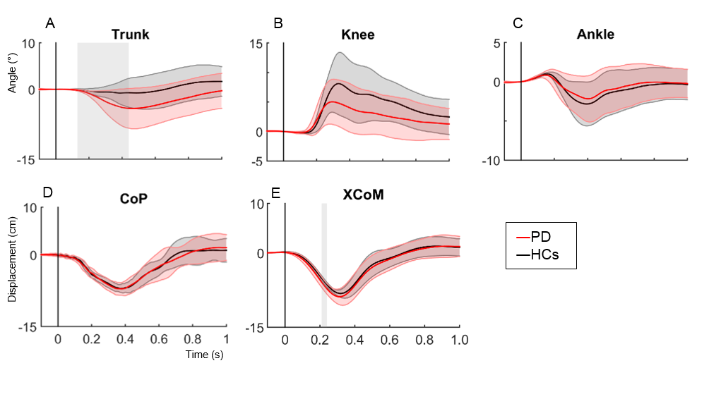
Supplementary Figure 1 - SPM analysis of XCoM and CoP responses in PD and HCs following a posterior perturbation. Figure shows the patterns of average (+SD) angular (°), XCoM and CoP displacement (cm) following a posterior perturbation in PD and HCs. Grey zones indicate the time zones where groups significantly differ from each other.

Supplementary Figure 2 – Mean EMG activity over 80-450ms after perturbation onset. Graphs display group means ± SD for magnitude (upper panel) and co-contraction of antagonists (GM) and agonists (TA), pooled for left and right leg. *p<0.05. (TA, tibialis anterior; GM, medial gastrocnemius; nu, normalized units; CCI, co-contraction index. N=17 PD; N=11 HCs).

Supplementary Tables

 |  | HCs | PD | p-value
Peak (°) | Trunk | 6.88 (4.15) | 11.61 (10.07) | 0.072
 | Knee | 17.24 (4.61) | 23.16 (7.44) | 0.007
 | Ankle | 7.01 (4.95) | 8.65 (4.95) | 0.328
ROM (°Δ) | Trunk | 4.12 (2.11) | 5.94 (3.89) | 0.096
 | Knee | 9.97 (4.80) | 6.81 (3.61) | 0.031
 | Ankle | 5.14 (2.31) | 4.50 (2.39) | 0.421
XCoM Peak (cm Δ) |  | 8.57 (0.10) | 9.19 (0.15) | 0.056
XCoM Time to Peak (s) |  | 0.34 (0.03) | 0.34 (0.2) | 0.236
CoP Peak (cm Δ) |  | 7.46 (9.13) | 7.49 (11.84) | 0.936
CoP Time to Peak (s) |  | 0.38 (0.13) | 0.35 (0.14) | 0.587
Supplementary Tabel 1 - Peak values of kinematic and kinetic data in PD and HCs. Values represent means (+std) of peak values and angular changes (°Δ ) from initial stance position following perturbation. (ROM, range of motion, XcoM, extrapolated center of mass).

