**Arabidopsis WRKY50 and TGA transcription factors synergistically activate expression of *PR1***

Rana M.F. Hussain1 , Arsheed H. Sheikh2*, Imran Haider1, Mussa Quareshy2, Huub J.M. Linthorst1



**Supplementary Fig. S1.** Western blot with GST-tagged C-terminal and full-length AtWRKY50, -51 and -59, as indicated above the lanes. Bands corresponding to the respective longest peptides are indicated with single (C-termini) or double (full-length) asterisks and with C-term* and FL** to the left of the panel. The size (kDa) of molecular weight markers is indicated to the right of the panel.

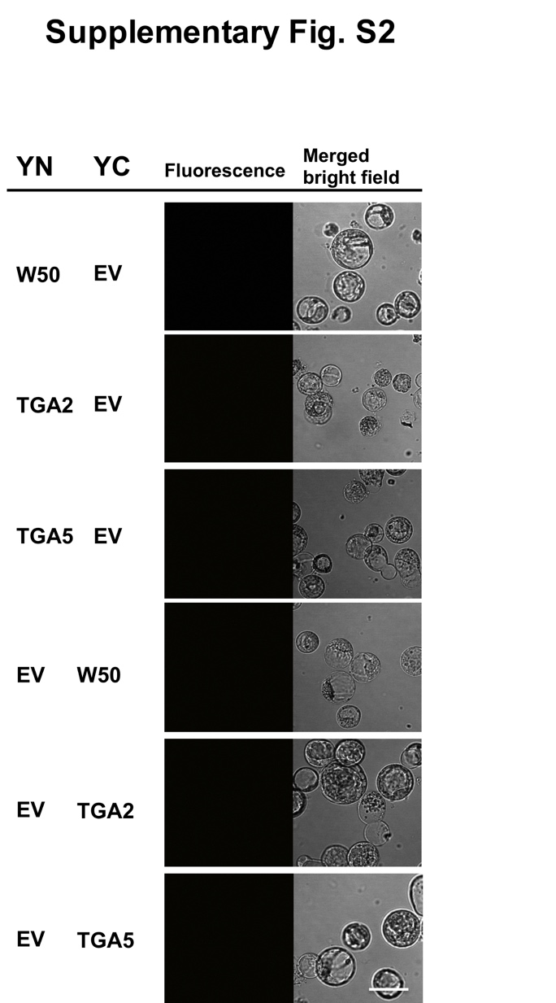

**Supplementary Fig. S2.** BiFC analysis of N-terminal and C-terminal of the indicated proteins with empty vectors. The lack of fluorescent signal served as negative control for the experiments performed in Fig. 5C (Scale bar = 10µm).



**Supplementary Fig. S3.** Propsed working model of WRKY50 and TGA activation of *PR1*.

**TABLES**

**Supplementary Table 1. Protoplast transactivation assays**

|  |  |  |
| --- | --- | --- |
| Name | Gene | Fold induction |
| AtWRKY50 | At5g26170 | 6.03 |
| AtWRKY42 | At4g04450 | 5.74 |
| AtWRKY26 | At5g07100 | 2.51 |
| AtWRKY28 | At4g18170 | 2.38 |
| AtWRKY10 | At1g55600 | 2.33 |
| AtWRKY35 | At2g34830 | 2.23 |
| AtWRKY25 | At2g30250 | 2.07 |
| AtWRKY47 | At4g01720 | 2.02 |
| AtWRKY6 | At1g62300 | 1.98 |
| AtWRKY17 | At2g24570 | 1.78 |
| AtWRKY38 | At5g22570 | 1.74 |
| AtWRKY22 | At4g01250 | 1.52 |
| AtWRKY44 | At2g37260 | 1.49 |
| AtWRKY12 | At2g44745 | 1.49 |
| AtWRKY46 | At2g46400 | 1.49 |
| AtWRKY75 | At5g13080 | 1.48 |
| AtWRKY43 | At2g46130 | 1.44 |
| AtWRKY72 | At5g15130 | 1.42 |
| AtWRKY21 | At2g30590 | 1.42 |
| AtWRKY29 | At4g23550 | 1.38 |
| AtWRKY45 | At3g01970 | 1.37 |
| AtWRKY33 | At2g38470 | 1.36 |
| AtWRKY55 | At2g40740 | 1.36 |
| AtWRKY41 | At4g11070 | 1.34 |
| AtWRKY9 | At1g68150 | 1.34 |
| AtWRKY69 | At3g58710 | 1.28 |
| AtWRKY70 | At3g56400 | 1.26 |
| AtWRKY1 | At2g04880 | 1.23 |
| AtWRKY15 | At2g23320 | 1.19 |
| AtWRKY61 | At1g18860 | 1.13 |
| AtWRKY20 | At4g26640 | 1.13 |
| AtWRKY56 | At1g64000 | 1.12 |
| AtWRKY23 | At2g47260 | 1.11 |
| AtWRKY13 | At4g39410 | 1.10 |
| AtWRKY67 | At1g66550 | 1.08 |
| AtWRKY65 | At1g29280 | 1.05 |
| AtWRKY40 | At1g80840 | 1.03 |
| AtWRKY7 | At4g24240 | 0.97 |
| AtWRKY62 | At5g01900 | 0.97 |
| AtWRKY53 | At4g23810 | 0.90 |
| AtWRKY60 | At2g25000 | 0.84 |

**Supplementary Table 2. List of primers used in this study**

|  |  |  |
| --- | --- | --- |
| **For Reporter assay** | | |
| PR1::LUC | F | GTGGAATTCCTGATTCGGAGGGAGTATATGTTATTG |
| R | CGATCCATGGTTTTCTAAGTTGATAATGGTTATTG |
| PR1::GUS | F | GTCAAAGCTTCTGATTCGGAGGGGTATATGTTATTG |
| R | CGATGGATCCTTTTCTAAGTTGATAATGGTTATTGTTGTG |
| AtWRKY50 pRT101 | F | ATAGCTCGAGGTATGAATGATGCAGACACAAACTTG |
| R | GCCTCTAGACGAGTCTTAGTTCATGCTTGAGTGATTGTG |
| AtWRKY51 pRT101 | F | AAACGAATTCAAATGAATATCTCTCAAAACCCTAGCC |
| R | GATGAGGTACCTGGATTAAGATCGAAGAAGGTGTTG |
| AtWRKY59 pRT101 | F | GAGACTCGAGAAATGAACTATCCTTCAAACCCTAACC |
| R | CTACTCTAGATCATTATGGAGCAGAATGAGAGAGAAAC |
| TGA2- pRT101 | F | TAGCGAATTCGATGGCTGATACCAGTCCGAG |
| R | TGACGGATCCGGTCACTCTCTGGGTCGAGCAAGC |
| TGA3- pRT101 | F | TAGCGAATTCGATGGAGATGATGAGCTCTTC |
| R | TGACGGATCCGGTCAAGTGTGTTCTCGTGGACGTG |
| TGA5- pRT101 | F | TAGCGAATTCGATGGGAGATACTAGTCCAAG |
| R | TGACGGATCCGGTCACTCTCTTGGTCTGGCAAGC |
| **For qRT-PCR** | | |
| *PR1* | F | GTTCTTCCCTCGAAAGCTCAAGAT |
| R | CACCTCACTTTGGCACATCCG |
| tubulin7 | F | GGAAGAAGCTGAGTACGAGCA |
| R | GCAACTGGAAGTTGAGGTGTT |
| actin3 | F | CCTCATGCCATCCTCCGTCT |
| R | CAGCGATACCTGAGAACATAGTGG |
| **For cloning WRKYs** | | |
| AtWRKY50-BD::GST | F | CTAGAATTCCTGCCGACAACCAAAACAAG |
| R | GCCAAGCTTCGAGTCTTAGTTCATGCTTGAGTGATTGTG |
| AtWRKY50-FL::GST | F | ATAGGAATTCGTATGAATGATGCAGACACAAACTTG |
| R | GCCAAGCTTCGAGTCTTAGTTCATGCTTGAGTGATTGTG |
| AtWRKY51-BD::GST | F | CTAGAATTCGAGGAAGTAAAGAGAGTGATCAG |
| R | GATGAAAGCTTTGGATTAAGATCGAAGAAGAGAGTGTTGG |
| AtWRKY51-FL::GST | F | AAACGAATTCAAATGAATATCTCTCAAAACCCTAGC |
| R | GATGAAAGCTTTGGATTAAGATCGAAGAAGAGAGTGTTGG |
| AtWRKY59-BD::GST | F | CTAGAATTCGGAAGAGACACAAAGAAGATCCG |
| R | CTACAAGCTTTCAATATGGAGCAGAATGAGAGAAAC |
| AtWRKY59-FL::GST | F | GAGAGAATTCAAATGAACTATCCTTCAAACCCTAACC |
| R | CTACAAGCTTTCAATATGGAGCAGAATGAGAGAAAC |
| **For EMSA** | | |
| PR1 80BP | F | ATCGGATCCGGTGATCTATTGACTGTTTCTCTAC |
| R | GCCTAGATCTGAAAAGTCCTGAAGAATATATGCC |
| PR1 fragA | F | GGTGATCTATTGACTGTTTCTCTACGTCACTA |
| R | TAGTGACGTAGAGAAACAGTCAATAGATCACC |
| PR1 fragB | F | TTTCTCTACGTCACTATTTTACTTACGTCATA |
| R | TATGACGTAAGTAAAATAGTGACGTAGAGAAA |
| PR1 fragC | F | TTTTACTTACGTCATAGATGTGGCGGCATATA |
| R | TATATGCCGCCACATCTATGACGTAAGTAAAA |
| PR1 fragD | F | GATGTGGCGGCATATATTCTTCAGGACTTTTC |
| R | GAAAAGTCCTGAAGAATATATGCCGCCACATC |
| Frag Am1 | F | GGGGGTGATCTATTGACTTTTCTCTACGTCACTAT |
| R | GGGATAGTGACGTAGAGAAAAGTCAATAGATCACC |
| Frag Am2 | F | GGGGGTGATCTATTGACTGCCTCTCTACGTCACTA |
| R | GGGTAGTGACGTAGAGAGGCAGTCAATAGATCACC |
| Frag Dm1 | F | GGGGATGTGGCGGCATATATTCCCCAGGACTTTTC |
| R | GGGGAAAAGTCCTGGGGAATATATGCCGCCACATC |
| Frag Dm2 | F | GGGGATGTGGCGGCATATATTCTTCAGGACCCTTC |
| R | GGGGAAGGGTCCTGAAGAATATATGCCGCCACATC |
| PR-2 LS10 | F | GGGCATATTGTTAGACTTTTCAAAGCGTATATT |
| R | GGGAATATACGCTTTGAAAAGTCTAACAATATG |
| Frag. ABC | F | ATCGGATCCGGTGATCTATTGACTGTTTCTCTAC |
| R | TATATGCCGCCACATCTATGACGTAAGTAAAA |
| Frag. BCD | F | TTTCTCTACGTCACTATTTTACTTACGTCATA |
| R | GCCTAGATCTGAAAAGTCCTGAAGAATATATGCC |
| Frag. ABC LS5m | F | ATCGGATCCGGTGATCTATTGACTGTTTCTCTAC |
| R | CATCTATGACGTAAGTAAAATAGTTGCGTAGAG |
| Frag. ABC LS7m | F | ATCGGATCCGGTGATCTATTGACTGTTTCTCTAC |
| R | CATCTATTGCGTAAGTAAAATAGTGACGTAGAG |
| Frag. BCD LS5m | F | CTCTACGCAACTATTTTACTTACGTCATAGATG |
| R | GCCTAGATCTGAAAAGTCCTGAAGAATATATGCC |
| Frag. BCD LS7m | F | CTCTACGTCACTATTTTACTTACGCAATAGATG |
| R | GCCTAGATCTGAAAAGTCCTGAAGAATATATGCC |
| Frag. ABC LS5+7m | F | ATCGGATCCGGTGATCTATTGACTGTTTCTCTAC |
| R | CATCTATTGCGTAAGTAAAATAGTTGCGTAGAG |
| Frag. BCD LS5+7m | F | CTCTACGCAACTATTTTACTTACGCAATAGATG |
| R | GCCTAGATCTGAAAAGTCCTGAAGAATATATGCC |
| **For cloning TGAs** | | |
| TGA2 | F | TAGCGAATTCGATGGCTGATACCAGTCCGAG |
| R | TGACCTCGAGGGCTCTCTGGGTCGAGCAAGC |
| TGA5 | F | TAGCGAATTCGATGGGAGATACTAGTCCAAG |
| R | TGACCTCGAGGGCTCTCTTGGTCTGGCAAGC |
| **For BiFC Assay** | | |
| W50-pRTL2  YNEE&YCHA | F | GATCGTCGACAATGAATGATGCAGACACAAACTTG |
| R | CAGTAGATCTGTTAGTTCATGCTTGAGTGATTGTG |
| W50-pRTL2  EEYN&HAYC | F | GATCGTCGACAATGAATGATGCAGACACAAACTTG |
| R | CGTAAGCGGCCGCGTGTTCATGCTTGAGTGATTGT |
| TGA2-pRTL2  YNEE&YCHA | F | GATCGTCGACAATGGCTGATACCAGTCCGAGAACT |
| R | CAGTAGATCTGTCACTCTCTGGGTCGAGCAAGCCA |
| TGA2-pRTL2  EEYN&HAYC | F | GATCGTCGACAATGGCTGATACCAGTCCGAGAACT |
| R | CGTAAGCGGCCGCGTCTCTCTGGGTCGAGCAAGCC |
| TGA5-pRTL2  YNEE&YCHA | F | GATCGTCGACAATGGGAGATACTAGTCCAAGAACA |
| R | GATCGTCGACAATGGGAGATACTAGTCCAAGAACA |
| TGA5-pRTL2  EEYN&HAYC | F | GATCGTCGACAATGGGAGATACTAGTCCAAGAACA |
| R | CGTAAGCGGCCGCGTCTCTCTTGGTCTGGCAAGCC |
| **For Yeast two hybrid assays** | | |
| W50-pAS2.1 | F | ATAGGAATTCGTATGAATGATGCAGACACAAACTTG |
| R | GCCGGATCCCGAGTCTTAGTTCATGCTTGAGTGATTGTG |
| AtNPR1-pAS2.1 | F | TAGCGAATTCTAATGGACACCACCATTGATGG |
| R | TGACGGATCCTCACCGACGACGATGAGAG |
| TGA2-pACT2 | F | TAGCGAATTCGATGGCTGATACCAGTCCGAG |
| R | TGACGGATCCGGTCACTCTCTGGGTCGAGCAAGC |
| TGA5-pACT2 | F | TAGCGAATTCGATGGGAGATACTAGTCCAAG |
| R | TGACGGATCCGGTCACTCTCTTGGTCTGGCAAGC |