**Supplementary Material**

Episodic Arctic CO2 limitation in the West Svalbard shelf

**Figures and tables**

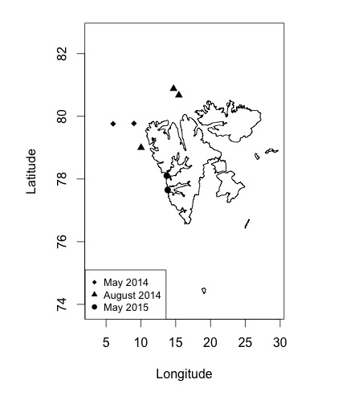

**Figure S1**: Study area of west and northwest of Svalbard. Sampled stations of the experiments May 2014 (diamond), August 2014 (triangle) and May 2015 (circles).

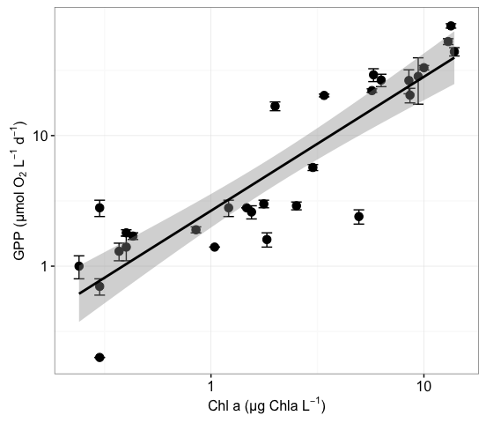

**Figure S2**: a) Relationship between log-log transformed gross primary production as the change in dissolved O2 (GPP-O2) (mean ± SE) and Chlorophyll *a* concentration (Chl a) at different depths (p <0.0001, R2 = 0.86, df = 35); The grey shadow represents the confidence interval.

**Tables**

**Table S1**: *p*CO2 and CO2 concentration at which the plankton communities of the Control and treatments of every experiments, as well as CO2 removal rates, GPP response and the standard errors (± SE), the averaged change in GPP, the Ln effect size of GPP (LN Effect Size GPP ± SE) and the averaged Ln effect size of GPP from each experiment.

