Supplementary Material
Predicting age from brain EEG signals – a machine learning approach.

Obada Al Zoubi^{1,2}, Chung Ki Wong¹, Rayus Kuplicki¹, Henry Yeah¹, Ahmad Mayeli^{1,2}, Hazem Refai² , Martin Paulus¹ and Jerzy Bodurka^{1,3}

Supplementary Figures and Tables

Figure 1. Histogram for the dataset divided based on groups and gender.

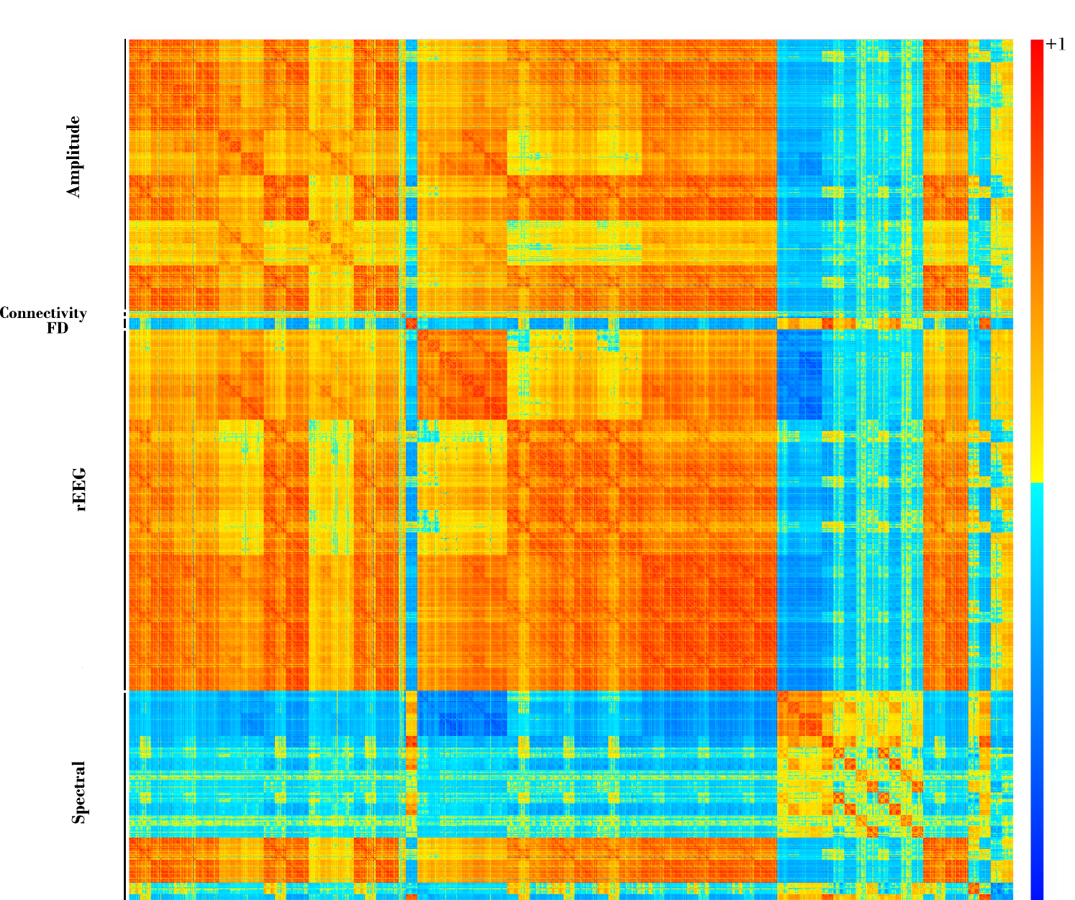

Figure S2. Correlation matrix for all features (before removing correlated features) arranged based feature type.

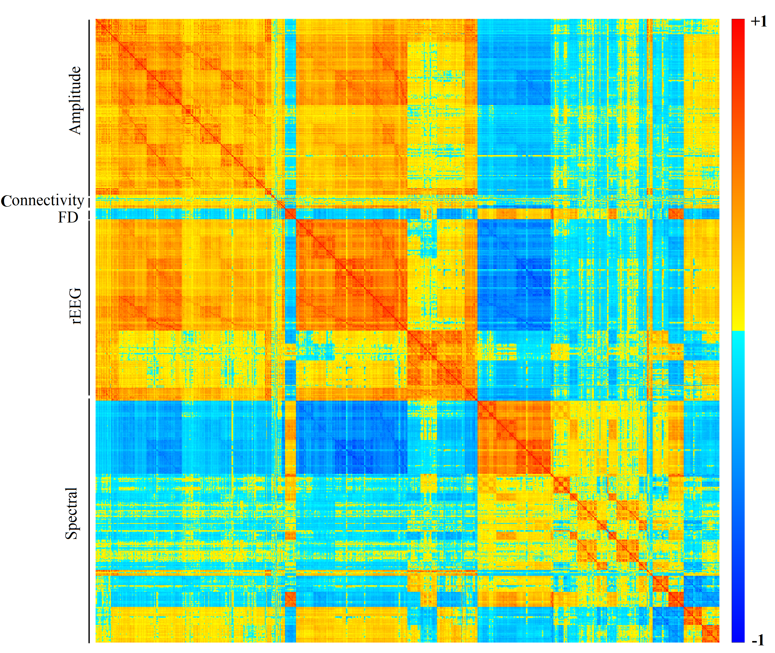
Figure S3. Correlation matrix for features (after removing correlated features: Thr=0.9) arranged based feature type.

Figure S4: Top features correlation with age.

Figure S5: The PDPs from Stack-Ensemble model for the top features. The red line represents the average values over the folds of NCV, while the thin lines are the individual PDPs for each fold.
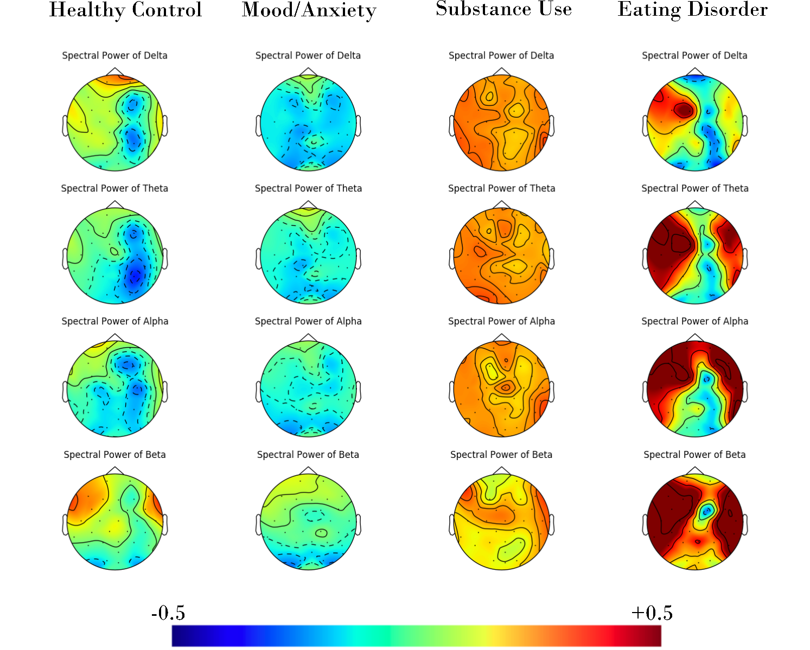

Figure S6. The correlation between spectral power feature and chronic age across different frequency bands and groups.
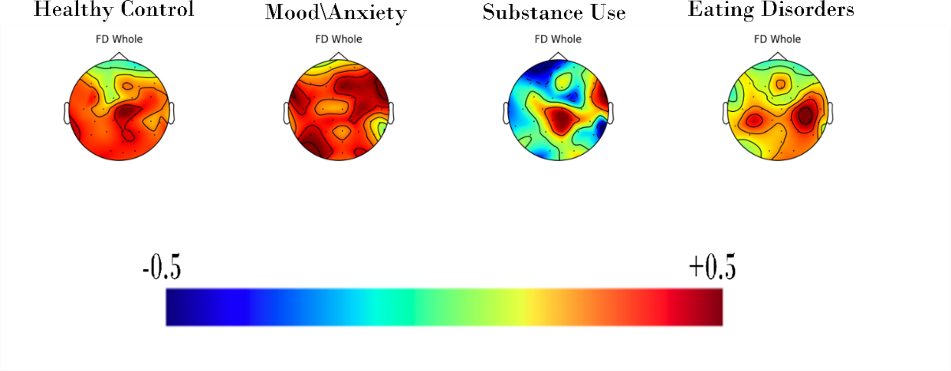
Figure S7. The correlation between FD feature and chronic age across groups (for the whole EEG frequency).

