Supplementary Material

No overt clinical immunodeficiency despite immune biological abnormalities in patients with constitutional mismatch repair deficiency (CMMRD)

Tesch VK¹, IJspeert H², Raicht A¹, Rueda D³, Dominguez-Pinilla N⁴, Allende L.M.⁵, Colas C⁶, Rosenbaum T⁷, Ilencikova D⁸, Baris HN¹⁰, Nathrath M¹¹, Suerink M¹², Januszkiewicz-Lewandowska D¹³, Ragab I¹⁴, Azizi AA¹⁵, Wenzel SS ¹⁶, Zschocke J ¹⁶, Schwinger W¹, Kloor M¹⁷, Blattmann C¹⁸, Brugieres L¹⁹, vanderBurg M², Wimmer K¹⁶*, and Seidel MG^{1, 20}*.

*, these authors contributed equally to the study.

¹⁻²⁰See main document for affiliations and correspondence.

Supplementary Data: None
Supplementary Figures: 1
Supplementary Tables: 2

- Supplementary Figures and Tables
  - Supplementary Figures

Supplementary Figure 1.
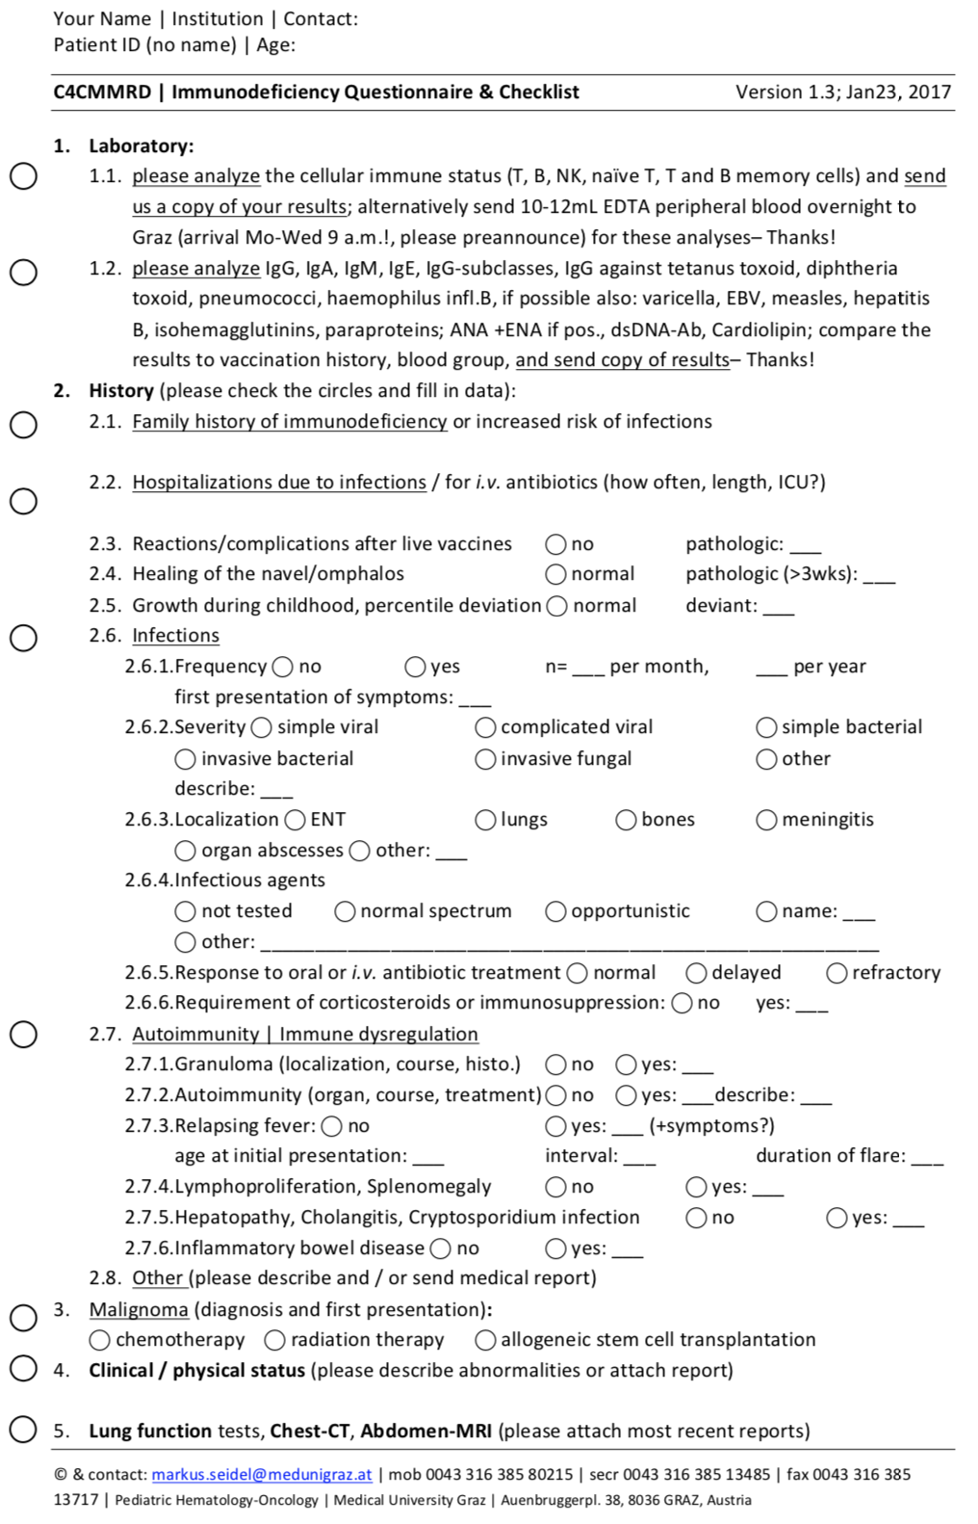

  - Supplementary Tables
    - Supplementary Table 1. Quantitative analysis of specific antibodies of 9 patients with CMMRD.
Parameter (units)  (reference range after vaccination or infection)# | P1 | P2 |  | P3 |  | P5 | P6 | P7 | P11 | P13 | P14 | P16
anti-Diphtheria-toxin-Ab (IU/mL)  (>0.1) | neg. | 0.22 |  |  | n.d. | n.d. | n.d. | 0.16 | n.d. | n.d. | 0.05 | 0.05
anti-Tetanustoxin-Ab (IU/mL)  (>0.1) | neg. | 0.29 | n.d. |  |  | n.d. | n.d. | 0.19 | n.d. | n.d. | 0.03 | 3.15
VZV IgG (mU/mL)  (> 60) | neg. | 132 | n.d. |  |  | pos. | n.d. | neg. | n.d. | n.d. | pos. | n.d.
EBV (VCA) IgG (U/ml)  (> 9) | n.d. | neg. | pos. |  |  | n.d. | n.d. | neg. | n.d. | neg. | pos. | n.d.
CMV IgG (U/mL)  (>15) | pos. | n.d. | pos. |  |  | neg. | n.d. | n.d. | n.d. | n.d. | pos. | n.d.
HBS-Ab (IU/L)  (>100) | neg. | 150 | n.d. |  |  | neg. | 146.58 | neg. | n.d. | >100 | n.d.* | n.d.
Morbilli IgG (U/mL)  (>0.15) | neg. | 169 | n.d. |  |  | neg. | n.d. | n.d. | n.d. | n.d. | n.d. | n.d.
Rubeola IgG-Ab titer  (>10) | 18 | n.d. | n.d. |  |  | n.d. | n.d. | n.d. | n.d. | n.d. | n.d. | n.d.
HiB IgG (mg/L)  (≥0.15) | neg. | 4.2 | n.d. |  |  | n.d. | n.d. | <0.11 | <0.11 | n.d. | 1.93 | 2.31
Pneumococci IgG (mg/L)  (>15-270) | pos. | 14.6 | n.d. |  |  | n.d. | n.d. | 5 | n.d. | n.d. | 3.8 | 103
Anti-nuclear Antibodies (ANA)  (negative when ≤1:80) | n.d. | neg. | n.d. |  |  | n.d. | pos. | neg. | pos. | neg. | n.d. | n.d.

* P14 has chronic Hepatitis C and is anti-HCV IgG positive (not shown), furthermore suffered from parvovirus B19-related erythroblastophthisis after chemotherapy;
#, although requested, vaccination and infection histories were unavailable from most patients; isoagglutinin analysis was only performed in two patients (normal, not shown).

    - Supplementary Table 2. Number of unique IGHG and IGHA rearrangements.

CMMRD patients | age | number of IGHG rearrangements | number of IGHA rearrangements
P11 | 7 | 263 | 305
P16 | 8 | 239 | 255
P5 | 10 | 121 | 132
P14 | 7 | 178 | 139
P13 | 10 | 198 | 85
Controls | age | number of IGHG rearrangements | number of IGHA rearrangements
NWK56 | 6 | 101 | 200
NWK64 | 7 |  | 69
NWK61 | 8 |  | 55
NWK66 | 9 | 47 | 76
NWK57 | 14 | 197 | 177
NWK42 | 15 | 130 | 106
NWK5 | 15 |  | 103
NWK53 | 18 | 423 | 405
NWK43 | 20 | 224 | 221
NWK303 | 22 | 545 | 812

