Supplementary Material

Upregulation of heme oxygenase-1 endues immature dendritic cells with more potent and durable immunoregulatory properties and promotes engraftment in a stringent mouse cardiac allotransplant model
Yue Zhao^{1, 5,6, †}, Yu Jia^{1,2,†}, Lu Wang^{1,3,4}, Song Chen^{1,3,4}, Xia Huang^{1,3,4}, Bingyang Xu¹, Guangyuan Zhao¹, Ying Xiang^{1,3,4}, Jun Yang^{1,3,4}, Gang Chen^{1,3,4,*}
* Correspondence: Dr. Gang Chen: gchen@tjh.tjmu.edu.cn

Supplementary Figure

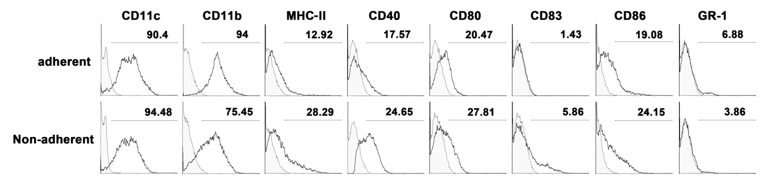
Supplemental Figure 1. Phenotype of murine BM-derived DCs
Adherent or non-adherent DCs derived from murine BM cells were characterized by cytofluorometry on day 10 of culture. Black lines in histograms show the expression of different markers in adherent and non-adherent BMDCs gated on live cells. Markers used were CD11c, CD11b, MHC-II, CD40, CD80, CD83, CD86, and GR1. Gray lines represent isotype controls. Numbers in quadrants indicate the percentage of positive cells. Data are representative of three independent experiments.

