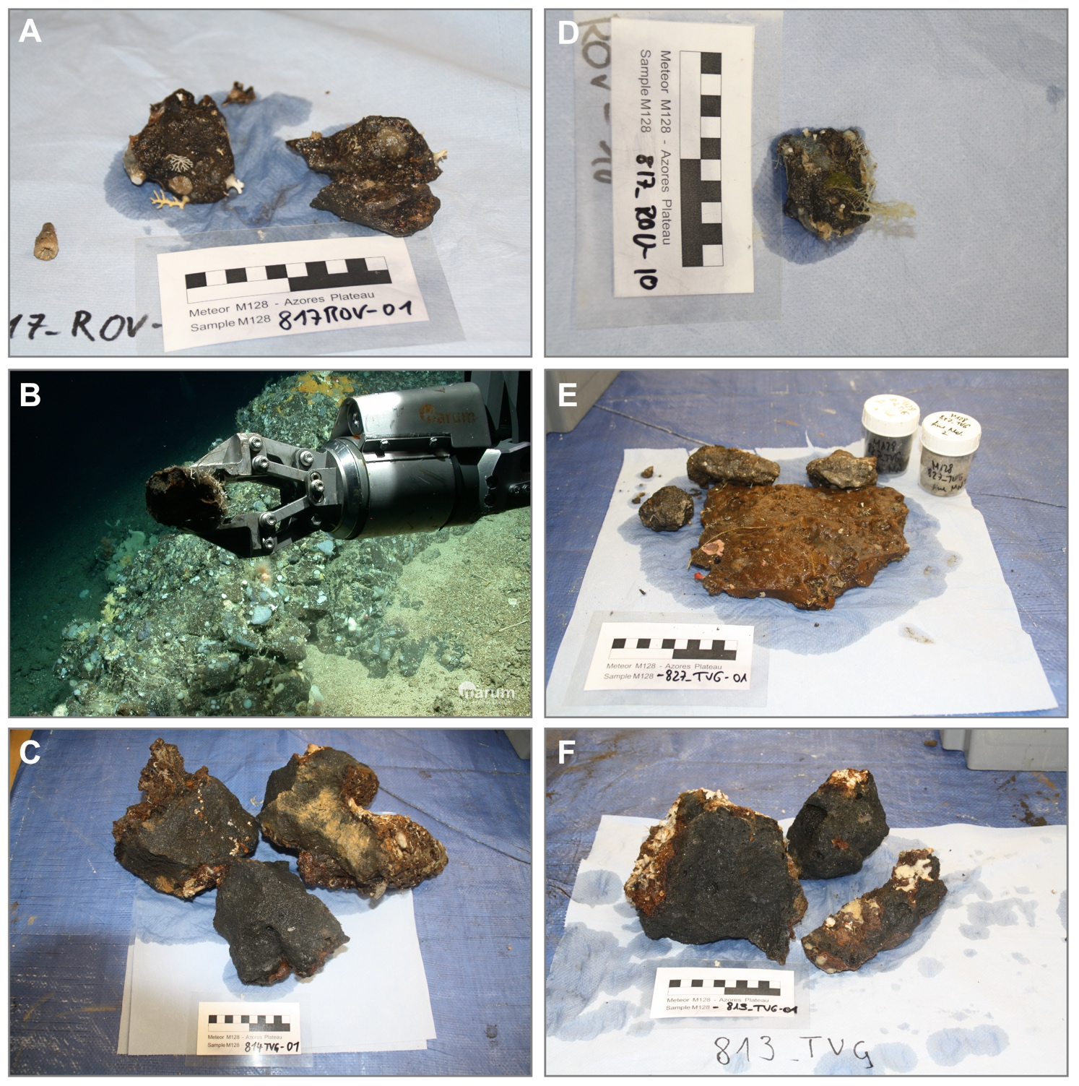
Supplementary Figure 3. Selected photographs of submarine rocks samples from (A, IEAZO1135), (D, IEAZO1144) Condor rift; (C, IEAZO1131), (F, IEAZO1130) Capelinhos rift and; (E, IEAZO1169) Northern rift (Beier et al. 2017a). (B) Photograph of sampling the Condor de Terra rift with MARUM Quest 4000 ROV. Note that the seafloor is covered by coarse carbonate sand and the volcanic rocks are covered by abundant biological overgrowths. Samples from Condor and Northern rifts are altered, vesicular volcanic rocks with abundant biological overgrowths and carbonate fillings. Lavas from Capelinhos rift are fresh, vesicular, glassy rock with only minor alteration of the glassy rims and scarce biological coatings. Scales are 10 cm.

