Supplementary File S3. Q-Q and Manhattan plots for the single-marker associations. The red line represents 5% FDR and the x-axis for the Manhattan plot represent the SNP number, not chromosome location.



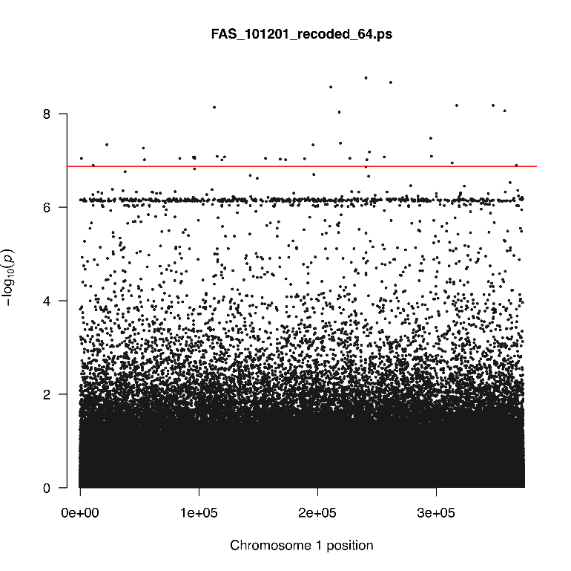

SNP number