Supplementary Material

PPAR-γ Modulates the Response of Macrophages to Lipopolysaccharide and Glucocorticoids
Michael Heming, Sandra Gran, Saskia-L. Jauch, Lena Fischer-Riepe, Antonella Russo, Luisa Klotz, Sven Hermann, Michael Schäfers, Johannes Roth and Katarzyna Barczyk-Kahlert*
* Correspondence: Corresponding Author: Katarzyna Barczyk-Kahlert bar@uni-muenster.de

Supplementary Figures

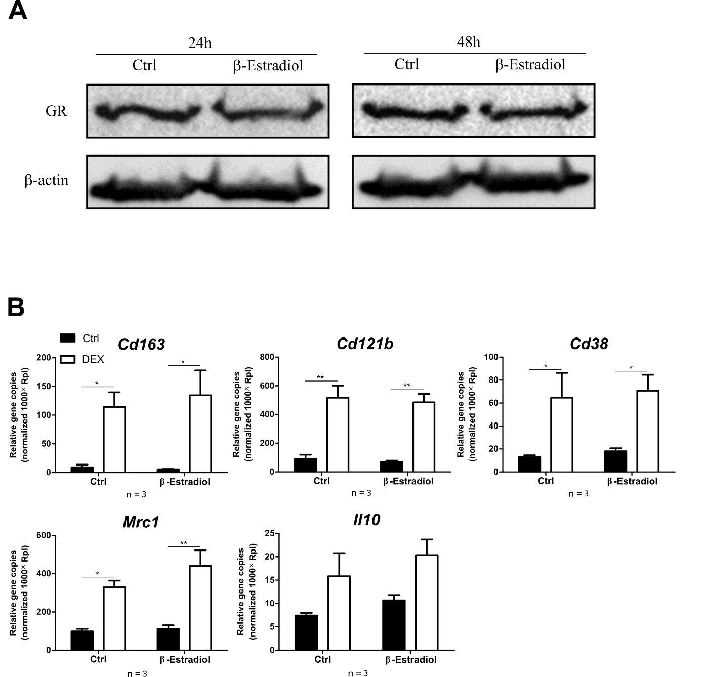
Supplemental Figure 1. β-estradiol does not influence the GC sensitivity. Bone marrow-derived monocytes were pretreated in the presence of β-estradiol for 24 h (A,B) and 48 h (A). (A) cells were analyzed for the expression of glucocorticoid receptor in Western blot. β-Actin was used as a loading control. (B) Control and β-estradiol treated bone marrow-derived monocytes were stimulated with DEX for 24 h and subsequently gene expression of the indicated genes was analyzed using qPCR. The bars represent the mean with the SEM of 3 independent experiments. * p < 0.05, ** p < 0.01 (calculated by using two-way ANOVA).

