SUPPLEMENTAL INFORMATION

Supplementary figure
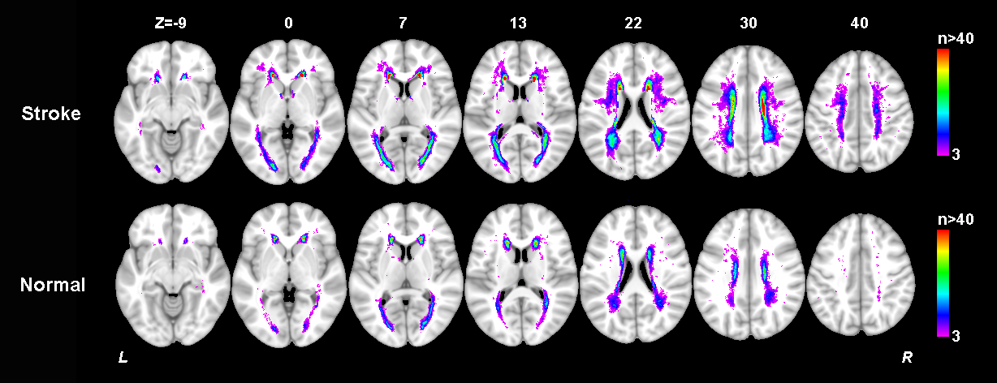
Figure S1. Lesion prevalence of while matter hyperintensity in the stroke cohort of our study and a normal control cohort well-matched in age, gender and education. Voxels that are damaged in at least three patients are projected on the 1mm MNI-152 template (Z coordinates: -9, 0, 7, 13, 22, 30, 40). Bar indicates the number of patients with a lesion for each voxel.
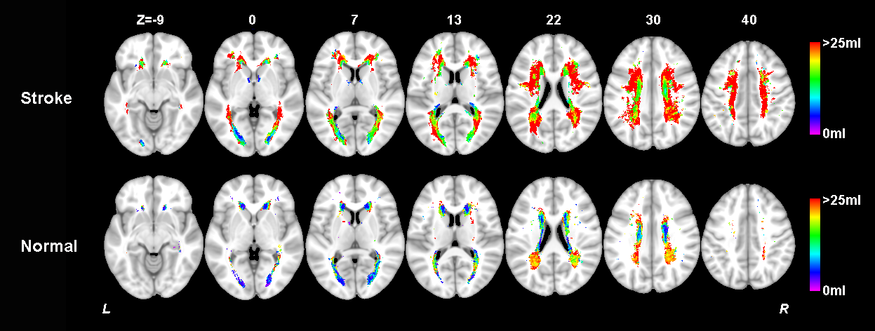
Figure S2. Lesion size topologies of while matter hyperintensity in the stroke cohort of our study and a normal control cohort well-matched in age, gender and education. Bar indicates the median white matter hyperintensity volume a patient would have, given that the specific voxel is lesioned.
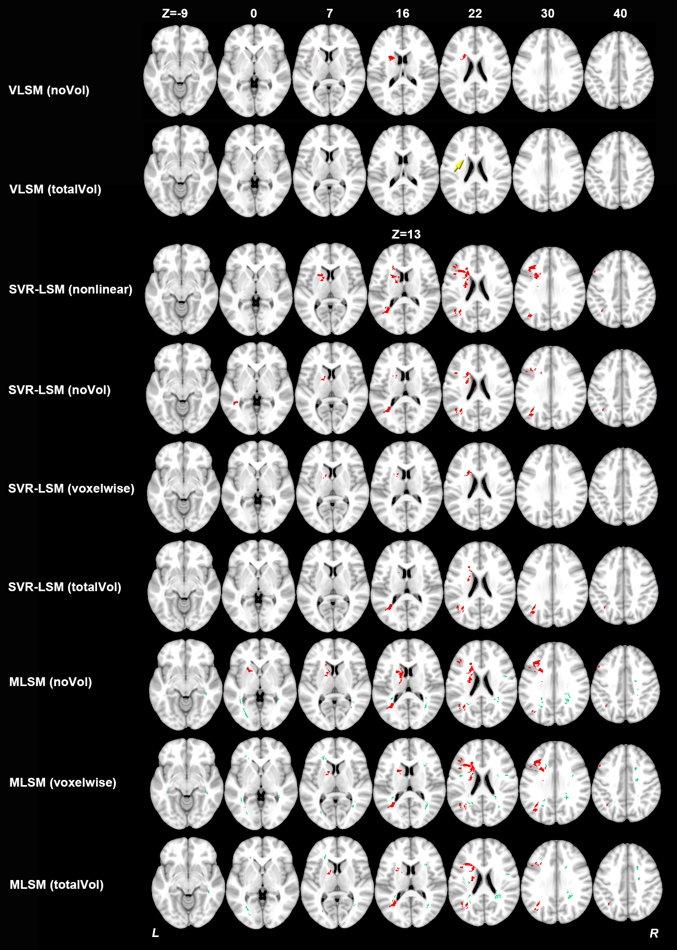
Figure S3. Statistical inference results of the mass-univariate VLSM, SVR-LSM and SVR-MLSM models for baseline cognitive impairment. The significant clusters of AIL (in red) and WMH (in green) were shown with p<0.05 from statistical inference with 1000 permutations. The yellow arrow points to the small significant cluster of VLSM results. noVol: without volume control; voxelwise: voxelwise normalization by weighting each voxel with inverse proportion to the square root of the corresponding lesion size: totalVol, volume control by regressing out the total lesion burden for baseline MoCA.
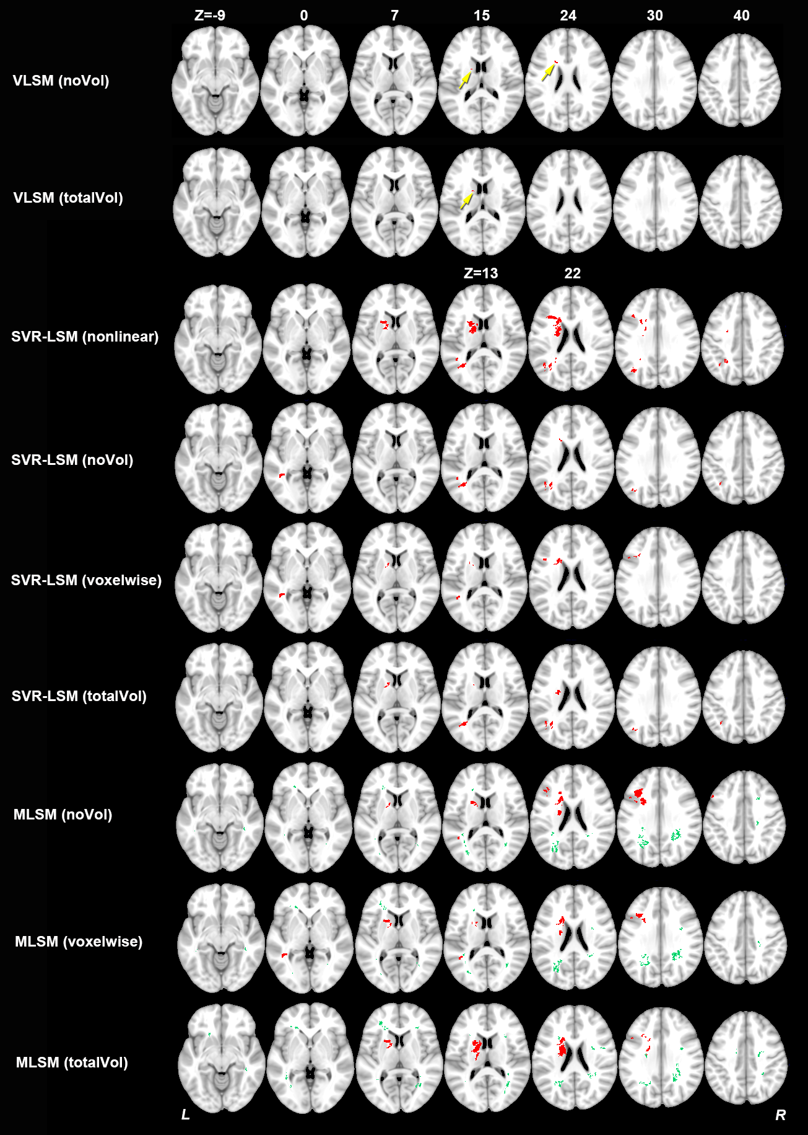
Figure S4. Statistical inference results of the mass-univariate VLSM, SVR-LSM and SVR-MLSM models for cognitive impairment at one year after stroke. The significant clusters of AIL (in red) and WMH (in green) were shown with p<0.05 from statistical inference with 1000 permutations. The yellow arrow points to the small significant cluster of VLSM results. noVol: without volume control; voxelwise: voxelwise normalization by weighting each voxel with inverse proportion to the square root of the corresponding lesion size: totalVol, volume control by regressing out the total lesion burden for year 1 MoCA.
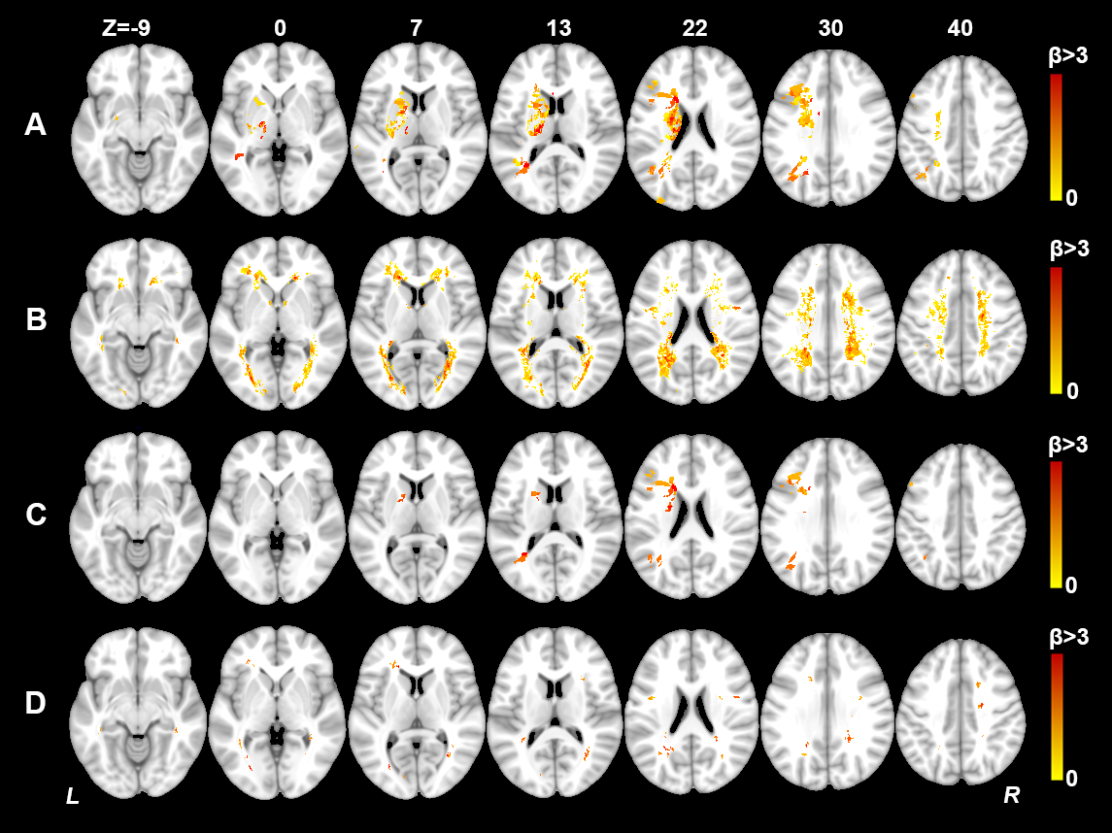
Figure S5. Beta map of SVR-MLSM (with volume control by voxelwise normalization) for baseline cognitive impairment. (A) Non-thresholded beta map of AIL; (B) Non-thresholded beta map of WMH; (C) Thresholded beta map of AIL with p<0.05 in the 1000 permutations; (D) Thresholded beta map of WMH with p<0.05 in the 1000 permutations. The beta maps of the AIL and WMH of the SVR-MLSM were normalized together to have a standard deviation of 1 for better visualization and comparison. Only the voxels with positive betas are displayed here.

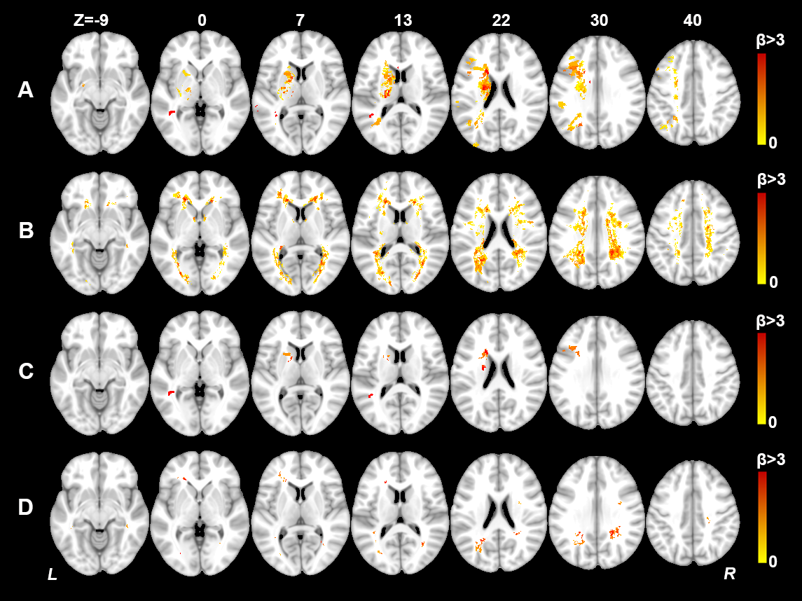
Figure S6. Beta map of SVR-MLSM (with volume control by voxelwise normalization) for cognitive impairment at one year after stroke. (A) Non-thresholded beta map of AIL; (B) Non-thresholded beta map of WMH; (C) Thresholded beta map of AIL with p<0.05 in the 1000 permutations; (D) Thresholded beta map of WMH with p<0.05 in the 1000 permutations. The beta maps of the AIL and WMH of the SVR-MLSM were normalized together to have a standard deviation of 1 for better visualization and comparison. Only the voxels with positive betas are displayed here.

Supplementary table
Table S1. Characteristics of the subjects in our stroke cohort and normal control cohort
Characteristics | Stroke cohort (n=76) | Normal controls (n=76) | p-value*
Age, mean ± SD (years) | 65.8 ± 10.1 | 68.0 ± 6.1 | 0.105
Education, mean ± SD (years) | 6.8 ± 4.2 | 6.8 ± 3.8 | 0.984
Female, n (%) | 32 (42.1) | 36 (47.4) | 0.625
WMH volume, mean ± SD (ml) | 14.2 ± 13.4 | 5.9 ± 8.4 | 1.30E-05
Baseline MoCA, mean ± SD | 21.6 ± 5.7 | 23.6 ± 3.2 | 0.009
*Group comparison were performed between the characteristics of the two groups with independent t-test or chi-square test where appropriate.
Table S2. SVR-MLSM results of acute ischemic lesions
Region | Patients with lesion (n)* | Region size in voxel (n) | Tested voxels (n) | Significant voxels of AIL [n (%)]
 |  |  |  | Baseline MoCA | Year 1 MoCA
Middle frontal gyrus L | 5 | 36072 | 2569 | 859 (33.44) | 182 (7.08)
Inferior frontal gyrus (opercular) L | 5 | 8304 | 385 | 81 (21.04) | 38 (9.87)
Inferior frontal gyrus (triangular) L | 5 | 20232 | 955 | 741 (77.59) | 98 (10.26)
Middle temporal gyrus L | 4 | 39536 | 486 | 129 (26.54) | 50 (10.29)
Middle occipital lobe L | 4 | 26160 | 1223 | 256 (20.93) | 0
Inferior parietal gyrus L | 5 | 19576 | 1513 | 26 (1.72) | 0
Angular L | 4 | 9384 | 1044 | 399 (38.22) | 0
Caudate L | 19 | 7696 | 2404 | 338 (14.06) | 342 (14.23)
Putamen L | 17 | 8072 | 3487 | 0 | 136 (3.90)
Pallidum L | 10 | 2344 | 816 | 39 (4.78) | 12 (1.47)
Body of corpus callosum | 5 | 17849 | 449 | 60 (13.36) | 36 (8.02)
Anterior limb of internal capsule L | 14 | 2889 | 1761 | 745 (42.31) | 649 (36.85)
Anterior corona radiata L | 6 | 7507 | 747 | 413 (55.29) | 0
Superior corona radiata L | 17 | 8929 | 4619 | 689 (14.92) | 411 (8.90)
Posterior corona radiata L | 11 | 5325 | 1388 | 133 (9.58) | 0
Posterior thalamic radiation L | 4 | 6387 | 906 | 447 (49.34) | 54 (5.96)
External capsule L | 12 | 3909 | 566 | 54 (9.54) | 0
Superior longitudinal fasciculus L | 4 | 9386 | 529 | 0 | 105 (19.85)
Superior fronto-occipital fasciculus L | 13 | 499 | 390 | 254 (65.13) | 179 (45.90)
Regions where there were significant AIL clusters (p<0.05) for global cognitive impairment at baseline and one year after stroke. The remaining regions in AAL atlas or ICBM-DTI-81 white matter tract atlas contained no significant voxels for cognitive impairment either at baseline or at one year after stroke; these regions are not shown here. L, left. * Number among 76 included patients had an AIL that overlapped (≥1 voxel) with the specified region of interest in AAL atlas and ICBM-DTI-81 white matter tract atlas.

