Supplementary information

Host defence versus immunosuppression: Unisexual infection with male or female Schistosoma mansoni differentially impact the immune response against invading cercariae
Martina Sombetzki, Nicole Koslowski, Anne Rabes, Sonja Seneberg, Franziska Winkelmann, Carlos Fritzsche, Micha Loebermann, Emil C. Reisinger

Supplementary Tables

Supplementary Table 1. Antibodies and enzyme-linked immunosorbent assays used in this study:
Antibody | Reference number | clone
anti-CD45-PerCP | 103129 | 30-F11
anti-CD11b-PE | 101207 | M1/70
anti-CD11c-Alexa488 | 117313 | N418
anti-Gr-1-PE-Cy7 | 108415 | RB6-8C5
anti-F4/80-APC | 123115 | BM8
anti-B220-PE-Cy7 | 103221 | RA3-6B2
anti-CD3-APC | 100235 | 17A2
anti-CD4-FITC | 100405 | GK1.5
anti-CD8-APC-Cy7 | 100713 | 53-6.7
anti-CD44-PE | 553134 | IM7
anti-62L-APC-Cy7 | 557655 | 1D3
anti-B220-APC-Cy7 | 552094 | RA3-6B2
anti-PD-L2-APC | 564715 | MIH5
anti-CD73-PE | 550741 | TY/23
anti-CD80-PerCP-Cy5.5-APC | 559370 | L307.4
IFN-γ, TNF-α, IL-1β, IL-12p70, IL-4, IL-5, IL-13, IL-10 | EPX110-20820-901
RANTES, Eotaxin, MIP-1α, MIP-1β, MCP-1, CXCL-1. CXCL-2, CXCL-10 | EPX090-20821-901
TGF-ß ELISA | 88-8350-22
IL-10 | EPX01A-20614-901

Supplementary figure legends
Supplementary figure 1. Experimental setup. To evaluate the effect of a primary unisexual S. mansoni infection on injected Schistosoma mansoni (air pouch) cercariae or on a bisexual challenge infection, three independent experimental designs were performed: study design “air pouch”, study design “antibodies and gene expression” and study design “bisexual infection”.
Supplementary figure 2: Female schistosomes suppress the recruitment of innate immune cells.
Total cell counts (A), percentage of Gr1+ inflammatory monocytes (B), eosinophils (C), neutrophils (D) and macrophages/resident monocytes (E) were analyzed in air pouch exudates. Data from individual experiments are depicted as individual symbols, lines represent mean +/- SEM; n = 5 or 10 mice each group; *p<0.05, **p<0.01, ***p<0.001, n.s., not significant.
Supplementary figure 3: Single sex or bisexual infection with Schistosoma mansoni has no impact on memory T- and memory B-cell recruitment following injection of cercariae into an air pouch.
Percentage (A) or cell counts (B) of memory T-cells and percentage (C) or cell counts (D) of memory B-cells were analyzed in air pouch exudates. Data from individual experiments are depicted as individual symbols, lines represent mean +/- SEM; n = 5 or 10 mice each group; n.s., not significant.
Supplementary figure 4: Serum biochemistry following bisexual challenge infection. Serum levels of aspartate aminotransferase (AST), alanine aminotransferase (ALT) and alkaline phosphatase (AP) are presented as mean ± SD; *p<0.05, **p<0.01, ***p<0.001
Supplementary Figures
Supplementary figure 1.
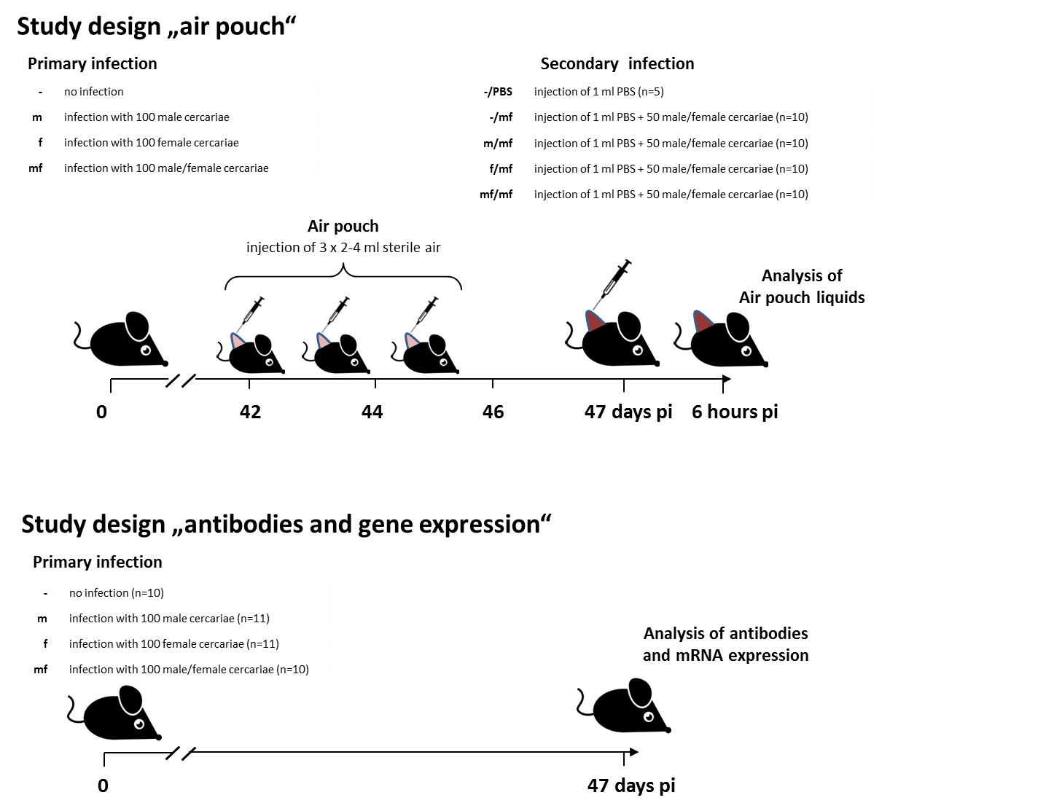
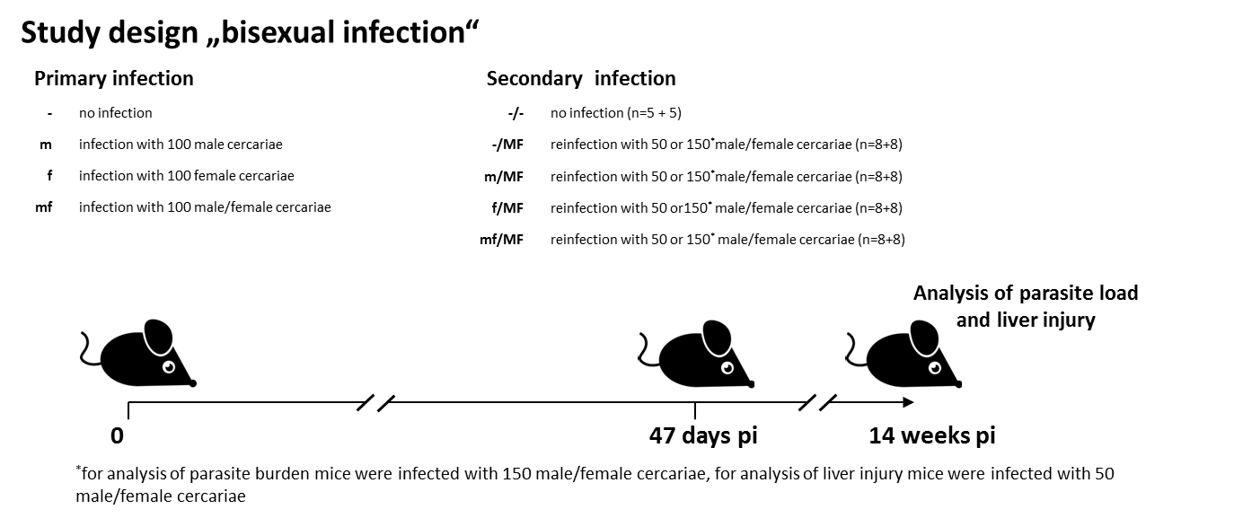

Supplementary figure 2.

Supplementary figure 3.

Supplementary figure 4.

