**Table S1**: Difference (%) in relative abundance between 1 μm and 0.2 μm fractions for October, November, and December for the dominant bacterial phyla

|  |  |  |  |
| --- | --- | --- | --- |
| **Phlya** | **October** | **November** | **December** |
| *Proteobacteria* | 1.65\* | 2.93\*\* | 3.89\*\* |
| *Actinobacteria* | -6.42\*\* | -7.72\*\* | -6.67\*\* |
| *Bacteroidetes* | 0.19 | 1.24\*\* | -1.67\* |
| *TM7* | 0.75\*\* | -0.44\*\* | 0.26 |
| *Cyanobacteria* | 1.55\*\* | 2.13\*\* | 2.38\*\* |
| Unknown | -0.53 | -0.24 | -0.82\*\* |
| *OD1* | -0.7 | -0.46 | -1.91\*\* |
| *Verrucomicrobia* | 0.23 | 0.42\*\* | 1.09\*\* |
| *Firmicutes* | 0.83\*\* | 0.55\*\* | 0.62\*\* |
| *Chloroflexi* | 0.83\*\* | 0.56\*\* | 1.35\*\* |
| Other | 1.6\* | 1.02 | 1.49\*\* |
| \*p <0.05, \*\*p <.01 | |  |  |

**Table S2**: Difference (%) in relative abundance of dominant bacterial phyla between sampling dates in 1 μm and 0.2 μm filter fractions

|  |  |  |  |  |  |  |
| --- | --- | --- | --- | --- | --- | --- |
| **Phyla** | **1 μm** | | | **0.2 μm** | | |
| **OCT-NOV** | **NOV-DEC** | **OCT-DEC** | **OCT-NOV** | **NOV-DEC** | **OCT-DEC** |
| *Proteobacteria* | 1.42 | -5.5\*\* | -4.08\*\* | 2.7\* | -4.55\*\* | -1.85 |
| *Actinobacteria* | -6.44\*\* | 0.073\*\* | 0.83 | -7.74\*\* | 8.33\*\* | 0.58 |
| *Bacteroidetes* | -1.28\* | -0.05 | -1.33\* | -0.22 | -2.96\*\* | -3.19\*\* |
| *TM7* | 0.95\*\* | 0.37\* | 1.32\*\* | -0.24 | 1.07\*\* | 0.83\*\* |
| *Cyanobacteria* | 2.58\*\* | -0.23 | 2.35\*\* | 2.79\*\* | -0.36 | 2.8\*\* |
| Unknown | -0.31 | 0.34 | 0.02 | -0.03 | -0.24 | -0.27 |
| *OD1* | -1.03\* | 1.33\*\* | 0.29 | -0.79 | -0.13 | -0.92 |
| *Verrucomicrobia* | 0.85\*\* | -0.98\*\* | -0.13 | 1.03\*\* | -0.31 | 0.72\*\* |
| *Firmicutes* | 0.32 | -0.19 | 0.13 | 0.04 | -0.13 | -0.09 |
| *Chloroflexi* | 0.56\*\* | -0.88\*\* | -0.32\* | 0.29\*\* | -0.09 | 0.2\* |
| Other | 2.39\*\* | -1.47\*\* | 0.92 | 1.81\* | -1 | 0.8 |
| \*p <0.05, \*\*p <.01 | | |  |  |  |  |

**Table S3**: Difference (%) in relative abundance between 1 μm and 0.2 μm fraction for October, November, and December for the dominant bacterial genera.

|  |  |  |  |
| --- | --- | --- | --- |
| **Genera/Taxa** | **October** | **November** | **December** |
| *Actinomycetales; ACK.M1* | -5.74\*\* | -3.96\*\* | -5.31\*\* |
| *Acidimicrobiales; C111* | -0.39 | -0.76\*\* | -0.58\*\* |
| *Limnohabitans* | -1.34\*\* | -0.74\*\* | -1.75\*\* |
| *Microbacteriaceae* | -0.43\*\* | -1.07\*\* | -0.64\*\* |
| *Synechococcus* | 1.35\*\* | 0.74\*\* | 0.35\*\* |
| *Comamonadaceae* | -0.33 | 0.17 | -0.23 |
| *Fluviicola* | 0.01 | 0.22 | -0.62\*\* |
| *Chitinophagaceae* | 1.24\*\* | 0.24\* | 0.40\*\* |
| *Sediminibacterium* | -0.44\*\* | -0.35\*\* | -0.80\*\* |
| *Polynucleobacter* | -0.99\*\* | -0.42\*\* | -0.69\*\* |
| *Sphingomonadales* | 0.00002 | -0.09 | -0.66\*\* |
| *Actinomycetales*; other | -0.69\* | -0.55\*\* | -0.73\*\* |
| *Rhodoluna* | -0.29 | -0.59\*\* | -0.28\*\* |
| *Sphingobacteriales* | -0.3\* | 0.21 | -0.42\*\* |
| *Dolichospermum* | 0.2\*\* | 1.16\*\* | 1.67\*\* |
| *Flavobacterium* | -0.02 | 0.11 | -0.23\*\* |
| *Cytophagaceae* | -0.36\*\* | -0.18\* | -0.57\*\* |
| *Actinomycetales* | 0.28 | -0.27\*\* | 0.03 |
| *TM7; TM7.1* | 0.41\* | -0.17 | 0.28 |
| *Rhodobacter* | 0.03 | 0.47\*\* | 0.95\*\* |
| *OD1; ZB2* | -0.4\*\* | -0.27\* | -0.76\* |
| *Rhizobiales* | 0.3\*\* | 0.15\* | 0.55\*\* |
| *Mycobacterium* | 0.28\* | -0.28\*\* | 0.02 |
| *Rhizobiales; other* | 0.06 | 0.06 | 0.23\*\* |
| *Bacteroidetes* | -0.25 | 0.02 | -0.28\*\* |
| *TM7; SC3* | 0.21\*\* | -0.18\*\* | 0.05 |
| *Betaproteobacteria; SC.I.84* | 0.63\*\* | 0.42\*\* | 1.24\*\* |
| *OD1; ABY1* | -0.16 | -0.17 | -0.61\*\* |
| *Betaproteobacteria* | -0.2\* | -0.09 | -0.39\*\* |
| *Gemmataceae* | 0.33\*\* | 0.13\*\* | 0.2\*\* |
| *OD1* | 0.04 | -0.03 | -0.38\*\* |
| \*p <0.05, \*\*p <.01 | |  |  |

**Table S4**: Difference (%) in relative abundance of dominant bacterial genera between sampling dates in 1 μm and 0.2 μm filter fractions

|  |  |  |  |  |  |  |
| --- | --- | --- | --- | --- | --- | --- |
| **Taxa** | **1 μm fraction** | | | **2μm fraction** | | |
| **OCT-NOV** | **NOV-DEC** | **OCT-DEC** | **OCT-NOV** | **NOV-DEC** | **OCT-DEC** |
| *Actinomycetales; ACK.M1* | -9.17\*\* | 4.21\*\* | -4.96\*\* | -7.39\*\* | 2.86\*\* | -4.53\*\* |
| *Acidimicrobiales; C111* | 0.54\*\* | 0.99\*\* | 1.53\*\* | 0.17 | 1.17\*\* | 1.34\*\* |
| *Limnohabitans* | -0.46\*\* | 0.73\*\* | 0.27 | 0.14 | -0.28 | -0.13 |
| *Microbacteriaceae* | -0.77\*\* | 0.52\*\* | -0.24 | -1.4\*\* | 0.95\*\* | -0.45 |
| *Synechococcus* | 3.34\*\* | 0.61\*\* | 3.94\*\* | 2.73\*\* | 0.22\* | 2.95\*\* |
| *Comamonadaceae* | -0.52\*\* | -0.08 | -0.6\*\* | -0.02 | -0.48 | -0.5 |
| *Fluviicola* | -1.7\*\* | 1.23\*\* | -0.48\*\* | -1.5\*\* | 0.39\* | -1.11\*\* |
| *Chitinophagaceae* | 1.48\*\* | -0.3\*\* | 1.18\*\* | 0.48\*\* | -0.14 | 0.34\* |
| *Sediminibacterium* | -0.68\*\* | 0.43\* | -0.25 | -0.59\*\* | -0.02 | -0.61\*\* |
| *Polynucleobacter* | -0.19\*\* | -0.3\*\* | -0.49\*\* | 0.38\*\* | -0.58\*\* | -0.19 |
| *Sphingomonadales* | -1.19\*\* | 0.2\*\* | -0.99\*\* | -1.28\*\* | -0.38\*\* | -1.65\*\* |
| *Actinomycetales*; other | -0.51\*\* | 0.65\*\* | 0.14 | -0.38 | 0.48 | 0.1 |
| *Rhodoluna* | 0.41\* | 0.85\*\* | 1.26\*\* | 0.11 | 1.16\*\* | 1.28\*\* |
| *Sphingobacteriales* | 0.41\*\* | -0.14 | 0.27\* | 0.92\*\* | -0.77\*\* | 0.15 |
| *Dolichospermum* | -0.93\*\* | -0.67\*\* | -1.6\*\* | 0.04 | -0.16\*\* | -0.12\* |
| *Flavobacterium* | 0.39\* | -0.69\*\* | -0.3\* | 0.53\*\* | -1.03\*\* | -0.5\*\* |
| *Cytophagaceae* | -0.46\*\* | 0.43\*\* | -0.04 | -0.29\*\* | 0.03 | -0.25\*\* |
| *Actinomycetales* | 0.59\*\* | -0.09 | 0.51\*\* | 0.04 | 0.22 | 0.26\* |
| *TM7; TM7.1* | 0.08 | -0.14 | -0.07 | -0.51\*\* | 0.3 | -0.2 |
| *Rhodobacter* | 0.66\*\* | -0.37\*\* | 0.28\*\* | 1.1\*\* | 0.1 | 1.2\*\* |
| *OD1; ZB2* | -0.62\*\* | .40\*\* | -0.22 | -0.49 | -0.09 | -0.58\* |
| *Rhizobiales* | 0.89\*\* | -0.08 | 0.81\*\* | 0.74\*\* | 0.32\*\* | 1.06\*\* |
| *Mycobacterium* | 0.93\*\* | 0.34\*\* | 1.26\*\* | 0.44\*\* | 0.64\*\* | 1.08\*\* |
| *Rhizobiales;* other | 0.51\*\* | 0.02 | 0.52\*\* | 0.51\*\* | 0.19\* | 0.7\*\* |
| *Bacteroidetes* | -0.79\*\* | 0.26 | -0.53\*\* | -0.52\*\* | -0.03 | -0.55\*\* |
| *TM7; SC3* | 0.76\*\* | 0.36\*\* | 1.12\*\* | 0.37\*\* | 0.59\*\* | 0.95\*\* |
| *Betaproteobacteria; SC.I.84* | 0.19\* | -0.89\*\* | -0.7\*\* | -0.01 | -0.07\* | -0.08\*\* |
| *OD1; ABY1* | -0.28 | 0.35 | 0.07 | -0.29 | -0.09 | -0.38\* |
| *Betaproteobacteria* | -0.33\*\* | 0.11 | -0.23\*\* | -0.23\*\* | -0.19\* | -0.42\*\* |
| *Gemmataceae* | 0.67\*\* | 0.1\* | 0.76\*\* | 0.47\*\* | 0.16\*\* | 0.63\*\* |
| *OD1* | 0.02 | 0.39\* | 0.41\* | -0.04 | 0.03 | -0.01 |

\*p <0.05, \*\*p <.01

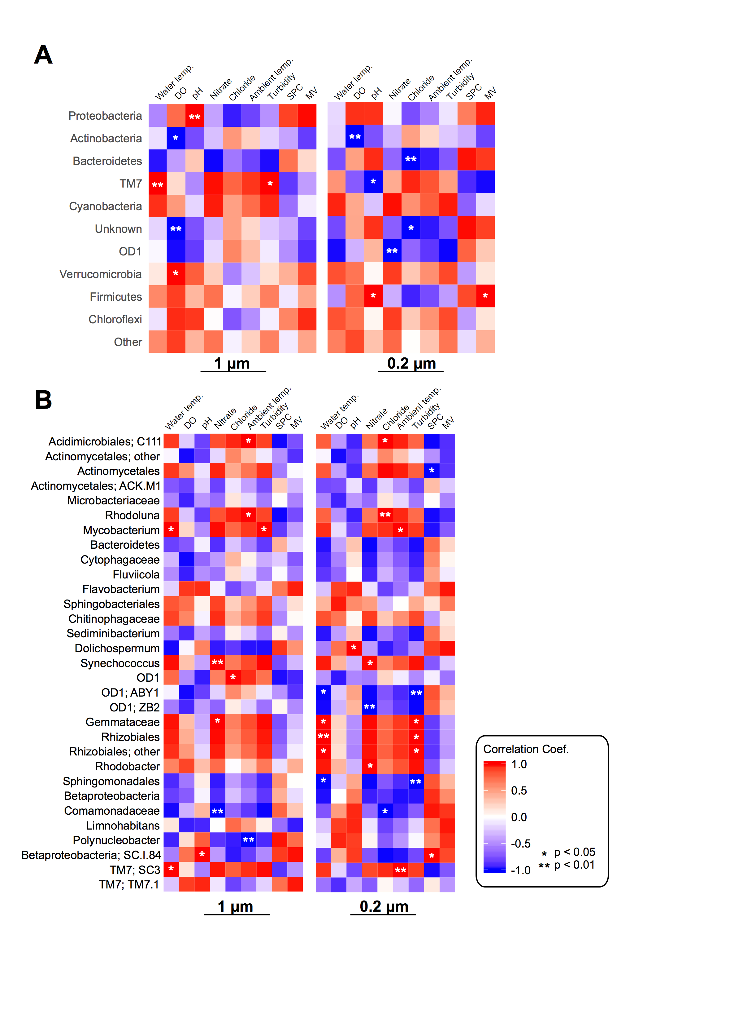

**Figure S1**: Heatmaps of the Pearson’s correlation coefficients between the water characteristics and relative abundance of bacterial (A) phyla and (B) genera for the 1 μm and 0.2 μm filter fractions. Color gradients reflect the different values of Pearson’s correlation coefficients. MV: Oxidation/reduction (mV), SPC: Conductivity (SPC uS/cm), DO: Dissolved Oxygen (%)

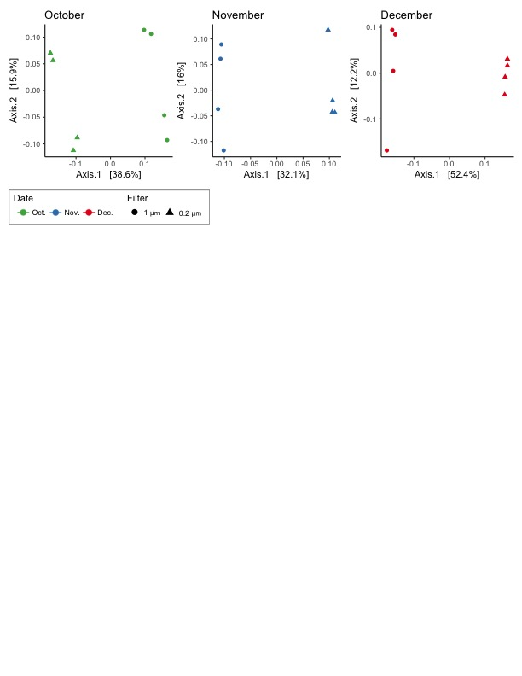

**Figure S2:** PCoA plots of beta diversity (by date) measured using Bray-Curtis. Shape denotes filter pore size, either 1μm (circle) or 0.2μm (triangle), and color denotes the month that water was sampled, October (green), November (blue), and December (red).

**Macintosh HD:Users:jessicachopyk:Desktop:Figure_S3_LV_core.pdf**

**Figure S3:** Core *Actinobacteria*, *Proteobacteria*, and *Bacteroidetes* OTUs for 1 μm and 0.2 μm filter fractions during the entire sampling period. Krona plots depicting the core OTUs in the (A) 1μm and (B) 0.2μm filter fractions for those assigned to the *Actinobacteria*, *Proteobacteria*, and *Bacteroidetes* phyla*.*

*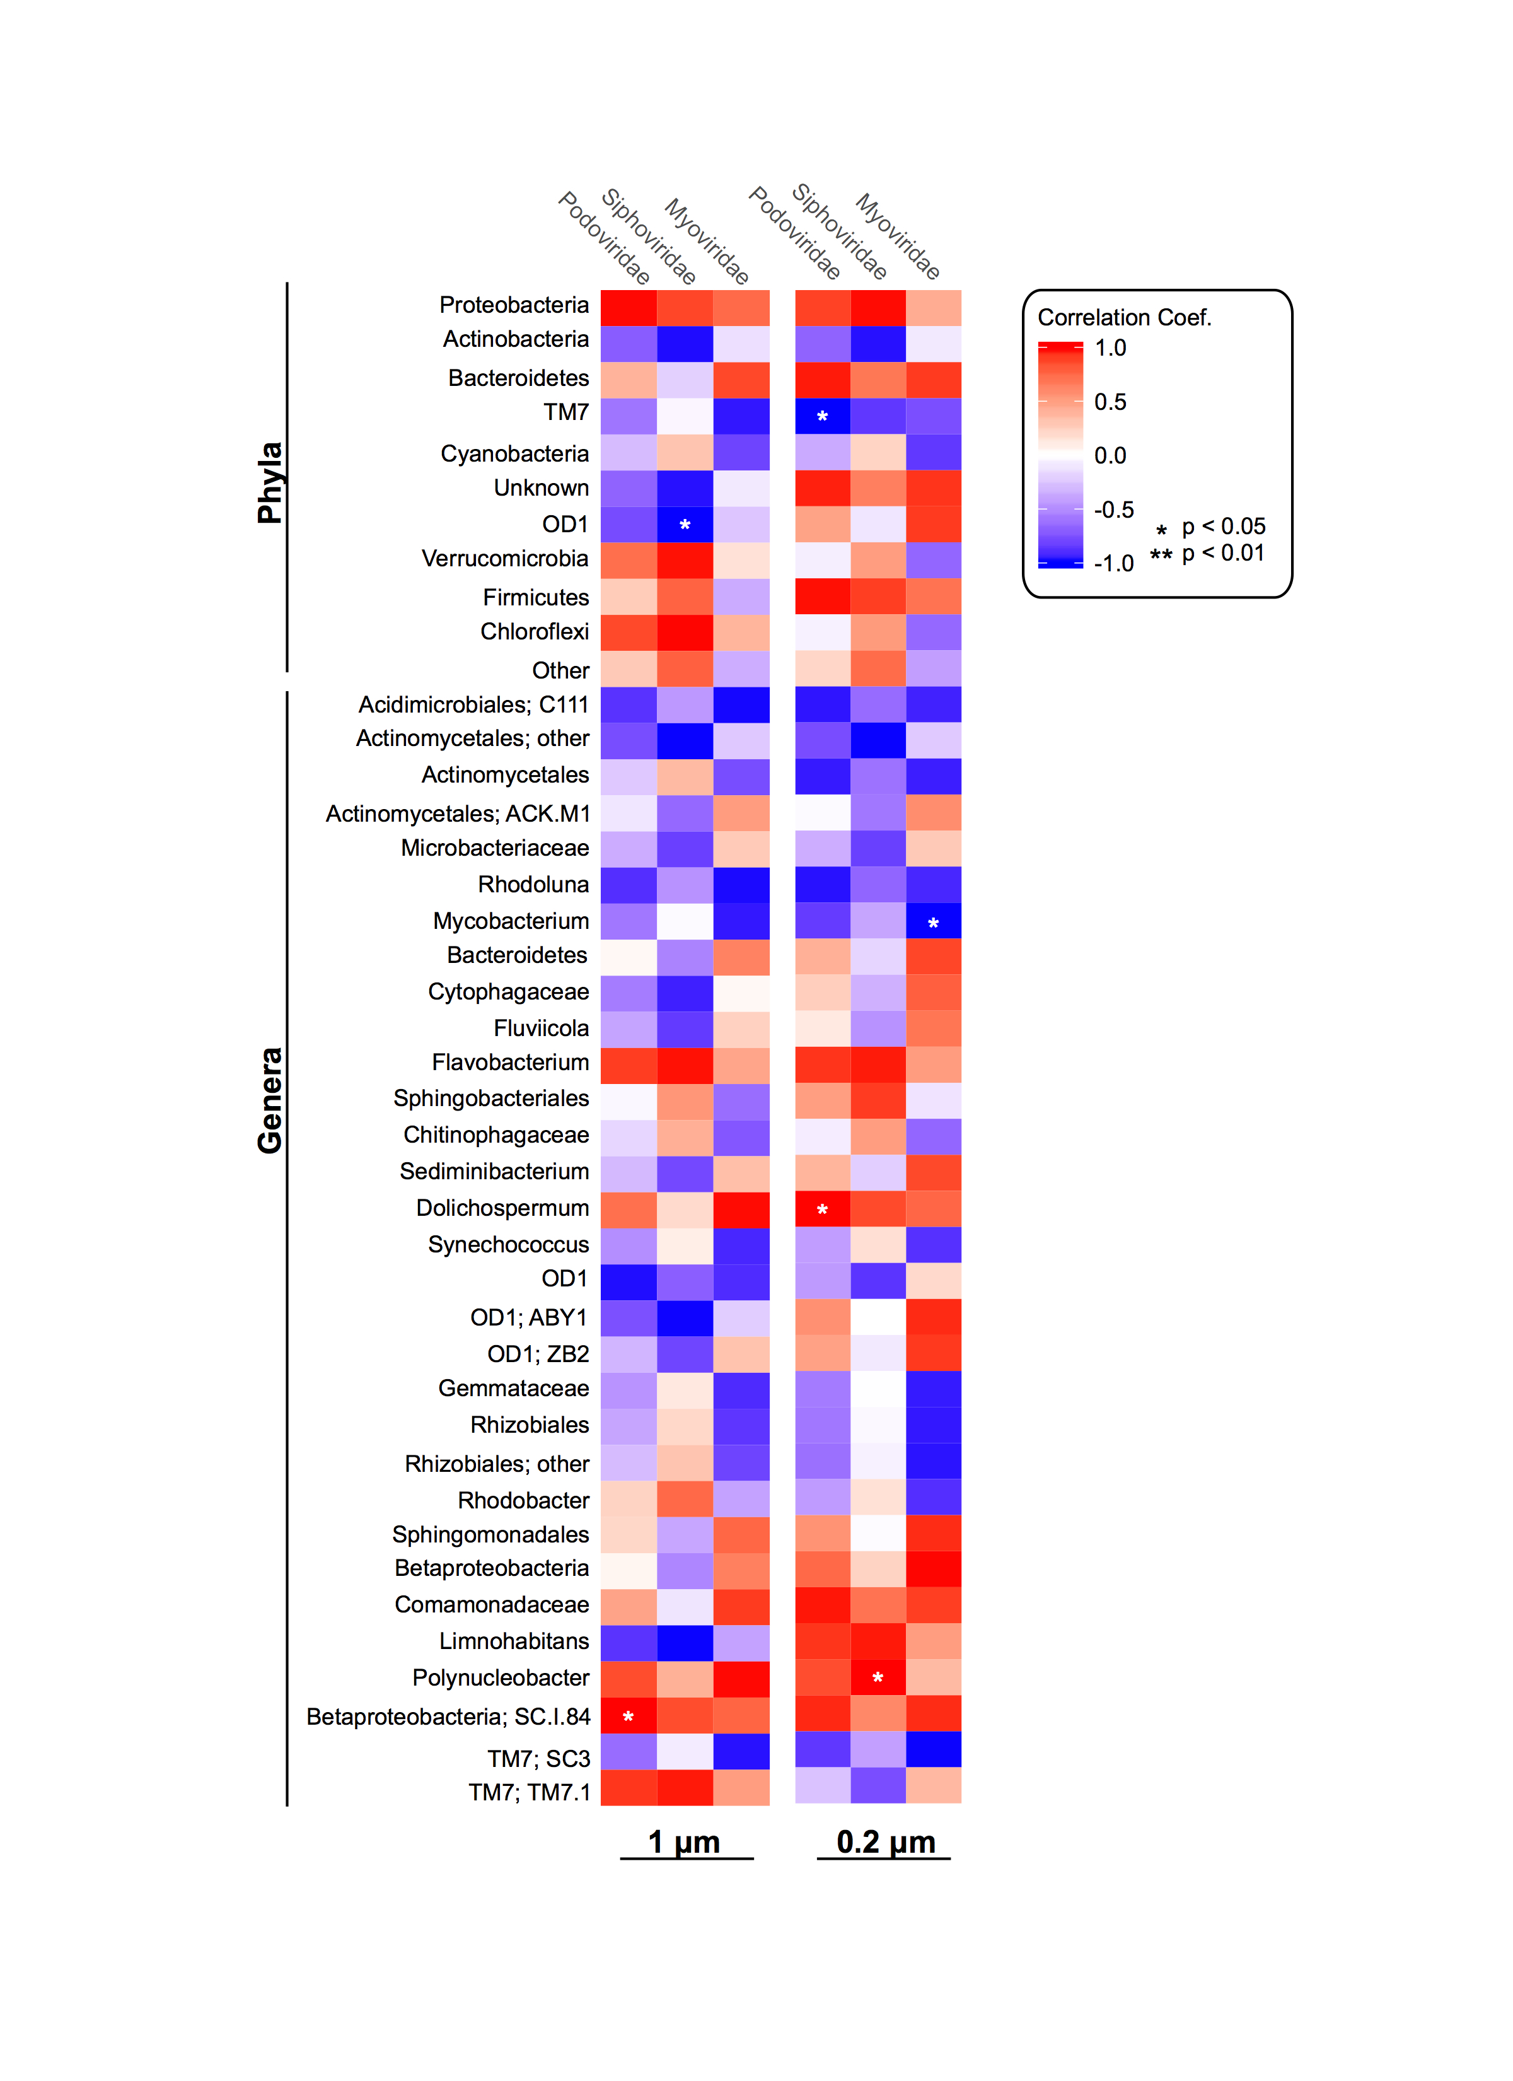*

**Figure S4**: Heatmaps of the Pearson’s correlation coefficients between dominant viral families and the relative abundance of bacterial phyla and genera in both the 1 μm and 0.2 μm filter fractions. Color gradients reflect the different values of Pearson’s correlation coefficients.