Supplementary materials

Effects of Phytochemically Characterized Extracts from Syringa vulgaris and Isolated Secoiridoids on Mediators of Inflammation in a Human Neutrophil Model

Marta Woźniakª, Barbara Michalakª, Joanna Wyszomirskaª, Marta K. Dudek^{b}, Anna K. Kissª*

ª Department of Pharmacognosy and Molecular Basis of Phytotherapy, Medical University of Warsaw, Banacha 1, 02-097, Warsaw, Poland
^{b} Centre of Molecular and Macromolecular Studies of Polish Academy of Sciences, Sienkiewicza 112, 90-363, Lodz, Poland

* Corresponding author. Medical University of Warsaw, Banacha 1, 02-097 Warsaw, Poland. Tel./fax: +48 22 572 09 85
E-mail address: akiss@wum.edu.pl

Figure 1S. Syringa vulgaris L.

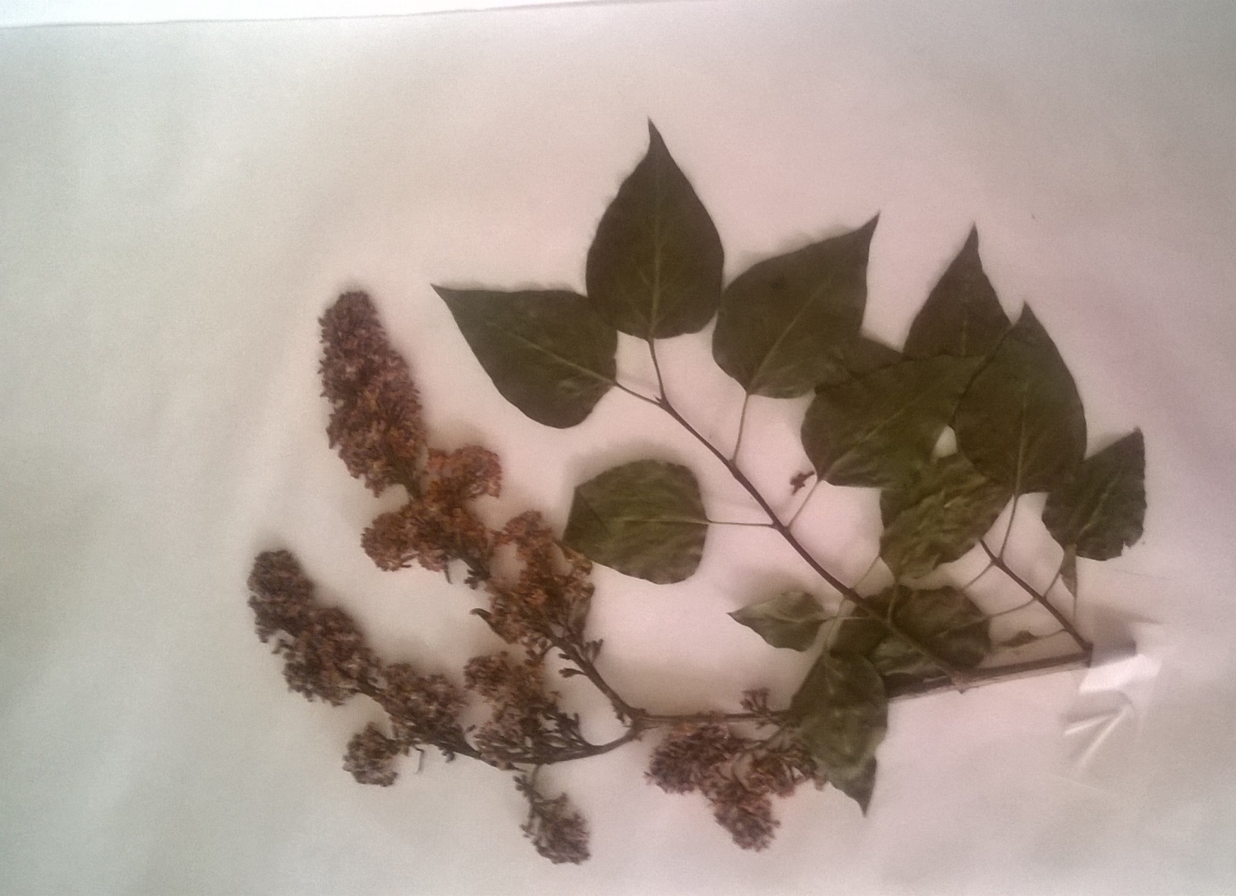

Figure 2S.
Extracted ion intensity for single compounds in each extract: A) 2’’-epiframeroside (1); B) oleonuezhenide (2); C) oleuropein (3); D) ligstroside (4); E) neooleuropein (5); F) hydroxyframoside (6); G) framoside (7)

