Supplementary Material

SNARE-derived Peptides for the Treatment of Atopic Dermatitis
Yoosoo Yang^{a,b,1}, Byoungjae Kong^{c,d,1}, Younghoon Jung^{c,d}, Joon-Bum Park^{c,d}, Jung-Mi Oh^{c}, Jaesung Hwang^{e}, Jae-Yeol Cho^{c,d} and Dae-Hyuk Kweon^{c,d,*}
* Correspondence: Dr. Dae-Hyuk Kweon: dhkweon@skku.edu

Supplementary Figures
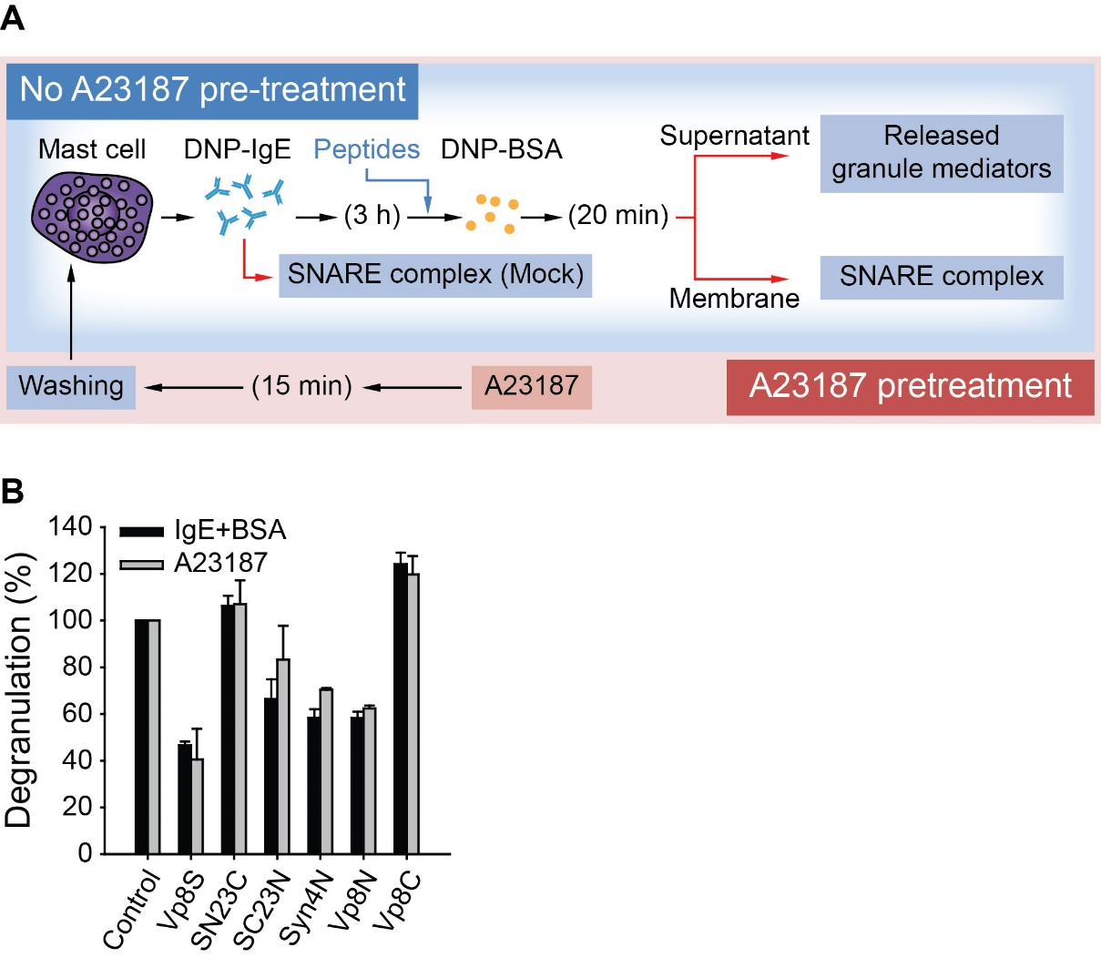
Supplementary Figure 1. Experimental scheme to evaluate the efficacy of inhibitory efficacy of synthetic peptides on the degranulation of RBL-2H3 mast cells with or without pretreatment with A23187. (A) Experimental schemes. Red box, A23187 pretreatment; blue box, no pretreatment group. (B) The inhibitory effects of the synthetic peptides against the release of β-hexosaminidase from mast cells stimulated with IgE/antigen (black) or the calcium ionophore A23187 (gray).

