SUPPLEMENTARY MATERIALS
The assignment of sub-codes allows for even more precise discrimination of the quality of social interaction. For example, consider periods of activity coded in the 3 behavioural dimensions in the following ways:

Examples of play-congruent-states:

a) Joint attention on the object/partner, holding object, positive affect:
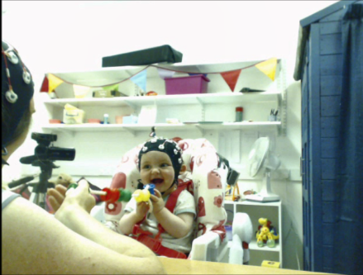
SE SM C
Parent 1.2 1.1 1.1
Child 1.2 1.1 1.1

b) Joint attention on the object/partner, holding object, neutral affect:
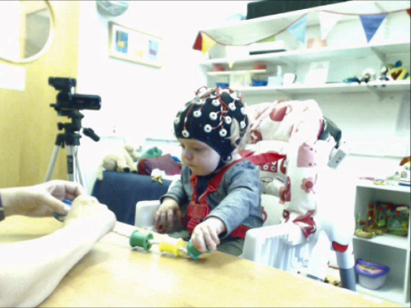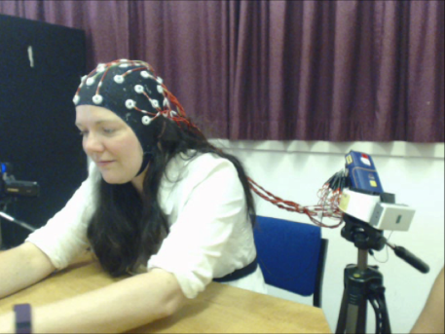
SE SM C
Parent 1.1 1.1 1.1
Child 1.1 1.1 1.1

c) Solo object-specific exploration by child, neutral affect
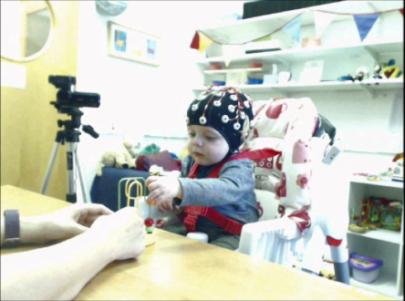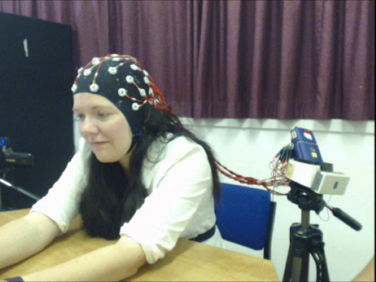
SE SM C
Parent 1.1 1.1 1.1
Child 1.1 1.3 1.2

d) Solo object-specific exploration by child, positive affect
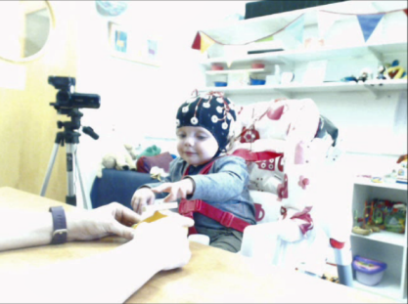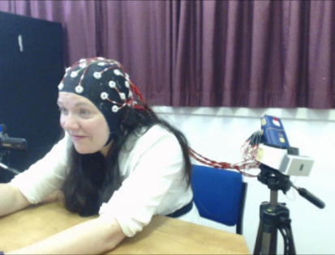
SE SM C
Parent 1.2 1.1 1.1
Child 1.2 1.3 1.2

e) Joint object-specific exploration plus display of positive affect:
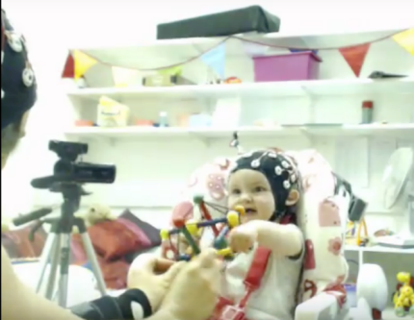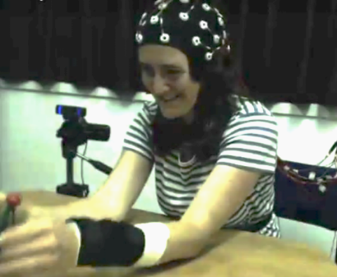
SE SM C
Parent 1.2 1.3 1.2
Child 1.2 1.3 1.2

Example of a play-incongruent state:

f) Both holding toy, positive affect, child distracted:
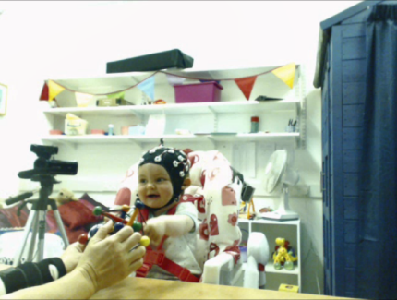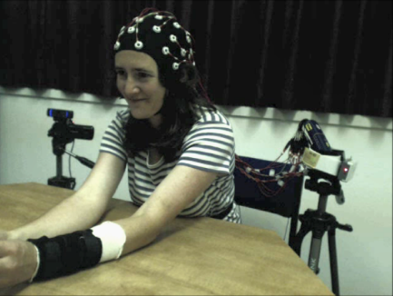
SE SM C
Parent 1.2 1.1 1.1
Child 1.2 1.1 0

