Supplementary Material

Fluoride retention on soil samples and by-products: Effects of pH, incubation time and As(V) competition
Ana Quintáns-Fondo¹, Vanesa Santás-Miguel², Juan Carlos Nóvoa-Muñoz², Manuel Arias-Estévez², María J. Fernández-Sanjurjo¹, Esperanza Álvarez-Rodríguez¹ and Avelino Núñez-Delgado^{1*}
¹Department of Soil Science and Agricultural Chemistry, Engineering Polytechnic School, Universidade de Santiago de Compostela, Lugo 27002, Spain
²Department of Plant Biology and Soil Science, Faculty of Sciences, Campus Ourense, University of Vigo, Ourense 32004, Spain
* Correspondence: Avelino Núñez-Delgado: avelino.nunez@usc.es

Additional information regarding materials
The forest soil (developed over granite) was sampled near an aluminum facility (San Cibrao, Lugo, Spain). The vineyard soil samples were taken in Sober (Lugo, Spain). The pyritic material was sampled in a mine tailing (Touro, A Coruña, Spain). The granitic material was sampled in Santa Cristina (Ribadavia, Ourense, Spain). For both soils, pyritic material and granitic material, samples were taken at 0-20 cm depth by means of a soil auger, performing composite samples by mixing 10 subsamples in each case. The fine and coarse mussel shells were sampled at Abonomar S.L. (A Illa de Arousa, Pontevedra, Spain). Mussel shell ashes were from Calizamar S.L. (Boiro, A Coruña, Spain). Oak oven wood ash was sampled in Baleira (Lugo, Spain). The slate processing fines were from Europizarras S.L. (A Fonsagrada, Lugo, Spain). For all these materials, composite samples were also performed by mixing 10 subsamples in each case. Pine sawdust was form Vitakraft (sold in the market), and a composite sample was performed by mixing 10 subsamples taken from the commercial packages previously obtained in the market. Figure S1 shows maps situating the places where the different samples were taken, all of them in Galicia (NW Spain).
In the laboratory, these materials were air dried, sieved (through 2 mm), and subjected to chemical determinations and trials (carried out on the <2 mm fraction), with triplicate determinations for all materials.

Characterization of materials
C and N were quantitatively determined as per Chatterjee et al. (2009) on triplicate 5-g samples using an auto-analyzer (Tru Spec CHNS, LECO corporation, USA). pH in water, using 10 g of solid sample, with solid:liquid relation 1:2.5, and a pH-meter (model 2001, Crison, Spain) (McLean, 1982). Exchangeable Ca, Mg, Al, Na and K were determined as per Sumner and Miller (1996), after displacement from 5-g samples with a NH₄Cl 1 M solution, then quantifying Na and K by atomic emission spectroscopy, and also Ca, Mg and Al (atomic absorption spectroscopy) (AAnalyst 200, Perkin Elmer, USA); the effective cationic exchange capacity (eCEC) was calculated as the sum of these cations (Kamprath, 1970). 1-g samples were used to determine total concentration of P, using nitric acid (65%) digestion (microwave assisted), followed by UV-visible spectroscopy (UV-1201, Shimadzu, Japan) (Tan, 1996). 1-g samples were used to determine total concentrations of Na, K, Ca, Mg, Al, Fe, Mn, As, Cd, Cr, Cu, Ni and Zn, using nitric acid (65%) digestion (microwave assisted), and ICP-mass quantification (820-NS, Varian, USA) (Nóbrega et al., 2012). Finally, 1-g samples were used to determine Al_{o} and Fe_{o} (total non-crystalline Al and Fe), using ammonium oxalate solutions extractions, and atomic absorption spectroscopy (by means of AAnalyst 200, Perkin Elmer, USA) (Álvarez et al., 2012). All trials were performed by triplicate.

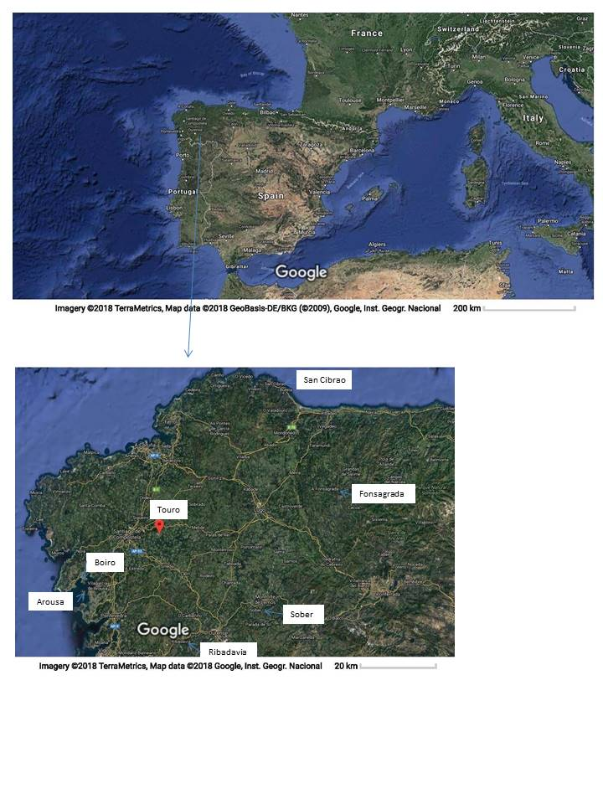Figure S1. Maps showing the places where the different soils, wastes and by-products were sampled

Table S1. General characteristics of the solid materials (average values for 3 replicates, with coefficients of variation always <5%)
 | Forest | Vineyard | Pyritic | Granitic | Oak
 | soil | soil | material | material | ash
C (%) | 4.22 | 2.94 | 0.26 | 0.11 | 6.69
N (%) | 0.33 | 0.23 | 0.04 | 0.04 | 0.10
pH_{water} | 5.65 | 4.48 | 2.97 | 5.72 | 11.19
Ca_{e} (cmol₍₊₎ kg⁻¹) | 4.37 | 1.78 | 0.36 | 0.18 | 9.81
Mg_{e} (cmol₍₊₎ kg⁻¹) | 0.66 | 0.24 | 0.29 | 0.13 | 8.49
Na_{e} (cmol₍₊₎ kg⁻¹) | 0.33 | 0.14 | 0.14 | 0.27 | 20.53
K_{e} (cmol₍₊₎ kg⁻¹) | 0.60 | 0.83 | 0.24 | 0.31 | 152.44
Al_{e} (cmol₍₊₎ kg⁻¹) | 1.92 | 2.28 | 2.86 | 1.63 | 0.00
eCEC (cmol₍₊₎ kg⁻¹) | 7.88 | 5.27 | 3.89 | 2.53 | 191.2
P_{T} (mg kg-1) | 423.9 | 679.3 | 606.3 | 88.62 | 663.7
Ca_{T} (mg kg⁻¹) | 708.5 | 607.1 | 603 | <0.01 | 81031
Mg_{T} (mg kg⁻¹) | 830.5 | 5003 | 8384 | 355 | 24505
Na_{T} (mg kg⁻¹) | 515.1 | 297.6 | 412 | 102 | 8095
K_{T} (mg kg⁻¹) | 1544 | 5441 | 3186 | 1434 | 70661
As_{T} (mg kg⁻¹) | 4.18 | 3.41 | 7 | 3 | 4.00
Cd_{T} (mg kg⁻¹) | 0.43 | 0.14 | 0.08 | <0.001 | 0.18
Cr_{T} (mg kg⁻¹) | 18.35 | 41.44 | 99 | 3 | 66.67
Cu_{T} (mg kg⁻¹) | 15.72 | 521.1 | 773 | 7 | 590.5
Ni_{T} (mg kg⁻¹) | 10.69 | 21.73 | 5 | 1 | 51.51
Zn_{T} (mg kg⁻¹) | 36.74 | 49.57 | 58 | 18 | 728.9
Mn_{T} (mg kg⁻¹) | 92.99 | 305.4 | 296 | 24 | 6778
Al_{T} (mg kg⁻¹) | 22676 | 25664 | 9624 | 5981 | 20218
Fe_{T} (mg kg⁻¹) | 9486 | 21284 | 135157 | 3505 | 41425
Al_{o} (mg kg⁻¹) | 4275 | 2003 | 563 | 1425 | 8722
Fe_{o} (mg kg⁻¹) | 2333 | 1239 | 41860 | 224 | 5239

X_{e:} exchangeable concentration of the element; X_{T}: total concentration of the element; Al_{o}, Fe_{o}: extracted with ammonium oxalate

Table 1 (Continuation)
 | Shell | Fine | Coarse | Pine- | Slate
 | ash | shell | shell | sawdust | fines
C (%) | 13.21 | 11.43 | 12.67 | 46.13 | 0.2
N (%) | 1.13 | 0.21 | 0.36 | 0.03 | 0.02
pH_{water} | 12.54 | 9.39 | 9.11 | 4.91 | 8.61
Ca_{e} (cmol₍₊₎ kg⁻¹) | 39.27 | 24.75 | 12.64 | 5.39 | 4.31
Mg_{e} (cmol₍₊₎ kg⁻¹) | 7.47 | 0.72 | 0.58 | 1.37 | 0.31
Na_{e} (cmol₍₊₎ kg⁻¹) | 19.92 | 4.37 | 5.24 | 0.66 | 0.63
K_{e} (cmol₍₊₎ kg⁻¹) | 2.61 | 0.38 | 0.31 | 1.55 | 0.31
Al_{e} (cmol₍₊₎ kg⁻¹) | 0 | 0.03 | 0.04 | 0.05 | 0.01
eCEC (cmol₍₊₎ kg⁻¹) | 69.28 | 30.25 | 18.82 | 9.02 | 5.57
P_{T} (mg kg⁻¹) | 1617 | 101.5 | 186.5 | 88.04 | 661.3
Ca_{T} (mg kg⁻¹) | 247859 | 280168 | 298085 | 8088 | 2810
Mg_{T} (mg kg⁻¹) | 5286 | 980.6 | 1020 | 164.4 | 11797
Na_{T} (mg kg⁻¹) | 8074 | 5173 | 5508 | 98.35 | 53.72
K_{T} (mg kg⁻¹) | 896 | 202.1 | 80.57 | 540.7 | 991.3
As_{T} (mg kg⁻¹) | 1.71 | 1.12 | 0.48 | 0.39 | 3.1
Cd_{T} (mg kg⁻¹) | 63.09 | 0.07 | 0.02 | 50.82 | 95.18
Cr_{T} (mg kg⁻¹) | 4596 | 4.51 | 1.32 | 234.2 | 54010
Cu_{T} (mg kg⁻¹) | 31.75 | 6.72 | 3.20 | 14.87 | 30.95
Ni_{T} (mg kg⁻¹) | 3421 | 8.16 | 5.64 | 260.6 | 24737
Zn_{T} (mg kg⁻¹) | 18.75 | 7.66 | 7.71 | 0 | 36.89
Mn_{T} (mg kg⁻¹) | 18.67 | 33.75 | 5.70 | 5.19 | 28.46
Al_{T} (mg kg⁻¹) | 3421 | 433.2 | 93.89 | 260.7 | 24737
Fe_{T} (mg kg⁻¹) | 4596 | 1855 | 170.37 | 234.2 | 54010
Al_{o} (mg kg⁻¹) | 1733 | 178.3 | 85.00 | 112.5 | 730.6
Fe_{o} (mg kg⁻¹) | 1659 | 171.0 | 42.67 | 15.62 | 1256

X_{e:} exchangeable concentration of the element; X_{T}: total concentration of the element; Al_{o}, Fe_{o}: extracted with ammonium oxalate

References
Álvarez E, Fernández-Sanjurjo MJ, Núñez A, Seco N, Corti G 2012 Aluminium fractionation and speciation in bulk and rhizosphere of a grass soil amended with mussel shells or lime. Geoderma 173/174:322–329
Chatterjee A, Lal R, Wielopolski L, Martin MZ, Ebinger MH 2009 Evaluation of Different Soil Carbon Determination Methods. Cr Rev Plant Sci 28:164–178
Kamprath EJ 1970 Exchangeable aluminium as a criterion for liming leached mineral soils. Soil Sci Soc Am P 34:252–54
McLean EO 1982 Soil pH and Lime Requirement. In: Methods of Soil Analysis Part 2 Chemical and Microbiological Properties. ASA, Madison, pp 199–223
Nóbrega JA, Pirola C, Fialho LL, Rota G, de Campos CE, Pollo F 2012 Microwave-assisted digestion of organic samples: How simple can it become? Talanta 98:272–276
Sumner ME, Miller WP 1996 Cation exchange capacity and exchange coefficients. In: Methods of Soil Analysis Part 3 Chemical Methods. ASA, Madison, pp 437–474
Tan KH 1996 Soil sampling, preparation, and analysis. Marcel Dekker, New York

