Supplementary Material

The histone demethylase JMJD2A modulates the induction of hypertrophy markers in iPSC-derived cardiomyocytes
Wendy Rosales¹ , Fernando Lizcano*¹
¹ Center of Biomedical Research University of La Sabana (CIBUS), University of La Sabana, Chía, Colombia.
* Correspondence:
Fernando Lizcano
fernando.lizcano@unisabana.edu.co

Supplementary Figures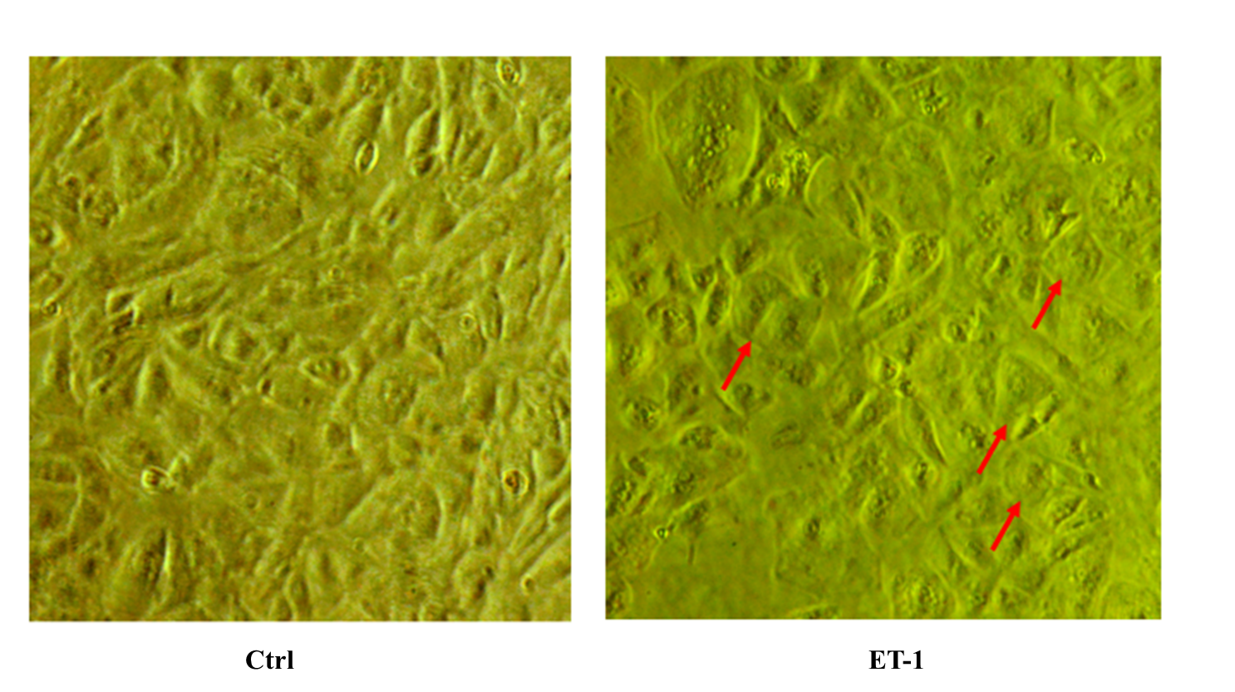
Figure S1. Cardiomyocytes derived from hiPSC before and after the induction of hypertrophy with Endothelin 1. In the figure we can observe a slight increase in the size of cells after the induction of hypertrophy with endothelin 1 (ET-1).

Figure S2. In order optimize the transfection without affect the cell viability. First was testing different DNA:Lipofectamine 3000 ratios from 1:2 to 1:5 in cardiomyocytes. The best result was 1:4 DNA:Lipofectamine 3000 ratio compared with the others relations like evidence the membrane.

